MEL editorial

Port-Hinterland Transport and Logistics: Emerging Trends and Frontier Research
Yellow marked is from the SI call and I took some parts for the text bellow
With growing containerized maritime transports the majority of seaports around the world experience an increase in the container throughput and therefore efficiency of rail and flexibility of road are increasingly needed for inland access to/from the seaports. Increase in the sea flow implies almost proportional increase in the inland flow; consequently functional seaport inland access is essential for the efficiency of the whole transportation chain. Variety of new logistics concepts tries to tackle the problem of dysfunctional inland access. The common nominator to these concepts is shift of container flows from road to rail or to the Intermodal Freight Transport (IFT) networks.
This special issue intends to reflect on the innovative trends, efforts and cutting-edge research – methodological and theoretical developments as well as applications – that address the variety of issues in management of hinterland logistics and intermodal freight transport systems. A particular interest is on the relation between maritime transport, port operations and hinterland transportation. However, other theoretical developments and applications around hinterland logistics and IFT systems are also welcome.
We encourage papers from all aspects of qualitative and quantitative research related to (but not limited):
• Integrated, multi-modal/synchromodal port hinterland transport systems
• Intelligent Logistics in port hinterlands
• Hinterland transport and logistics freight rates and markets
• Hinterland transport incorporating maritime transport
• Big Data and IT-technologies in hinterland transportation
• Collaboration and coordination in hinterland transport
• Dry ports and their network design
• Seaport development related to hinterland connections

Ever since it appeared on a large scale in the 1960’s, containerization provided opportunities for more efficient maritime transportation that has improved its performance at an impressive pace. Containerization was followed by intermodality and transportation industry was revolutionized. The biggest portion of the market share of the goods transported worldwide goes to maritime transport that accounts for 80 % of volume and 70% of value (UNCTAD, 2017). However, hinterland transport as the part of maritime intermodal transport chain represents more than 60 % of the total transport costs (Beresford et al 2012). Growing containerized maritime transport has resulted in employment of bigger container vessels to cope with that demand; the latest generation of vessels on order, Ultra Large Container Ship, is of 21,000 TEU (Rodrigue et al, 2017). These economies of scale in container vessel size have created concentration of container flows to shrinking number of ports that can accommodate those mega vessels. Consequently major seaports around the world experience increase in container volumes and despite heavy investments in container terminal capacity, handling equipment and/or dragging their drafts; increased container volumes strain their handling capacity, gate access and connections to the hinterland. Increase in the maritime flow generates almost proportional increase in the hinterland flow; therefore to utilize these economies of scale, progress at seaports and hinterland operations must match (Roso, 2013). As the result of the general growing maritime containerized transport, the main problems seaports face today are lack of space at seaport terminals and growing congestion on the access routes serving the hinterland. Consequently functional seaport hinterland access is essential for the efficiency of the whole intermodal transportation chain.
Seaports are crucial nodes in the intermodal transport chain and recently have moved their narrow focus from pure cargo handling activities to involvement in wide range of logistic activities, which give them a more active role in the transport chain. Related to that there has been a trend in organizational and technological changes towards offering door-to-door service rather than only port-to-port (Paixão and Marlow 2003). This trend resulted in expansion of seaports’ hinterland; which is defined by van Klink and van den Berg (1998) as the “the interior region served by the seaport”; and consequently created overlap in those regions that eventually generated a competition among neighboring seaports (Roso, 2013). That competition requires that the seaports focus not only on improvements within the seaport area such as developing seaport container terminals or acquiring new equipment to handle big volumes but the seaports need to focus also on their hinterland access via innovative logistics concepts. The common nominator to these concepts is shift of container flows from road to rail or to the Intermodal Freight Transport (IFT) networks.
However, productivity in the maritime part of the transport chain has not been followed by the productivity in the hinterland part; apart from the introduction of doublestack trains in the US in 1980s (DeBoer, 1992) or implementation of the dry port concept in 2000s (Roso et al, 2009). Still the road sector has by far the biggest portion of the market share for inland freight transport of 76,4 % in 2016 (Figure 1). Moreover, in the period from 2011-2016 European hinterland transport market share for road increased, while for rail it decreased; see figure 1.

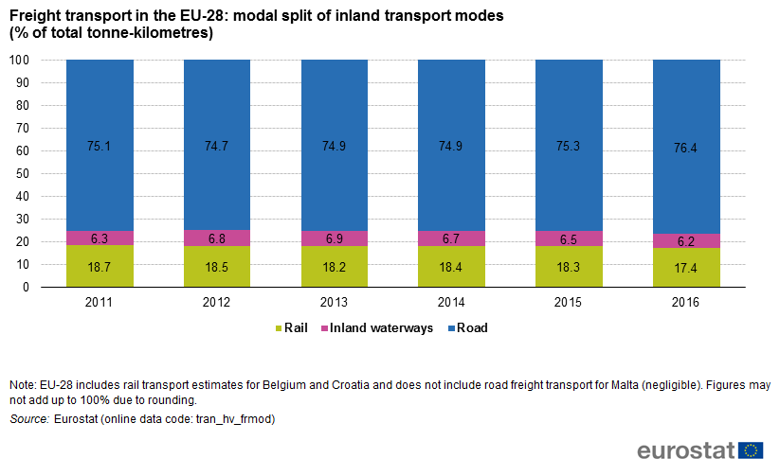

Despite various policies proposing and encouraging increased use of rail and intermodal solutions, the modal share of rail and road for inland freight transport diverged mostly due to the removal of trade barriers and the liberalization of markets, which resulted in increased market share of road transport (EEA, 2009). A change in the geographic orientation of trade from east to west has also contributed to this current situation since the new markets are not well connected by rail and therefore road with its flexibility prevails (EEA, 2009).

Containerization together with intermodality, extended seaports’ hinterlands and redefined seaport competition in a way that seaports have to strive for a position in intermodal corridors (Notteboom, 1997). For many seaports the weakest link in their transportation chain is their hinterland access due to congested roads, inadequate or non-existing rail connections that cause delays and increase transportation costs. Transport Research Board (1993) already in 1990’s identified infrastructure, land use, environmental and institutional impediments that reduce the efficiency of hinterland freight transport. To add to this, the quality of hinterland freight transport and seaport inland access depend on the behavior of a large variety of actors involved in the seaport transport system (de Langen and Chouly, 2004).

Hinterland is defined by van Klink and van den Berg (1998), as “those places that can be served by the seaport cheaper than from other seaports” However, direct transport costs are not the only determinants of seaports’ competitiveness but costs related to risks and time as mentioned above should also be considered. Furthermore hinterland can be defined also as captive/primary and contestable/secondary hinterlands (de Langen and Chouly ,2004). Primary hinterland is the area where the seaport is well-established and secondary hinterland are the regions outside immediate hinterland where seaports compete for volumes (ibid). The concept of hinterland changes constantly and it is generally accepted today that serving seaport hinterlands is more competitive than before containerisation and intermodality (McCalla, 1999). Many seaports and shipping lines integrate vertically to control hinterland transport in order to increase volumes (Notteboom, 2006). Seaports do try to attract volumes from hinterlands, however, as elaborated by McCalla (1999) the size and the shape of seaports’ hinterland is not statically determined but changes with developments in technology, economy, and society.

Further research
Based on the contributions to this special issue and on the literature review we observe the following areas for further research into maritime transport, ports and hinterlands: coping with increasing volumes, synchromodality, sustainability of intermodal freight transport, information, formalization of relations, intermodal freight transport policy making, and cooperation versus control.
Increasing ship sizes at the maritime side create challenges in deep-sea ports towards the hinterland. The often non-regular arrival patterns of deep-sea vessels pose challenges to the port terminals. Next, often capacities of inland modes and inland terminals have not kept pace with the high growth rates in deep-sea shipping. These capacity shortages manifes6t themselves in congestion and also sustainability (too much emissions and CO2 exhaust) issues. In terms of further research this leads to capacity optimization challenges, performance modeling, and also further research into system breakthroughs in order to greatly reduce emissions and exhaust of the transport system.
A next interesting issue for further research is synchromodality. Synchromodality seeks the integrated combination of hinterland modes (rail, IWW and road) to transport freight to and from the hinterland. Synchromodality especially integrates the planning of the different modes and therefore calls for the development of planning optimization models that optimize the hinterland transport.
Sustainability efforts of existing intermodal modes needed should increase enormously. Road freight transport quickly improves its environmental performance and intermodal freight transport clearly lags behind. Efforts are needed in the development of cleaner technologies for intermodal freight transport. The effects of these new cleaner technologies need to be modelled in order to be able to analyze their effects on the freight transport system.
Further research is also needed into the role, effects and impacts of the increasing use of information in intermodal freight transport. Much efficiency improvements are attributed to the increased usage of information in freight transport chains (e.g. Blockchain). However, so far, the actual prove of these efficiency improvements lack. Therefore, further research into the use of information and the modelling of its impacts on freight transport chains deserves attention.
A next interesting issue for further research is the formalization of relations (e.g. between maritime terminals and barges) in freight transport chains. Certain relationships in freight transport chains are not characterized by a service for a payment. The most notable in intermodal freight transport is the handling of a barge by a deep-sea terminal. The deep-sea terminal provides a service to the barge operator but is not paid by the barge operator but by a freight forwarder or a logistics service provider. This leads to the effects that the barge has a lower priority to the deep-sea terminal than other paying services. Research is needed into efficient solutions that can change this type of relationship and make them more formal. Modelling the effects in the total freight transport chain might be able to show the efficiency impacts on the freight transport chains.

Revisiting intermodal freight transport policy making as the last 30 years this policy has had no effect since the market share of road transport increased from 75.1% to 76.4%. More research is needed into policy options that are really able to increase the market share of intermodal freight transport versus single-mode road transport. IFT has been able to keeps its market share more or less stable but not more than that while policy has focused on increasing market share, thus failed!

Different models for cooperation versus control could be analyzed in operational research models. These different forms of cooperation and control deserve attention as transport chains get more and more integrated and thus require more cooperation. Also interesting about this further research subject are the competitive implications because initially, more cooperation in chains tends to reduce competition which will not be appreciated by competitive authorities.

References:

Beresford, A.; Pettit, S.; Xu, Q.; Williams, S. (2012), A study of dry port development in China. Maritime Economics & Logistics, 14, 73–98.
de Langen, P.W. and Chouly, A. (2004), Hinterland Access Regimes in Seaports, European Journal of Transport and Infrastructure Research, Vol. 4, no. 4, pp. 361-380.
DeBoer, D.J. (1992), Piggyback and Containers – A History of Rail Intermodal on America’s Steel Highway, Golden West Books, San Marino, Ca.
EEA (2009), Transport at a crossroads. TERM 2008: indicators tracking transport and environment in the European Union. ISSN 1725-9177
McCalla, R. J. (1999), Global change, local pain: intermodal seaport terminals and their service areas, Journal of Transport Geography, 7:247-254.
Notteboom T.E. (1997), Concentration and load centre development in the European container port system, Journal of Transport Geography, Vol. 5, 2:99-115.
Notteboom, T. E. (2006), Chapter 2 Strategic Challenges to Container Ports in a Changing Market Environment, Research in Transportation Economics, Vol. 17, 2006, Pages 29-52.
Paixão, A. and Marlow, P. (2003), Fourth generation ports – a question of agility, International Journal of Physical Distribution & Logistics Management, Vol. 33:355-376.
Rodrigue, J-P; Comtois, C. and Slack, B. (2017), The Geography of Transport Systems. New York: Routledge, 440 pages. ISBN 978-1138669574
Roso, V. (2013), Sustainable intermodal transport via dry ports - Importance of directional development, World Review of Intermodal Transportation Research, 4 (2/3), pp. 140-156, DOI: 10.1504/WRITR.2013.058976.
Roso, V., Woxenius, J. and Lumsden, K., (2009), The dry port concept: Connecting container seaports with the hinterland, Journal of Transport Geography, 17(5), pp. 338-345. DOI: https://doi.org/10.1016/j.jtrangeo.2008.10.008
Transport Research Board (TRB) (1993), Landside Access to U.S. Ports, Special Report 238, National Academy Press, Washington.
UNCTAD (2017) Review of Maritime Transportation.; United Nations Publication.
van Klink, H.A. and van den Berg, G. (1998), Gateways and Intermodalism, Journal of Transport Geography, 6:1-9.

