Development of a Typology for the Classification of Shared Mobility Hubs

Shuainan Liu (5296331)
Supervisors: Gonçalo Homem de Almeida Correia; Anastasia Roukouni

- Introduction
The sharing economy, a developing trend based on renting and borrowing goods and services instead of owning them, could improve efficiency, provide cost savings, monetize underused resources, and offer social and environmental benefits (Shaheen, et al., 2016). Shared mobility is one aspect of the sharing economy. It includes the modes of carsharing, personal vehicle sharing (peer-to-peer carsharing and fractional ownership), bike sharing, scooter sharing, traditional ridesharing, transportation network companies (or ridesourcing such as Lyft and Uber), and e-Hail (taxis). Flexible transit services including microtransit, a supplement to fixed-route bus and rail services, could also be included (Shaheen & Chan, 2016).
Shared mobility performing as an innovative transportation concept has sprung up in global cities to improve urban mobility, and it is associated with several benefits. Liao & Correia (2019) summarize the impacts of shared mobility, ranging from transportation impacts, environmental impacts, health impacts, social impacts to land use impacts, most of which are positive. Shared mobility services are expected to achieve transport mode substitution and car ownership reduction, leading to less car use which directly benefits the GHG emission problem. Apart from the health benefits brought by more physical activity, Langford, et al. (2017) claims that bike sharing equipped with e-bikes could lead to lower avoided deaths due to the less intense activity level compared to conventional vehicles. Furthermore, scooter sharing may lead to a net reduction in injuries since many car trips which are related to a higher number of injuries and fatalities are replaced by shared mobility (PBOT, 2019). Social impacts are also always mentioned when talking about shared mobility in terms of accessibility and equity. Shared mobility could make more places accessible. The catchment area of public transit could be extended by shared mobility through addressing the first/last-mile issue related to public transit access (Shaheen & Chan, 2016). Shared mobility services allow people to reach places that are beyond walking distances and poorly connected by public transport (MacArthur, et al., 2017). Shared mobility also has the potential to improve accessibility for regions and equity for groups that are under-served by traditional modes (MacArthur, et al., 2017).
Shared mobility hub, an emerging concept consisting of shared mobility modes and even other transportation modes and related facilities, has been proposed by some studies, organizations, and authorities in the last decade as a tool expected to solve some problems and achieve certain goals in the aspects of transportation, environment, and society. However, in the existing literature, no matter if they refer to shared mobility hubs or general mobility hubs, the simple term “mobility hubs” is used in the majority of cases. Thus, the searching results of “mobility hubs” in Google Scholar are filtered to a selection of studies in which the term “mobility hubs” contains at least one mode of shared mobility and one geographical location. This filtering is done because on the one hand the transport mode(s) that this paper focuses on is shared mobility mode(s) and on the other hand when shared modes do not need to be parked at a specific geographical location (a hub), for instance in the case of free-floating carsharing, these applications fall out of the scope of this work. Moreover, to avoid confusion, the term “shared mobility hubs” is always used in this paper even though most of the cited cases use “mobility hubs” in their works.
The remainder of the paper is structured as follows. First off, the definitions and objectives in the literature in the global context (mainly in Europe and North America which take the initiative in shared mobility hubs) are introduced to give a general idea of shared mobility hubs and a broader perspective of their benefits. The reasons why the purpose of this paper, proposing a shared mobility hubs typology, is important are then presented. The next section is the literature review of the existing shared mobility hubs typologies with their strengths and shortcomings. This is followed by presenting the methodology about how to determine our typology based on the findings from the literature review and proposing the final typology. The paper ends with general conclusions.

  - The definitions of shared mobility hubs
There is no universal definition of shared mobility hubs. Nearly every paper/report has a unique definition of shared mobility hubs. This is because each study defines shared mobility hubs considering their specific case and it is still an emerging concept. However, there are still some common themes based on which we identify three types of definitions. The first type of definition has the most relaxed requirements, one geographical location including shared mobility mode(s). Shared mobility hubs are seen as physical places that connect a variety of transport modes (RISE & ARUP, 2020). Their locations are flexible, from a bus stop, a bike sharing station to an inner-city main train station. Anderson et al. (2017) suggest that the agglomerations of transportation modes should concentrate on emerging shared mobility services. The hubs could be located in low-density residential neighborhoods with low-quality mobility options, high-density areas (large employment centers and non-residential uses), and key-transport-node-related areas. NWE (2019) gives the chosen shared mobility modes a more specific restriction, that they should be electric, such as e-bikes, e-cargo bikes, e-scooters, and/or e-cars. Thus, shared mobility hubs are referred to as e-mobility hubs (eHUBS) in this study. There is no restraint about the locations of hubs which are described as on-street locations.

Public transport being a necessary component of the concept of shared mobility hubs is one main character in the second type of definition. According to CoMoUK (2019) and SEStran (2020), a shared mobility hub is a recognizable place housing public and shared mobility modes with enhanced facilities, services, and information features to attract and benefit travelers. They can be developed in a wide range of contexts from the city center to the rural area. RIPTA (2020) adds car commutes to the combination of active modes and transit in terms of multi-modality of shared mobility hubs. The facilities are specified as public, commercial, or residential amenities which are considered to attract more people using public transport due to the convenience. SANDAG (2016) also thinks of shared mobility hubs in a multi-modality provision way. Particularly, this study assigns different functions to different types of transportation modes. Shared mobility modes are for making short trips within the neighborhood, however, public transport is for making long trips to the area outside the neighborhood. Besides including the similar components (public transit, shared mobility modes, and other elements, e.g., dedicated curb space, EV charging station, interactive kiosks), shared mobility hubs in SUMC (2018) are also considered as a small subset of Transit Oriented Development (TOD) since they are always supposed to include transit nodes. SUMC (2019) adds the concept of places (within a one-quarter mile of transit nodes) where people have seamless access to multiple transportation modes in a safe, comfortable, and accessible environment into the definition of shared mobility hubs.
Many other studies (e.g. SANDAG, 2019; Metrolinx, 2011; BrookMcllroy, 2014; Los Angeles Department of City Planning, 2016; Transportation Management & Design, 2019) also follow the same concept extension, they even require a certain concentration of people, activities, and destinations to be located within the surrounding areas, creating an intensive land use around transit stations and making the shared mobility hubs become activity centers. This extended definition also shows that public transport becomes the key element in shared mobility hubs. BrookMcllroy (2014) even considers the intersections of multiple rapid transit lines to be shared mobility hubs. The main differences between these studies are the range of the included surrounding areas. Transportation Management & Design (2019) proposes a 5-to-10-minute walking area to include the nearby retail and services as destinations. Metrolinx (2011) defines the surrounding area within an 800-meter radius of the rapid transit station. Particularly, the shared mobility modes in Metrolinx (2011), coordinated first/last-mile feeder buses and demand responsive transit service, are not the above-mentioned common shared mobility services, however, they still belong to the shared mobility range given by Shaheen & Chan (2016). Also, there is a specific geographical location for shared modes to park, thus, this study is under the range of study of this paper.

Shared mobility hubs in some studies are residential-area specific. In the study of Claasen (2020), a shared mobility hub is a location in a residential area, offering shared cars, mopeds, e-bicycles, and e-cargo bicycles together. Besides this basic definition, shared mobility hubs could be located in the old residential areas connecting with public transport (Miramontes, et al., 2017) and they could also be located in the new residential areas combining shared mobility modes, innovative spatial and parking concept, and amenities (Goudappel Coffeng, 2018). Snel (2020) proposes shared mobility hubs as the ‘heart of the neighborhood’, forming the network in the whole city. Due to the neighborhood character, hubs are supposed to be within the walking distance (max. 300 meters or 5-minute walk) from home.

  - The objectives of shared mobility hubs
Mentioned objectives of shared mobility hubs in each study also vary from study to study because of the various given definitions of shared mobility hubs, the different aimed problems to be addressed in each study, and the factors (such as travel behaviors) that influence the practical effects. In some cases where shared mobility hubs are applied already, the impact of them as their benefits is discussed. However, although the objectives (impact) of shared mobility hubs in each study are different, they consist of the benefits from shared mobility itself and the additional benefits brought by the combination of shared mobility modes and other elements (such as public transport and related amenities), thus, showing much in common.
First off, a hierarchical network of such hubs is considered to create a smarter sustainable mobility lifestyle (lower car use and mitigated associated problems, such as relieved neighborhood congestion (SANDAG, 2019)) because the provided modes, shared mobility modes (and public transport), are sustainable and equitable. This benefit is one of the main benefits of shared mobility itself, being part of the objectives of shared mobility hubs in many studies (NWE, 2019; CoMoUK, 2019; SEStran, 2020; RIPTA, 2020; SANDAG, 2019). RIPTA (2020) and SEStran (2020) also pay attention to sustainable travel behaviors change, modal shift. To this end, the concept of shared mobility hubs in RIPTA (2020) providing environmentally-friendly travel modes is as important as its positive influence on user behavior towards adopting these alternative transport options. Some of the sustainable side objectives are proved in residential areas that already apply shared mobility hubs (Claasen, 2020). It shows that hubs reduce the household car ownership to some level in two German cities, Munich and Würzburg, mainly due to carsharing. However, the effects of bicycle sharing on car ownership are unknown in Munich and it is unlikely to be an influential factor for Würzburg. Claasen (2020) also points out that the effects of shared mobility hubs on new residential areas would be more positive than they are on the existing ones even though the characteristics of their applied shared mobility hubs are the same. This is because the inhabitants in old residential areas are used to their existing travel choices.
Secondly, shared mobility hubs could provide convenience to make multi-modal trips and, thus, encourage people to consider multi-modality (CoMoUK, 2019; RIPTA, 2020; SANDAG, 2016) that is thought to be necessary to achieve efficient and fair transportation (Litman, 2017). Also, RIPTA (2020) thinks it in turn attracts more people using shared mobility modes.
Shared mobility hubs could serve as supplements to make up for the shortcomings of existing transport networks. They are supposed to solve several notable deficiencies, including poor first/last-mile access to key bus and rail transit stations and long travel time for public transport trips caused by the inefficiency of core high-frequency transit services, in the current transportation system, focusing on Oakland, USA (Anderson, et al., 2015). CoMoUK (2019) regards shared mobility modes as adaptive and inclusive modes and thus employs them as part of overall transport solutions. Among the above supplement functions of shared mobility hubs, first/last-mile connection is the most popular one (Anderson, et al., 2015; CoMoUK, 2019; SEStran, 2020; SANDAG, 2016; Metrolinx, 2011; BrookMcllroy, 2014; Los Angeles Department of City Planning, 2016; Transportation Management & Design, 2019). Because it could be applied in suburban areas (CoMoUK, 2019), which means that the catchment of public transport is increased and the accessibility of suburban areas is improved. It is also expected to increase the ridership of transit since the first/last mile may be the deterrent for people to choose public transport (SANDAG, 2016; Transportation Management & Design, 2019).
The first/last mile connection, the provided convenient amenities (RIPTA, 2020), and the high concentration of human activities and destinations when the definition of shared mobility hubs extends to include the surrounding areas around transit nodes (SANDAG, 2019; Metrolinx, 2011; BrookMcllroy, 2014; Los Angeles Department of City Planning, 2016; Transportation Management & Design, 2019) all improve the attractiveness of public transport. Especially in the latter case, the main objectives of shared mobility hubs are to create activity centers (trips origins and destinations) around transit nodes to make an effective and efficient transit system like TOD.
Furthermore, shared mobility hubs are expected to create a safe and comfortable space for dwelling, gathering, and social contacting and improve the public realm (SEStran, 2020; RIPTA, 2020; Snel,2020). Snel (2020) specifies that these spaces are the ‘heart of the neighborhood’ when shared mobility hubs are all neighborhood-based. Reducing space occupied by mobilities could also be achieved by the efficient space use of shared mobility hubs (Snel, 2020). This is considered to be especially beneficial in existing residential areas (Goudappel Coffeng, 2018).
The ability of shared mobility hubs to combine transportation and other services (SEStran, 2020) and provide a safer travel environment within neighborhoods under the case that shared mobility modes are used to make neighborhood-short-distance trips (SANDAG, 2019) brings economic benefits. Moreover, shared mobility hubs could play a role in improving equity and enhancing accessibility for disabled people and disadvantaged people (SEStran, 2020; SANDAG, 2019). Finally, shared mobility hubs may raise the profile of shared and sustainable modes and manage the emerging services (CoMoUK, 2019).

  - Reasons of typology review
The definitions of shared mobility hubs and their objectives in the existing studies are various because they highly depend on real-world application. However, using the general description to define shared mobility hubs and describe their objectives is not possible because shared mobility hubs indeed contain many possible configurations. Thus, proposing a general typology to show what kinds of form shared mobility hubs could be is helpful to understand the variability and complexity of shared mobility hubs and understand the underlying objectives of each form. Also, the display of various forms in a general typology could act as a guideline for the regions or cities which plan to implement shared mobility hubs project.
However, currently, there is no general typology of shared mobility hubs. The existing classifications in the literature are categorized aiming for a specific geographical region or city like their definitions. They are therefore too specific to show the variability of shared mobility hubs and act as a reference that could be used by other regions or cities. To fill this gap, the purpose of this paper is to come up with a general typology of shared mobility hubs in a European context.

- Literature review of shared mobility hubs typology
To propose a general typology of shared mobility hubs in a European context, the literature review of typologies that are already proposed worldwide (case-specific ones in Europe and North America) is conducted, to find out the logic and methods they use to classify the typology and their strengths and shortcomings. However, the typologies in North American studies should be filtered, excluding the ones that are closely connected to the transit network (such as their functions in the transport network, the customer movement they include). This is because the priorities in terms of taking advantage of shared mobility services of Europe and North America are so different, which could be seen from the definitions and objectives in different studies. Promotion of public transport is the key objective in most projects in North America, however, the applications of shared mobility hubs in the European context are much more flexible with more variability and varied objectives.

From section one, it is clear that shared mobility hubs are built with purposes. To be more specific, a shared mobility hub is built in an area by the authority in an attempt to solve certain urban, social, or transportation problems of this area. Therefore, the objectives (policy) from the authority’s perspective that are expected to be achieved by shared mobility hubs usually determine their locations. For instance, in some North American cities, the objectives of the government are transferred to be a set of variables that are used to characterize the suitability of locations for locating shared mobility hubs within the whole research area (Anderson et al., 2015; Anderson et al., 2017). Another more common example in North America is that the priority of the government, promoting the efficiency of the transit network, make shared mobility hubs are always combined with transit stations (SANDAG, 2016; SANDAG, 2019; RIPTA, 2020; SUMC, 2018; SUMC, 2019; Metrolinx, 2011; BrookMcllroy, 2014; Los Angeles Department of City Planning, 2016; Transportation Management & Design, 2019). Based on the relationship between the city’s objectives and locations and the more varied objectives in Europe, one European study, VIANOVA (2021), determines several types of locations of shared mobility hubs based on different objectives, resulting in that each type of location has its objectives that are expected be achieved by hubs. Thus, the method to classify shared mobility hubs in this study is through different types of locations which are determined by the city’s objectives.
The first purpose in VIANOVA (2021) is to alleviate the disruption to the public realm caused by poorly parked micro-mobility devices, such as bicycles, scooters, and mopeds, on the curb. Thus, the first type of shared mobility hubs is always located on the curb with the chaos caused by parked micro-vehicles. The second type of shared mobility hubs could be placed on low-density areas which always suffer from low and decentralized demand for shared mobility modes as well as the leading low profit for operators. They could concentrate demand in a few locations within the areas with low density and make the operators more profitable due to the economy of scale. Under the objective to improve the connection between shared mobility modes and public transport (multi-modality) to expand the catchment of public transport, the third type of shared mobility hub is near public transport modes. Furthermore, shared mobility hubs could also be located near parking locations or congested roads to remind drivers of alternatives for their next trips. This is to convert users’ behaviors who would have chosen more carbon-intensive modes and introduce the public to new technologies.
However, even though the same type of location groups shared mobility hubs having the same objectives, their forms of hubs may be still different. For example, in the residential area, while Snel (2020) does not come up with a clear typology of shared mobility hubs, he mentions that their sizes should be dependent on the density of the urban environment since there will be more people living within the 300-meter radius of the hubs in the denser environment. The type of people or households could be the determinant of the type and quantity of transportation modes in shared mobility hubs. This is following the opinion of Claasen (2020) that the same shared mobility hub applied in the old and new residential areas separately would lead to different effects because of the various travel behaviors of users. This shows that there are some other factors (such as user density, socio-economic factors, travel behaviors) influencing the forms of shared mobility hubs in other aspects (sizes, modes) except objectives determining the type of location.

Two European studies give an insight that what other factors would have an impact on the forms of shared mobility hubs besides objectives (MAXWAN; RISE & ARUP, 2020). There are four types of shared mobility hubs with the same kinds of modes (shared cars, shared bikes, shared scooters), different in sizes and quantities of each shared mode (MAXWAN). In this case, the typology is intended for the hub network instead of the hub itself since shared mobility hubs always appear in a network form. There are four basic network types each of which consists of different sizes of the hub. One neighborhood area which is supposed to locate shared mobility hubs network chooses the best network variant based on the local analysis of this area (socio-economic, density, land use (type), and mobility analysis) and the objectives, the expected amount of each shared mobility mode per 50/100 dwellings and maximum net spatial gain.
RISE & ARUP (2020) divide shared mobility hubs into two components: mobility (an enabler for sustainable mobility, such as bike parking, bike sharing, car-sharing, parking, etc.) and service (an anchor to draw users, such as bakery, bank, delivery, kiosk, etc.) and define each element of these two parts in a highly standardized and modularized way. The elements could be combined in a variety of forms to satisfy the local requirements for hubs determined by local analysis results (ranging from the urban context, density, area characteristics, mobility characteristics (function), transport modes, to stakeholders) and certain objectives (such as quality of stay, destination, last-mile integration, etc.). The objectives mentioned in MAXWAN and RISE & ARUP (2020) are area-specific ones that are different from the objectives mentioned before (city’s objectives). Their relationship is shown in figure 2-1. The types of locations usually are chosen by the city’s objectives, resulting in each type of location with its objectives. The objectives of one type of location are considered as global objectives of one area that belongs to that type of location. Meanwhile, each area has its local objectives (such as the expected quantity of shared modes) that vary from area to area. Area-specific objectives in MAXWAN and RISE & ARUP (2020) consist of local objectives and global objectives of one area.
MAXWAN and RISE & ARUP (2020) show that area-specific objectives and local analysis about potential users (such as socio-economic factors, user density) and the location itself (such as land density, mobility function, transport modes) mainly influence the final form of a shared mobility hub. However, the type of location, one aspect of the form of shared mobility hubs, is determined by the city’s objectives (figure 2-1).
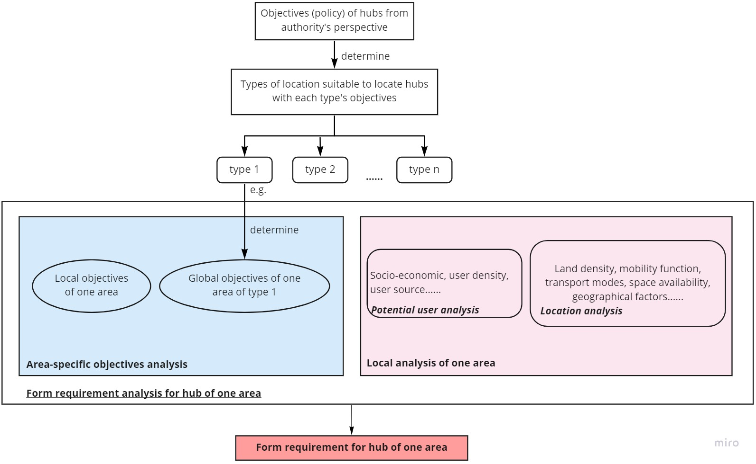
Figure 2-1: Process to determine the form of a hub in an area

The city’s objectives have an impact on the form of shared mobility hubs in terms of the type of location. When hubs are classified based on the type of location, it means that the typology groups the hubs with the same type of location and the same city’s objectives. These two could be considered as an explicit dimension of shared mobility hubs and the corresponding implicit factors respectively. Many other studies classify shared mobility hubs in this way as well, to group the hubs with one explicit dimension and the corresponding implicit factor since many implicit factors would have their corresponding explicit dimensions.
Size dimension sometimes is used to categorize shared mobility hubs (SUMC, 2018; RIPTA, 2020; NWE, 2019). RIPTA (2020) connects directly the size of hubs to land density in a positive correlation, which means the larger size of the hub should be located on higher-density areas because of more users, in line with the opinion of Snel (2020). However, SUMC (2018) proposes an opposite opinion that higher-density areas would have smaller hubs because the available spaces in dense areas are frequently constrained.
Apart from considering potential user density to classify shared mobility hubs from the perspective of size, Los Angeles Department of City Planning (2016) introduces another aspect of users, where the users come from, which influences the scale/impact of hubs (neighborhood, central, and regional) and then take this explicit dimension as the category.
Transportation function is also one of the usually used dimensions (Transportation Management & Design, 2019; Metrolinx, 2011). Because this represents what transportation function (an entry point, destination, or transferring point ) this hub should serve.
Each of the above-mentioned typologies classifies shared mobility hubs based on one explicit dimension of shared mobility hubs and its corresponding implicit factor (figure 2-2), similar to the one only applying the type of location as the category. Thus, they have the same problem, the different forms of shared mobility hubs under the same group still exist, because other factors would also influence the form of shared mobility hubs besides the considered implicit factor, leading to the differences in other explicit dimensions of hubs.

However, there is one used category even implying the information about other implicit factors besides its implicit factor. CoMoUK (2019) and SEStran (2020) employ the type of location under urban context, the extension of the type of location, to categorize shared mobility hubs, which takes into account the type of location demonstrating its objectives as well as other implied factors influencing the form of hubs (figure 2-2). To be specific, the authorities’ objectives in these two studies are relatively all-inclusive (which could be seen from the introduction of the objectives in section one), thus, the application range of shared mobility hubs is quite wide and the type of location ranges from the city center to the rural area with its corresponding objectives. Also, each type of location under urban context implies much information about characteristics of areas and users, including the volume of demand for transport (high/low), transportation function (transfer/destination), users (e.g., residential, car rider), available space size (land density), and current mobility description (e.g., limited transport offer, limited parking space, no space for bike storage), shown in the description of each type in these two studies. Due to more information that the type of location under urban context could contain than other categories, many other studies use this as the category to classify shared mobility hubs as well (PBOT, 2019; Metrolinx, 2011; SANDAG, 2019; Transportation Management & Design, 2019).
However, variant forms of shared mobility hubs still exist under each type of location under urban context, even though it seems that it already implied many factors needed for the requirement for hub analysis. One reason is that when several implied factors influence one dimension of shared mobility hubs, such as the size of the hub influenced by both the user density and space availability, the leading factor varies from time to time depending on the real situation, resulting in the inconsistent levels of the size of the hub, in analogy to the fact that there are several sizes of hubs suitable for one type of location under urban context (PBOT, 2019). Also, the type of location under urban context only implies general information which could include multiple possibilities since there is no certainty, for instance, transportation function in the city center could be transfer or destination (CoMoUK, 2019; SEStran, 2020). The uncertainty of information that the type of location under urban context implies would be more when shared mobility hubs applied in this paper are not supposed to necessarily be combined with public transport, because the applications under the same type of location are even more flexible. Furthermore, there is one aspect of objective analysis out of the information that the type of location under urban context could imply, local objectives of one area, which also affects the forms of shared mobility hubs. To be specific, the size, the scale of hubs, and the transportation function are also influenced by the local objectives (figure2-2).
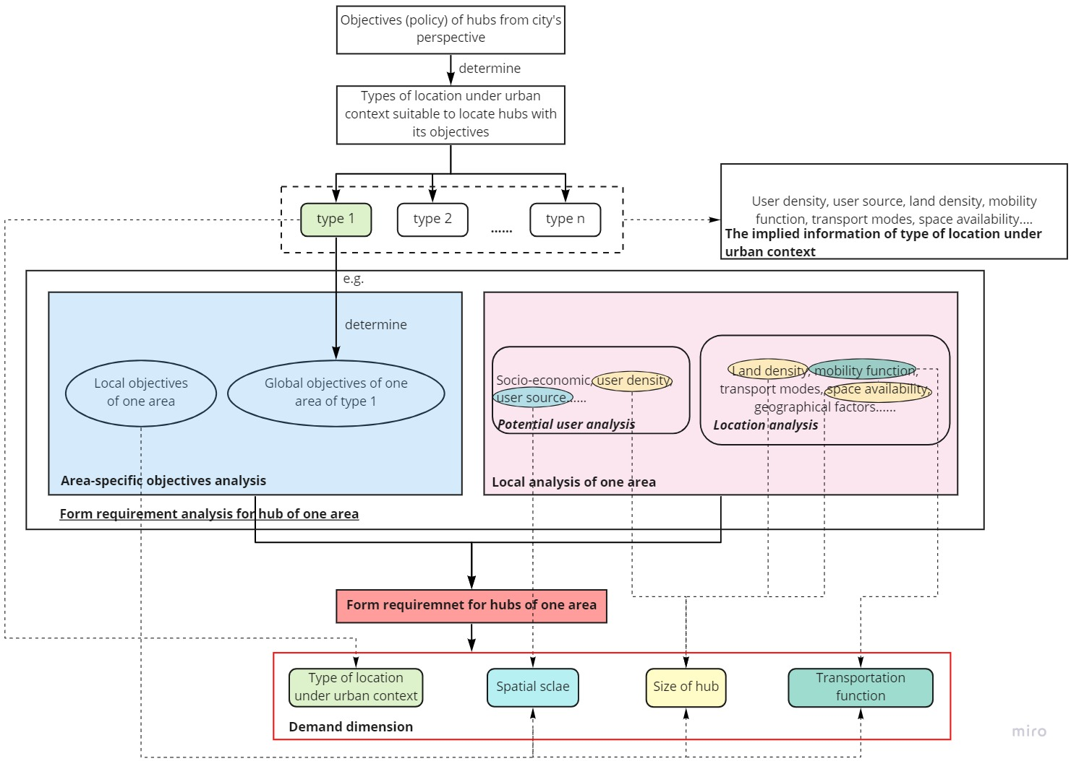
Figure 2-2: Justification of reviewed categories

- Proposing a typology of shared mobility hubs
  - Methodology
The methodology is intended for determining the final shared mobility hubs typology step by step. It is divided into five steps each of which would be explained in detail following. The summaries of the five steps are shown in figure 3-1.
Categories determination
The general goal of a typology is to show the common characteristics within groups and differences between groups, which is achieved to some level by the existing shared mobility hubs typologies. However, there are still different forms of shared mobility hubs under the same group even when the type of location under urban context, the category including more factors that influence the form of hubs than other categories, is used because any single category only represents one explicit dimension of the hub and demonstrate one corresponding implicit factor or implies more factors but with uncertainties. This shows that using only one category to classify shared mobility hubs is not enough. We, therefore, employ the multiple categories in our typology to avoid the case that the form variance is not considered when only one category is used and try to specify each form of shared mobility hub as unique as possible.
The considered dimensions include the type of location under urban context, the size of the hub, the spatial scale, the transportation function. On top of these, we also add another dimension, proximity to public transport. This is because transit service is always included in the shared mobility hubs in North America, however, the application of shared mobility hubs is more flexible in the European context, ranging from small ones located on the street to large ones combined with existing public transport. Thus, this is considered as one explicit dimension of the hub. It also shows the corresponding implicit factors since whether the hub is combined with public transport depends on the objectives and current transport modes.

Levels of each category determination
After the five dimensions of hubs are determined, the next step is to decide the levels of each category. The levels of category, the type of location under urban context, are different in the existing studies because it highly depends on the urban land use and the context where shared mobility hubs are applied. For instance, SANDAG (2019) considers “Coastal” (places near the sea) as one level of the type of location since the San Diego Region is near the Pacific and Metrolinx (2011) incorporates the level of “Urban Transit Nodes” and “Suburban Transit Nodes” since the shared mobility hubs should always be connected with public transport. In this study, the urban land uses in a general European city are chosen, trying to make differences in the information that the type of location under urban context should imply (potential user density, potential user source, land density, etc).

Table 3-1 Level of the type of location under urban context and their descriptions
(Table 3-1 to Table 3-6 are all based on ongoing work conducted in the context of the project SmartHubs, funded by the EIT Urban Mobility KIC)
Term | Description
Type of location under urban context
City Centre | High population density, areas that attract a large number of people and jobs. Existing multi-modal environment, mixed uses, limited room for further land development.
Emerging urban growth centre | Areas that have more land available and thus more potential for development. Could be new-built areas or areas where renovation and urban renewal are taking place (through for instance new infrastructure projects or the opening of attractive land uses namely museums, theatres, cinemas, shops restaurants, and bars. e.g. new “hipster” city neighborhoods).
Historic centre | Lower population density, mixed uses, walkable areas (e.g. existing extensive network of pedestrianized streets/shared space/traffic calming measures). Limited room for further development, special rules/regulations could apply (e.g. protected buildings, landmarks). Areas that show high touristic interest.
Suburban | Areas outside the core of a main city, that usually accommodate a large numbers of commuters or/and leisure travellers to/from the main city (e.g. the so-called satellite-cities, or any other area that is not in the city centre such as residential areas/business areas). Usually with more potential for land development, similarly to emerging urban growth centres.
Key (standalone) destination | Areas that attract and generate a large volume of trip and activities, due to a main attraction that is located there (e.g. a stadium, a University Campus, a popular park, or business parks/shopping centres that are located outside the city centre). The attraction gives the area its character (people rarely go there for other reasons than visiting this place).

The transportation function is normally divided into three levels, entry/origin, exit/destination, transfer (Metrolinx, 2011; Transportation Management & Design, 2019). Their meanings are closely related to public transport since the hubs in these two studies are always combined with transit networks. If the hub is intended for entering to, exiting from, or transferring within the transit network, the transportation function it provides is an entry, exit, or transfer respectively. However, this report assigns the above three terms different meanings which only consider the transportation role that a hub plays in a person’s whole trip. Also, in our case, origin and destination are grouped into one class because the reason they are two different levels in North America is the entry hub could require specific facilities, such as commuter parking for people changing their modes from private car to public transport, however, in our definition, the mentioned case is a transfer hub and then there are no obvious differences in facilities requirement between the beginning point and endpoint of a trip.

Table 3-2 Level of transportation function and their descriptions
Transportation function
Origin/Destination (mainly) | Areas that generate or/and receive trips. Serving mainly as the start or/and end point of a trip.
Transfer (mainly) | Areas that might be the origin/destination for some travellers, but the majority of trips that take place there are for the purpose of transferring to another location – therefore most people go there to change transport mode. The transfer function requires the existence of public transport station(s) or a Park & Ride area while the previous function of origin/destination not necessarily.

The levels and their meanings of the mobility spatial scale follow those of catchment area in Los Angeles Department of City Planning (2016). Levels are divided into Neighborhood, City, and Region.

Table 3-3 Level of mobility spatial scale and their descriptions
Mobility spatial scale
Neighborhood | This distinction has to do with the “buffer-zone/catchment area” of the hub, so it is very related to the target users. If the aim is to address the needs of one (or a few) neighbourhoods, then the scale of the hub is the neighbourhood.
City | The catchment area of the hub is the whole city.
Region | The hub aims to serve an area that exceeds the city limits, so a larger region/the whole metropolitan area. Located in areas that have regional transit options.

The levels of the size of a hub are determined based on the size classification in NWE (2019) having more levels in the size of a hub than other North American studies, Minimalistics, Light, Medium, and Large. This is because the shared mobility hubs applied in Europe could be small enough to contain only one type of shared mobility mode.

Table 3-4 Level of mobility spatial scale and their descriptions
Mobility services offered at the hub
Mini | Small-scale hub, minimum one (shared) transport mode offered. Usually has elements that are easy to install, suitable for demonstration projects. Minimal physical impact.
Light | At least two transport mode options, relatively easy to install or expand.
Medium | A variety of modes offered, thus more space is required and the physical impact is higher.
Large | Large – scale hub with even larger variety of modes offered, usually aiming at having both commuters and visitors as users.

Proximity to public transport could easily have two levels: Yes and No. When it refers to No, the hubs could be next to the public transport, but this is not the hard requirement.

Table 3-5 Level of mobility spatial scale and their descriptions
Proximity to public transport
Yes | Multi-modality and connection with (usually fixed-track) public transport is a key for this hub type.
No (not necessarily) | Can be close to public transport station/stops, but this is not one of the key attributes of the hub type.

Hubs grouping
However, if we want to use the above five dimensions and combine one level under each of them with each other at a time to represent one type of hub, making each form of a hub as unique as possible, it is not realistic. This is because the categories are multiple, the levels under each category are various, and then the number of possible combinations would explode to do so.
Hubs grouping by one category that could maximize the differences between groups and minimize the differences within groups is created to both avoid the exploded number of types and achieve the elementary goal of one typology. Therefore, the most commonly used typology category, the type of location under urban context, representing more information that influences the form of a hub compared to other dimensions is chosen. The differences under one group are shown through the possible levels chosen under other dimensions.

Possible level choices of other four categories
Based on the high quality of public transport and multi-modality characteristics, the hubs in the city center are supposed to be combined with public transport. They could be the end of one’s trip since there is a high concentration of destinations around them or people change their transport modes there, such as from public transport to shared bikes, to the beginning point of their next trip of taking another type of public transport. In the latter case, shared mobility modes fill in the gap between different public transport networks. The potential user in the city center usually comes from the whole city. The size of the hub could be flexible since the user volume would be large but the space availability should be one constraint. Thus, besides the minimalistic which only has one type of transportation mode, other levels of size would all be possible.
The historic center is next to the city center. It is usually developed from the old town of a city, thus, does not accommodate modern public transport. Since this type of area always contains some old residential areas and tourist attractions, the hubs provide origin and destination functions. This fact also determines that users of the hub would be from the neighborhood (residents) and the whole city (tourists). The size could be mini or light because there would not be that many users like the city center and the space availability is limited.
The next level of the outer area is the emerging urban growth center. This area has a medium intensity of human activities and medium density of public transport network because of the newly developed and modern nature. Thus, the hubs could combine with public transport or only include shared mobility modes for areas (e.g., new residential areas and other destinations) far away from public transport. The hubs in former cases could provide origin/destination function due to the destinations clustering around the transit nodes or transfer function for travelers to reach the areas that are beyond the traditional catchment of public transport or for travelers coming from the surrounding areas to change their modes to public transport for traveling to the inner city. The spatial scale of hubs could be neighborhood (residents) or city depending on the different users. The size of hubs could be mini, light, or medium based on the user volume of hubs since there is no space limitation.
The suburban area, such as so-called satellite cities, is similar to the emerging center since it also includes the residential areas and relevant amenities. The intensity of human activities and the density of public transport are also quite similar as well as the transportation function of hubs and the size of hubs. However, the spatial scale is the neighborhood (residents) or region instead of the city, this is because satellite cities are located within two or more cities, which means the user sources are not limited to one city.
The hubs in key destinations normally do not act as transfer points due to their high destination interest. Also, the key destinations usually could be reachable by public transport even though the frequency may be limited. However, for the large key destination, such as campus and popular park, small hubs that are within the destination itself could emerge. Thus, the size of hubs could be mini, light, or medium depending on the different locations and real user volume. Some of the key destinations serve only one city (e.g., hospital), some of them (e.g., campus, popular park, super shopping mall) serve for several cities. Thus, the spatial scale would be city or region.

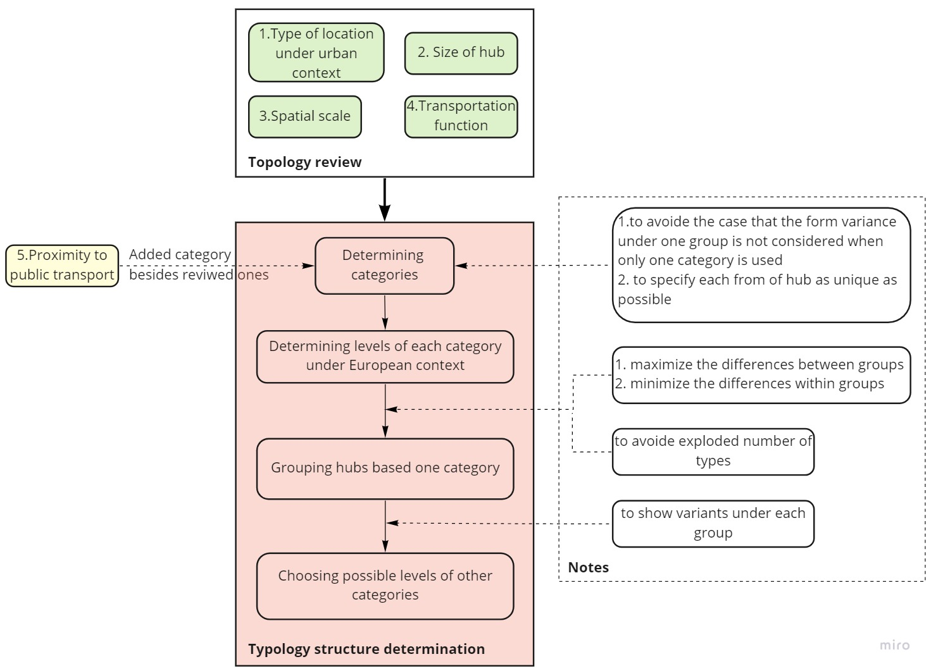
The above four steps are summarized in the Typology structure determination block in figure 3-1.
Figure 3-1: Methodology flow chart

  - Typology proposal
The final typology is shown in table 3-6.
Table 3-6 Final typology proposal
 | City center | Historic center | Emerging urban growth center | Suburban | Key destination
Transportation function
Origin/Destination (mainly) | x | x | x | x | x
Transfer (mainly) | x |  | x | x
Mobility spatial scale
Neighbourhood |  | x | x | x
City | x | x | x |  | x
Region |  |  |  | x | x
Mobility services offered at the hub
Minimalistic |  | x |  |  | x
Light | x | x | x | x | x
Medium | x |  | x | x | x
Large | x
Proximity to public transport
Yes | x
No (not necessarily) |  | x | x | x | x

- Conclusion
In this paper, we first introduce the state of art about shared mobility hubs in the global range in the aspects of their definitions and objectives which are more region-specific, especially the definitions. To understand the variability and complexity of shared mobility hubs, we decide to propose a general typology of it which is also the main purpose of this paper. To this end, the literature review about existing shared mobility hubs typologies is conducted to find out the logic behind them and their strengths and weaknesses. We observed that existing typologies categorize shared mobility hubs based on one explicit dimension of the form of hubs and its corresponding influential factor(s), however, the form variance still exists under one group because other factors besides the considered ones would influence the final form of shared mobility hub as well. In the end, all the reviewed categories are used in our typology to consider the influential factors as many as possible. However, specifying each form of hubs as unique as possible by combining one level of each category at a time is considered to be unrealistic due to the multiple levels of each category and several categories. Hubs grouping by one category that maximizes the differences between groups and minimizes the differences within groups is then created and the form variants under each group are shown through the possible levels of other categories. Based on the analysis, the chosen category for hubs grouping is the type of location under urban context, the possible levels of other categories are determined according to the description of each type of location under urban context and their implied information. Then, the final typology is proposed.

Bibliography
Anderson, K. et al., 2015. City of Oakland Mobility Hub Suitability Analysis Technical Report, Oakland: s.n.
Anderson, K., Blanchard, S., Cheah, D. & Levitt, D., 2017. Incorporating Equity and Resiliency in Municipal Transportation Planning: Case Study of Mobility Hubs in Oakland, California. Transportation Research Record.
BrookMcllroy, 2014. James Street North Mobility Hub Study, Hamilton: s.n.
Claasen, Y., 2020. Potential effects of mobility hubs, Twente: s.n.
CoMoUK, 2019. Mobility Hubs Guidance, s.l.: s.n.
Goudappel Coffeng, 2018. Mobility Hubs Utrecht, Utrecht: s.n.
Langford, B. C. et al., 2017. Comparing physical activity of pedal-assist electric bikes with walking and conventional bicycles. Journal of Transport & Health.
Liao, F. & Correia, G., 2019. eHUBS-Smart Shared Green Mobility Hubs, s.l.: INTERREG.
Litman, T., 2017. Introduction to multi-modal transportation planning. Canada: Victoria Transport Policy Institute.
Los Angeles Department of City Planning, 2016. Mobility hubs, Los Angeles: s.n.
MacArthur, J., Kobel, N., Dill, J. & Mumuni, Z., 2017. Evaluation of an electric bike pilot project at three employment campuses in Portland, Oregon, Portland: s.n.
MAXWAN, P., n.d. How data analysis can optimize applications of mobility hubs in existing neighborhoods, s.l.: s.n.
Metrolinx, 2011. MOBILITY HUB GUIDELINES For the Great Toronto and Hamilton Area, s.l.: s.n.
Miramontes, M. et al., 2017. Impacts of a multimodal mobility service on travel behavior and preferences: user insights from Munich’s first Mobility Station. Transportation.
NWE, 2019. eHUBS - Smart Shared Green Mobility Hubds. [Online]
Available at: https://www.nweurope.eu/projects/project-search/ehubs-smart-shared-green-mobility-hubs/
NWE, I., 2019. eHUBS - Smart Shared Green Mobility Hubds. [Online]
Available at: https://www.nweurope.eu/projects/project-search/ehubs-smart-shared-green-mobility-hubs/
PBOT, 2019. 2019 E-Scooter Report and Next Steps. [Online]
Available at: https://www.portland.gov/transportation/escooterpdx/2019-e-scooter-report-and-next-steps
PBOT, 2019. Mobiltiy Hub Typology Study, s.l.: s.n.
RIPTA, 2020. TRANSIT FORWARD RI, Rhode Island: s.n.
RISE & ARUP, 2020. MOBILITY HUBS OF THE FUTURE, s.l.: s.n.
SANDAG, 2016. Mobility Solutions Toolkit, s.l.: s.n.
SANDAG, 2019. 5 big moves: mobility hubs, San Diego: s.n.
SEStran, 2020. A Strategic Study for the South East of Scotland/SEStran region, s.l.: s.n.
Shaheen, S. & Chan, N., 2016. Mobility and the sharing economy: Potential to facilitate the first-and last-mile public transit connections.. Built Environment.
Shaheen, S., Cohen, A. & Zohdy, I., 2016. Shared mobility: current practices and guiding principles, United States: s.n.
Snel, W., 2020. How Mobility Hubs Create Synergy Between Mobility, Energy and Social Challenges, s.l.: s.n.
SUMC, 2018. Mobility Hub Principles, s.l.: s.n.
SUMC, 2019. Mobility Hubs, s.l.: s.n.
T. M. &. D., 2019. RTD Mobility Hub Guidelines, s.l.: s.n.
VIANOVA, 2021. Mobiltiy Hubs on Any Budget, s.l.: s.n.

