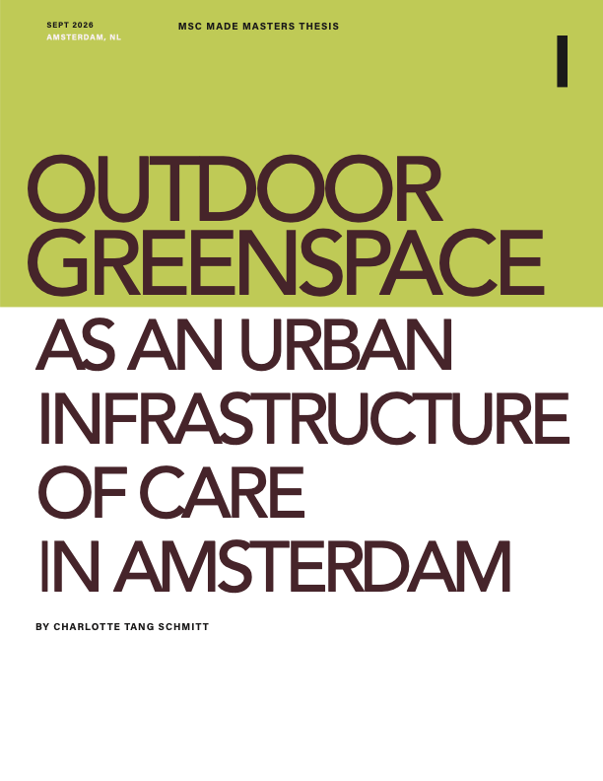
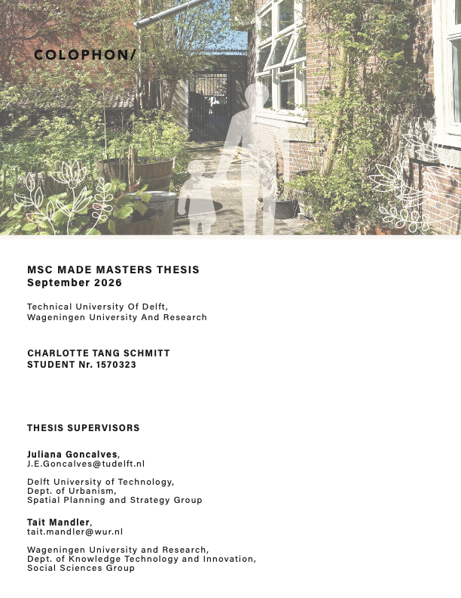

ABSTRACT
Drawing on feminist ethics of care, and situated within an ecofeminist planning perspective, this research explores outdoor urban green space in Amsterdam as an urban infrastructure of care. Through two case studies of care space organizations and an analysis of municipal planning practices, this research investigates the embodied experiences of caregivers and the spatial and temporal burdens involved in navigating and using outdoor green spaces. The first perspective shows how care for children is organized through a municipally funded playgroup, and how this care is conducted in city playgrounds. The second perspective reflects how a privately-owned neighborhood center care for both human and more than human life.
The findings demonstrate that outdoor green spaces function as infrastructure of care not through the physical characteristics of the space alone, but through the relationships between spatial affordances, organizations, mobility networks, and the institutional and financial conditions that sustain them. The experiences of care participants reveal that accessibility extends beyond the physical boundaries of green spaces to include the journeys required to reach them, as well as the time, weather, safety, and everyday scheduling conditions that shape their use. The case studies further demonstrate how neighborhood organizations can activate existing outdoor spaces as places of care by providing social connection, purpose, flexibility, and opportunities for reciprocal participation. At the municipal level, many elements of care infrastructure are already addressed through planning for accessibility, mobility, safety, biodiversity, climate adaptation, maintenance, and participation; however, these functions remain fragmented across policies, departments, and responsibilities.
The research contributes to care-full planning by demonstrating the importance of connecting planned infrastructure with lived experiences of care. The findings suggest that planning for care requires improved coordination of existing planning priorities around these experiences of care to create the spatial, organizational, and institutional conditions that enable care to be continuously practiced, negotiated, and sustained.

Keywords: urban infrastructure of care ; care-full planning; urban green space;

eco-feminist city; more-than-human life; care mobility, Amsterdam

TABLE OF CONTENTS
1 INTRODUCTION 5
1.1 Context: City of Amsterdam 6
1.2 Problem statement and research questions 7
2 THEORETICAL FRAMEWORK 9
2.1 Ecofeminist City 9
2.2 Urban Infrastructure of Care 12
2.3 Spaces of Care 13
2.4 Outdoor Greenspace as Infrastructure of Care in Amsterdam 14
3 METHODOLOGY 17
3.1 Selection Criteria & Case Study Neighborhoods 18
3.2 Data Collection Methods 21
3.3 Qualitative Data Analysis Methods and Analytical Framework 27
3.4 Synthesis 28
4 RESULTS 29
4.1 Cross-perspective Synthesis 29
4.2 Physical care functions of outdoor green space in Amsterdam 33
4.3 Social care functions of outdoor green space in Amsterdam 37
4.4 Emerging themes 43
5 Discussion 51
5.1 Tension 1 Formal planning vs. lived experiences of care infrastructure in Amsterdam 51
5.2 Tension 2 “Care spaces” as organizational infrastructure of care in the city 55
5.3 Tension 3 Caring for Multispecies Entanglement: Human care vs. more-than-human care 56
5.4 Tension 4 Financial structure and crisis of care 57
5.5 Limitations 59
5.6 Future Research 60
6 Conclusion 62
7 Declaration and Acknowledgements 63
Acknowledgements 63
8 References 64
8.1 Literature Review 64
8.2 Desk Research 67
9 Appendix 69
9.1 Perspective 1 Photo Journeys 69
9.2 Perspective 2 Midwest Experiential Maps of Care Functions 71
9.3 Dynamo Care Functions 74
9.4 Midwest Care Functions 79
9.5 City of Amsterdam Planning Documents 88

INTRODUCTION
The concept of care is historically and systemically undervalued and underrecognized in capitalistic societies, “despite being necessary for the economy to function” p.283 Binet et al., 2023; Nelischer et al., 2025). One of the ways this is reflected is through urban planning practices, which many feminist planning scholars argue have contributed to, and exacerbates the modern “crisis of care” (Binet et al., 2023; Davoudi & Ormerod, 2025; Morrow & Parker, 2020; Müller et al., 2025). The effects of the current neoliberal global economic system, where the demands for monetary growth have led to increasing divide along economic, racial, and gender lines, are all concentrated in cities. Daily necessities such as healthcare, food, housing, and education are becoming increasingly inaccessible and unaffordable. These urban inequalities continue to increase, and they influence how easily people can meet the needs and necessities of everyday life (Binet et al., 2023; Dengler et al., 2025).
This paper refers to feminist ethics of care theory to define care work as “everything we do to maintain, continue and repair our world so that we can live in it as well as possible,” (Tronto, 1993, p. 103). Through care work, effort necessary to maintain existing life and reproduce the next generation, hereby referred to as social reproduction, is possible. This includes sustaining life for both human and more-than-human life, as care is not just confined to caring for other people but can be practiced towards other species, objects and environments (Bayas Fernández, B. & Bregolat i Campos, J., 2021). The people that conduct care work successfully are referred to as caregivers in this research (Tronto, 1993). Care is culturally defined, and practices and norms differ between cultures and among individuals. Therefore, the embedded, situational context of care work is necessary to determine specific care needs (Binet et al., 2023; Alam & Houston, 2020). The undervalorisation of care work contribute to the modern “crisis of care,” in western society, in which people’s capacity to perform life sustaining care work has been generally “overextended in unequal and unsustainable ways"(Binet et al., 2023, 282).
To address the crisis of care, firstly by making this care work visible, scholars have shifted attention to urban infrastructures of care. These are the components of the urban environment that caregivers rely on to perform life sustaining care work. When these components are absent, inaccessible, or inadequate, care work becomes difficult and hard to fulfill (Nelischer et al., 2025). Urban infrastructure of care can therefore include both the physical environments that support care, and the social, organizational structures through which care is enabled and sustained, particularly the institutional planning practices.
Green spaces represent one aspect of the urban infrastructure of care that is already addressed indirectly through planning efforts. Green spaces are an important aspect of the urban infrastructure of care, as they are sites where care for both human and more-than-human life occur (Dengler et al., 2025). The benefits of nature in cities have already been widely recognized by planners, and are considered an important aspect of urban care infrastructure (Binet et al., 2023). In general, green spaces are places of leisure and relaxation that can offer reprieve for humans in urban environments. Some of these “caring” benefits for both human and more than human life include the improvement of biodiversity and a reduction in climate stress (Pellerey & Giezen, 2024). The recognized health benefits of urban green space for residents include “helping people maintain adaptive resources needed to meet the demands of life.” (Hartig et al., 2014, p. 214). Nature in urban environments can reduce risk of illnesses by improving subjective well-being as it relates to air quality, physical activity, social cohesion, and stress reduction (Hartig et al., 2014). Due to these widely recognized benefits, one of the UN Agenda 2030 goals is to “provide universal access to safe, inclusive and accessible, green and public spaces, particularly for women and children, older persons and persons with disabilities (United Nations, 2025; Pellerey & Giezen, 2024, p. 856). Many cities, such as Amsterdam, are actively taking efforts to encourage improvement and increase of urban green space to achieve both sustainability efforts and resident well-being in alignment with the UN goals (Pellerey & Giezen, 2024).
The extent to which outdoor urban green spaces function as infrastructure of care depends not only on the allocation of green space itself, but also on how these spaces are planned, maintained, and experienced, which is determined by municipal planning practices. Local neighborhood organizations and everyday users are both influenced by, and contribute, to how care is conducted in these outdoor spaces.
This study examines two “care space” organizations (Müller et al., 2025) and the municipality’s planning practices, to better understand how outdoor green spaces in Amsterdam function as an urban infrastructure of care. The embodied daily experiences of caregivers are examined in relation to these spaces to determine what care burdens they may have to overcome as they navigate outdoor space as an infrastructure of care. Drawing on theory from feminist ethics of care, ecofeminist, and “caring” city planning values, the physical and social care functions of outdoor greenspace in Amsterdam are evaluated not as centers for productivity, but rather as essential sites that either support or hinder care work, for both human and more-than-human life (Binet et al., 2023; Dengler et al., 2025; Tronto, 1993).

Context: City of Amsterdam
Amsterdam provides a crucial context for studying outdoor urban green space as an infrastructure of care due to the intersections of its progressive sustainability agendas, gendered care disparities, and municipal green space policies. Amsterdam, like many cities in Europe, is actively working toward UN sustainable development goals. It currently has a politically left-leaning administration that prioritizes sustainability efforts in the city, according to interviews with municipal employees, and which is reflected in the Green vision 2020-2050 policy agenda. This vision document outlines strategies to manage green spaces in alignment with the UN Sustainability goals (Pellerey & Giezen, 2024). The aim of the vision is “to increase the amount of green infrastructure wherever possible and to make better use of existing green areas”(City of Amsterdam, 2020, p. 5). While these efforts include goals to address accessibility of green space specifically for women and children (Pellerey & Giezen, 2024), these policies do not address green space as an infrastructure of care or mention the role of care in their green policies. Regarding care work performed by caregivers in the city, reproductive and care labor remains heavily gendered. In the Netherlands: among parents with children aged 0–11, 49% of women devote more than five hours daily to childcare compared to only 26% of men (European Institute for Gender Equality, 2025). Despite this pronounced gender gap in daily care responsibilities, and the influence this has on how caregivers navigate the urban infrastructure of care in the city (Binet et al., 2023), Amsterdam lacks explicit municipal planning policies tailored specifically to "care."

Problem statement and research questions
When examining the city of Amsterdam as an infrastructure of care, current planning practices contribute to the burdens caregivers must overcome when conducting care work, as the urban environment directly limits caregivers' capacity to carry out life-sustaining work. Though planning practices in Amsterdam indirectly serve to provide resources of care such as outdoor green space, how these green spaces function as care infrastructure is unknown. Furthermore, the daily, embodied experiences of caregivers are central in efforts to make care work visible in cities (Binet et al., 2023; Alam & Houston, 2020), but these specific experiences as they relate to outdoor green space have not yet been studied in this context. Therefore, to address the modern crisis of care through planning practices, outdoor green spaces must be understood in how they either support or hinder care work conducted in the city. This is necessary to understand how care can be centered in future planning efforts. This is based on the approach introduced by Binet et. al (2023) to understand urban infrastructures of care from a planning perspective, in which recommended steps are to: “understand caregivers’ goals and how they are trying to accomplish these goals, how the urban environment supports or hinders these strategies, and evaluate social and spatial differences in the quality of the urban infrastructure of care (p. 291).

Therefore, the research questions this thesis asks is:
How do Amsterdam’s outdoor greenspaces function as an infrastructure of care in the city?
The main question is guided by three sub-questions. This approach moves from understanding what care functions outdoor greenspaces currently provide, to examining how these functions are experienced in everyday life, and finally to considering how planning practices support, constrain, or overlook these forms of care. In doing so, the three sub-questions establish a basis for identifying how planning can better respond to the contemporary crisis of care in Amsterdam.

SQ1-What are the current “care functions” of outdoor green spaces in Amsterdam?
This question is important to better understand how outdoor green spaces function as urban infrastructure of care, in terms of the physical (spatial features) and social functions that these spaces provide to facilitate care practices in the city.

SQ2-What are the daily embodied experiences of care participants as they navigate outdoor green space in the city?
Building from the identifications of care functions in SQ1, where infrastructure of care features are understood, this questions examines how these features influence the daily embodied experiences of care participants, primarily caregivers and care receivers, in relation to outdoor green spaces as sites of care. As care is something all people have experiential insight into (Binet et al., 2023), it is necessary to understand experiences of how people navigate the “care functions” of urban infrastructure that are available to them.

SQ3- How do the current planning practices of green spaces address the contemporary crisis of care in Amsterdam?
The third question brings the spatial functions identified in SQ1 and the lived experiences examined in SQ2 into relation with current municipal planning practices. The current planning practices in Amsterdam must be understood in comparison to the daily experiences within spaces, to understand what tensions may emerge between what is planned for and what should be planned for. To address the crisis of care in the city, limitations may exist in the urban infrastructure of care that is available. This question therefore considers planning as a mechanism through which care can be addressed at the urban scale, rather than focusing solely on individual policies, designs, or participatory processes.

THEORETICAL FRAMEWORK
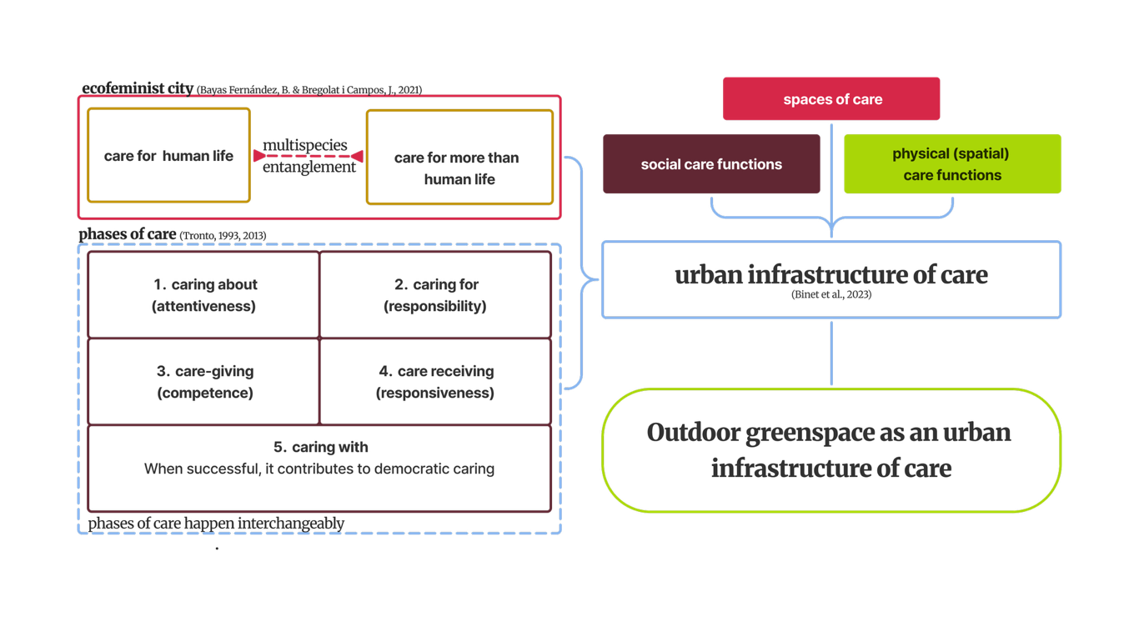
Figure 1 Theoretical Framework Graphic

Ecofeminist City
This research is situated within the ecofeminist city perspective, which centers relational ontologies in city life. Stemming from feminist and environmental ideals, ecofeminist theory supports the creation of new imaginaries for cities by rejecting the current socioeconomic system of neoliberalism as a starting point to enable connections between humans and the habitat itself, and to explore alternative ways of urban living that can support life-sustaining activity. From this perspective, care is viewed as ‘the very fabric of city life, woven through moments where life is maintained, continued and repaired’ (Dengler 2025 p. 862, see also Williams 2020). Ecofeminist scholars argue that “the same features of cities that made them unsuitable for women’s needs are also not apt for non-heteronormative people and non-human species. All of these groups are marginalized...”(Privitera, 2025, p. 154). This research focuses not only on human-centered care, but on care for non-human species as well, referred to as more-than-human life in this research, and how multispecies entanglement occurs in urban outdoor green spaces during care work (Bayas Fernández, B. & Bregolat i Campos, J., 2021).
Furthermore, because acts of care are embedded and embodied in their “biophysical surroundings” (Dengler et al., 2025, p. 863), the modern perception of time and space should be reconsidered in relation to care work so that time and space are not used for efficiency and to “produce surplus value” (Dengler et al., 2025, p. 866). Though time is currently measured as “linear clock time,” care work is much more unpredictable, fluid, and relational (Dengler & Lang, 2022). Therefore, space and time must be considered together to understand how they can promote care and participation in cities.

Ethics of care
The contemporary crisis of care is a direct result of the current capitalistic society and the neoliberal ethics of self-reliance. As previously stated, and widely acknowledged by feminist scholars, social reproduction has been historically, and persistently, undervalued and underrecognized (Binet et al., 2023). This contributes to the crisis of care, as in the absence of adequate public infrastructures, “those who are unable to outsource care work to paid service providers are left to rely on themselves and their social networks” (Müller et al., 2025, p.4). Furthermore, it is important to note that care work is associated with and “predominantly performed by, women as unpaid or poorly paid work” (Müller et al., 2025, p. 5) in modern society. This is why urban planners call for a “care-full” approach, also referred to as a “caring city,” in which principles that originate from feminist ethics of care theory create a care-centric planning framework (Dengler et al., 2025; Müller et al., 2025; Privitera, 2025).
When applied to urban planning, the ethics of care perspective argues that care is “a transformative ethic that can guide our thinking about what constitutes the just city” (Nelischer et al., 2025, p. 2792). This is because the ethics of care are relational and recognize that all humans need care. Because of this, all living beings are interdependent, and we are reliant on each other to fulfill our needs. By acknowledging this, the current neoliberal ethics of self-reliance is challenged, and welfare is not seen as a monetary burden but rather a natural caring need for all life (Alam & Houston, 2020). Thus, care work is crucial to support the life sustaining activities in cities. Existing research has shown that urban care can be understood through spaces of care, materialities of care, and subjects of care, while also emphasizing the potential to reveal unequal spatial experiences of care, in order to imagine new relationships between individuals, communities, and institutions through this understanding (Williams, 2017).

Tronto’s Phases of Care
The definition of care in this research is based on the work of feminist scholar Joan Tronto (1993), in which care is understood as a “species activity that includes everything that we do to maintain, continue, and repair our ‘world’ so that we can live in it as well as possible. This ‘world’ includes our bodies, ourselves, and our environment, all of which we seek to interweave in a complex, life-sustaining web (Tronto, 1993 p.113). This heavily influences the view of care in this research, which is considered a “situated ethic that focuses on how it is needed in the here and now in order to bring more caring and just worlds into being” (Williams, 2017, p. 825). Care emerges when care actors, such as volunteers, staff and service providers are predisposed to “the concerns and needs of the other” (Tronto, 1993, p. 205), reach out to those in need of care and involve in care actions. Care is provisional, fragile, relational and an “embodied practice” (Conradson, 2011; Held, 2018) that promotes “social relationships of mutuality and trust rather than one-way dependence” (Alam & Houston, 2020, p. 2).
The five phases of caring (Tronto, 1993:106–108) are used in this research to evaluate how the sociomaterial system of outdoor greenspaces influences the care work conducted in and in relation to these spaces. These phases of care have since been expanded upon by other feminist ethics of care scholars to support the notion of care as an infrastructure of care (Alam & Houston, 2020; Binet et al., 2023; Williams, 2017). Care arises out of the fact that “not all humans or others or objects in the world are equally able, at all times, to take care of themselves”(Tronto, 1993, p. 145) which deems care work an essential practice that all living beings take part in to some capacity (Nelischer et al., 2025).
These five phases are:
(1) Caring about (attentiveness) “delineates unmet caring needs, which are identified by an individual or a group.”
(2) Caring for (responsibility) occurs “when the group or individual takes on responsibility to ensure the needs are met”.
(3) Care-giving (competence) “requires actual care-giving work, that should be done with competence and skill”(Tronto, 1993, p. 106), using the right resources and services in a timely fashion (Rivano Eckerdal et al., 2024, p. 209).
(4) Care receiving (responsiveness) starts when the person who has been cared for responds to the act of care. The response should be observed and evaluated to see whether the received care was sufficient, successful, or complete.” (Tronto, 1993,p. 107).
The four ethical elements of care: attentiveness, responsibility, competence, and responsiveness, arise out of each of these phases.
Later, Tronto added a fifth aspect, (5) caring with. This phase extends the relationship between the care giver and care receiver, as a dynamic process where both must actively participate to achieve care meaningfully; the care giver works with the care receiver rather than for. Through this, care neither “disempowers nor reduces the care receiver as an object of care.” (Alam & Houston, 2020, p. 3).
The reciprocal quality of care’s fifth dimension also applies to the desired effect if successfully implemented: democratic caring co-creates a caring democracy (Tronto, 2013). In relation to outdoor space, it would mean that outdoor space infrastructure promotes inclusion, community and ultimately democracy (Morrow & Parker, 2020; Tronto, 2020). This research recognizes that the phases of care happen interchangeably, and explores how planning can serve to support “caring with” for more democratic planning practices (Davoudi & Ormerod, 2025), as this phases recognized that care occurs unequally depending on the needs of the participants so must be adaptable for this as people care to their own capacity. Therefore, it shows that care is both multi-dimensional and context-specific. To work towards “caring with”, care can achieve justice in cities(Williams, 2017).
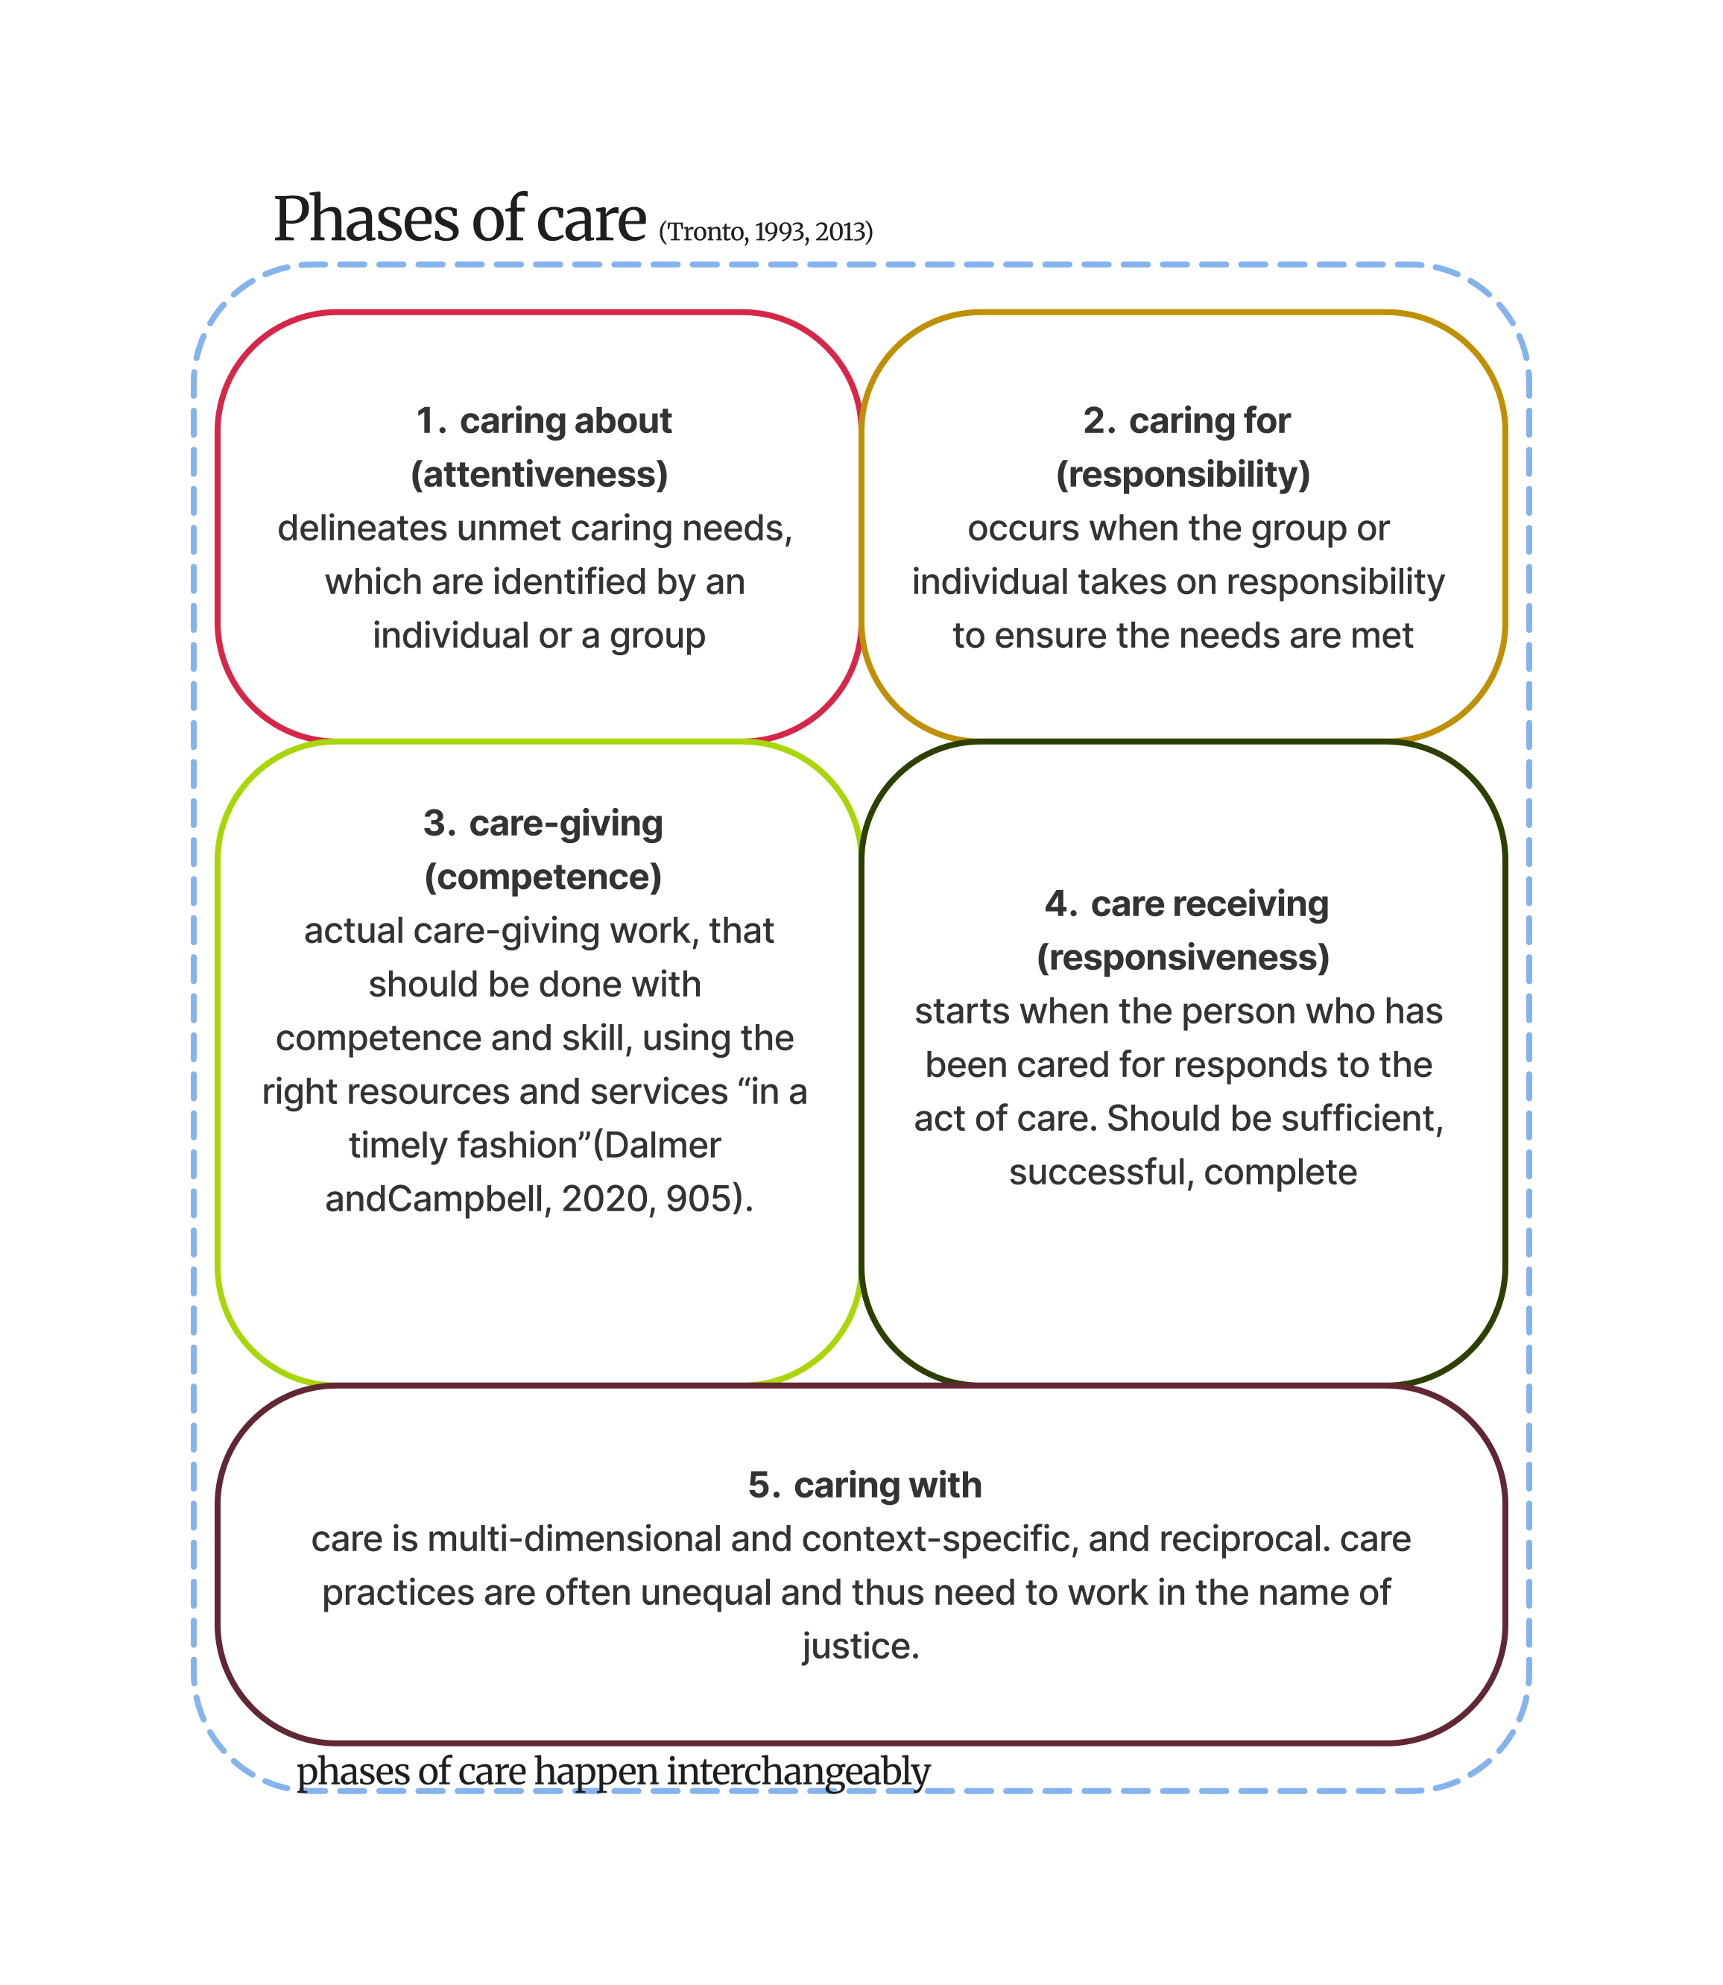
Figure 2 Phases of Care Diagram

Urban Infrastructure of Care
Care-centric planning scholars argue that in order to make care visible and valued, it must be viewed as a form of infrastructure, as meeting care needs relies on access to interconnected sets of resources and supports that must be analyzed as a system (Binet et al., 2023; Morrow & Parker, 2020). In this thesis, urban infrastructure is recognized as a socio-technical system rather than solely the “material stuff” of cities, where inequality and unjust structural processes are “operationalized through infrastructures,” as they organize social lives of people differently and can enable or constrain certain forms of life. Therefore, an individual’s experience of infrastructure is inherently unique, making care infrastructure a key dimension of everyday life (Alam & Houston, 2020, p. 1). Care infrastructure includes “practices of care for both people and place”.…such as watching children on the playground, providing food and aid to the unhoused, and tending to shared space, as well as care for nature. These practices are critical to advancing public space justice (Nelischer et al., 2025, p. 2791)
In alignment with Binet et al. (2023), the urban infrastructure of care comprises of interconnected physical, social, material, and institutional components. These are: private and public spaces, economic opportunities, material resources, social support networks, safety features, childcare activities, and spatial accessibility. Care infrastructure focuses not only on the physical aspects of infrastructure, but the social infrastructure as well (Binet et al., 2023; Williams, 2017).
Lack of planned care infrastructure leads to what is referred to as care binds, or “situations where care- givers’ abilities to carry out caregiving strategies were constrained by their urban context, making it harder for them to fulfill their caregiving goals by making care work more difficult and taxing”(Binet et al., 2023, p. 288). This is articulation work that caregivers must do to compensate for shortcomings of the urban infrastructure of care infrastructural labor and see it as a variable component of the overall burden of care work that depends on the quality of local urban infrastructures of care” (Binet et al, p. 290).

Spaces of Care
As this research focuses on infrastructure of care as a socio-technical system, this thesis examines care-related social organizations in Amsterdam as spaces of care. Spaces of care can be defined as organizational spaces that “disclose care and facilitate practices of caring for, about, and with others”(Nelischer et al., 2025, p. 2792), both human and non-human life. The structural organization influences the care work conducted and received in care spaces. Therefore, the organizational aspects of these spaces of care are also a key component of the overall infrastructure of care network in cities and influence the spatial and social care work conducted in relation to them (Müller et al., 2025). According to scholars focused on care-full cities, “an exploration and understanding of in-common spaces is needed to radically enlarge and broaden our understanding of the social and the sites of collective responsibility”(Williams, 2017, p. 828). By understanding people as relational and connected “we re-think our understanding of responsibility and the sites where social change towards care-full justice might be taking place” (Williams, 2017, p. 828). How these spaces of care are organized in relation to the spatial aspects of outdoor greenspace is explored in this research.
This research explores both organized, institutional spaces of care, such as the municipality, and non-institutional care spaces, sometimes referred to as “care collectives” (Alam & Houston, 2020, p. 2). Care-collectives differ from more institutionalized spaces of care where care is typically conducted in one direction, from the “have” to the “have-nots” in the role of caregiver to care receiver. Through less formalized care collectives, care can be conducted in a more reciprocal manner, reflecting “caring with” in practice, as through these spaces, “care can remain flexible to accommodate the caregiver and the care receiver without differentiating their abilities (or inabilities) of caring” (Alam & Houston, 2020 , p 2). For this research, care collectives therefore provide a useful lens for examining organizations and community groups that operate within outdoor spaces and whose care practices may extend beyond the formal responsibilities of municipal institutions, for both human and more than human life.

Outdoor Greenspace as Infrastructure of Care in Amsterdam
Urban green space (UGS) is typically characterized as urban land “partly covered with grasstrees shrubs or other vegetation," and includes “parks, community gardens, cemeteries and sport grounds, rooftop gardens, meadows and woods” (De Haas et al., 2021, p. 1). ​This thesis focuses on outdoor, publicly accessible UGS and thus refers to these spaces as outdoor green spaces. For this research, outdoor green space is defined as: accessible outdoor green space used for both leisure purposes and care work for both human and more than human life. “Accessible” outdoor greenspace is difficult to define concretely in this research as the answer is subjective and depends on individual’s personal interpretation and feelings within a space. Nonetheless, it focuses on public parks and community spaces that are deemed accessible in terms of: physical ease of access, ownership, finances, (Binet et al., 2023; Nelischer et al., 2025) as well as a general feeling of inclusion and belonging within the city (Tronto, 2013; Müller et al., 2025).
To evaluate local spatial dynamics, this study assesses Amsterdam's planning practices compared to the lived experiences of caregivers in outdoor green spaces. According to findings from the municipality’s Green Survey of 2024 (City of Amsterdam, 2024), “three-quarters of Amsterdammers agree…and indicate that greenery in the city is (very) important for their social lives” and improves their social well-being. The survey has also found that forty percent of park visitors in Amsterdam go for peace and relaxation. However, only twenty-five of visitors find city parks peaceful. City parks are defined as “a park in an urban setting. The target audience is broad. There are a wide range and variety of amenities,” which differs from “nature parks” in the city that are considered “large, wild looking parks” with designated nature zones for rare and protected animals and plants, often separated from human recreation zones (City of Amsterdam, 2024, p. 10). This research focuses mainly on care work in city parks and semi-public spaces, that are necessary for caregivers to conduct care work in their immediate neighborhoods.
Regarding the amenities offered in these parks, approximately half of the visitors are (very) satisfied with the benches and dog walking areas in parks and public gardens. However, only 40 percent of parents are satisfied with the play facilities for children, which impacts the care work caregivers of children conduct. In terms of accessibility, the green survey also showed that people also sometimes avoid green spaces due to feelings of social insecurity. “Four out of ten Amsterdammers sometimes avoid green areas because they feel unsafe there. This applies more often to young adult Amsterdammers, women, Amsterdammers with a migration background, and families with children” (City of Amsterdam, 2024, p.35). These findings are relevant for understanding general feelings and experiences within city parks and other outdoor greenspaces in Amsterdam.

Formal vs. Informal care for children in Amsterdam
The caregiving of children is one of the primary “life-sustaining” activities that takes place in the city. One perspective this thesis focuses on is caregivers of children, particularly parents of young children under 3, where care labor is the most time intensive as formal preschool is not yet available.
In Amsterdam, the care of young children is increasingly organized through a combination of formal childcare, preschool, family-based care, and informal community spaces (Centraal Bureau voor de Statistiek [CBS], 2022). Before entering mandatory primary school at approximately four years of age, children may attend daycare, preschool, or a combination of the two. Daycare generally serves children from approximately ten weeks to four years old, with most providers offering full-day contracts for one to five days per week. In Amsterdam, preschool (voorschool) begins at age two and is typically offered for approximately 15 hours per week, distributed over three days (Carter, 2025). Despite the availability of formal childcare, the Netherlands has relied heavily on informal and part-time forms of childcare, as this formal care is not easily accessible for many due to the cost, even with support via childcare benefits. According to the CBS, only 13 percent of preschool-aged children are reported to be exclusively cared for through formal daycare, among the lowest rates in Europe. 45 percent of children younger than three were cared for at a day care center or playgroup, while 64 percent were (also) looked after by relatives, au-pairs or nannies. By comparison, approximately seventy percent of children in Denmark attend official fulltime crèches (Lundberg, 2016). Part-time employment is also relatively common among women with children in the Netherlands (CBS, 2022), meaning that childcare responsibilities are often distributed between formal childcare, parental care, and other informal arrangements. These broader care arrangements were also reflected in informal interviews and observations with caregivers in Amsterdam parks and at the playgroup, many of whom were either full-time or part-time caregivers for their children under age 3.
This organization of childcare is particularly relevant when considering young children under school age as a group requiring intensive care work. Children under approximately six years old are generally less independent and require greater levels of supervision, accompaniment, and physical and emotional support (Karsten et al., 2015). Studying the experiences of caregivers of young children therefore provides insight into the wider infrastructure required to sustain everyday care in the city. For these caregivers, outdoor greenspace may not simply function as a place for leisure or recreation, but as an extension of the spaces in which childcare takes place.
The increasing institutionalization and specialization of childhood has also shaped children's relationship with urban public space. Karsten et al. (2015) describe how, particularly for younger children, creating personal leisure time while simultaneously providing care can be difficult. They identify a broader historical process through which children have increasingly been excluded from the urban public realm and moved into homes and specialized private, semi-private, and institutional spaces for play, leisure, and care. These processes are reinforced by contemporary concerns around children's safety, achievement, and working parenthood, as well as by the planning and design of residential environments in which children's needs have not always been prioritized, contributing to the modern crisis of care. In Amsterdam, this raises an important question about where care takes place when it extends beyond the home and formal childcare institutions. The city does not provide every household with access to private outdoor space, while the costs and availability of formal childcare can make accessible, free, or low-cost public spaces particularly important to families. Therefore, urban greenspace serves as a crucial space for care work to be conducted (Binet et al., 2023) especially for caregivers that do not have access to private care spaces or can afford to outsource care work.

METHODOLOGY
As presented in Section 2, understanding care infrastructure in the context of Amsterdam requires understanding the embedded daily experiences of people within outdoor urban greenspaces in relation to the planning practices of these spaces. This study employs a multi-method qualitative research approach to understand the subjective multisensory experiences of care participants as they interact with urban green space, to understand the physical and social care functions of these spaces.
To get a wider picture of these care functions in Amsterdam, three different “care space” perspectives are studied, including the municipality of Amsterdam and two other perspectives via case studies to understand the care functions of outdoor spaces from each perspective. For these three perspectives, deductive thematic analysis was conducted on: interview transcripts, compiled observation notes, experiential maps and field photos, and the thick descriptions made of the care spaces and their respective organizations websites, as well as on planning documents. Inductive codes also were created, as there were emerging themes across the three perspectives that emerged. They are then cross compared to understand the relations and tensions between them as they interact with outdoor green space.
The three perspectives were chosen to represent different forms of care within the city:
Perspective 1: Dynamo playgroup as informal care for children
Perspective 2: Midwest as informal neighborhood care/care for more than human life
Perspective 3: Municipality of Amsterdam as formal/institutional care for human/more than human care via planning practices
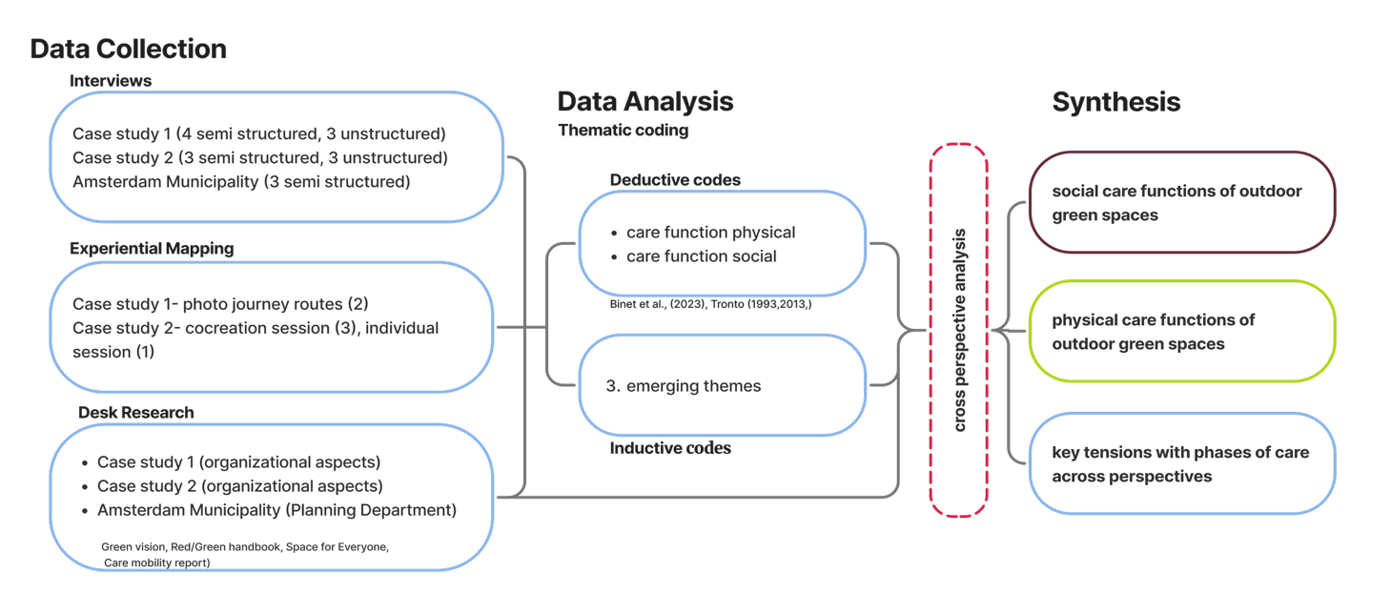
Figure 3 Methodology Diagram

Selection Criteria & Case Study Neighborhoods
Amsterdam is divided into 25 administrative areas that capture distinct socioeconomic characteristics (Gemeente Amsterdam, 2020). Case study selection was guided by location, population density, green space accessibility, and researcher access. Differences in sociodemographic makeup of neighborhoods were considered initially but due to access, not prioritized. This research recognizes that embodied experiences of care within an area vary greatly and is dependent on personal factors related to income, time, culture, as well as the public infrastructure of the neighborhood, and the city at large. Having case studies in two different neighborhoods allow for a somewhat more comprehensive understanding of the state of care infrastructure in Amsterdam. The researcher’s personal access to certain social groups and areas was also considered. As shown by the map below (City of Amsterdam, 2026), both case studies are in neighborhoods with relatively low availability of public greenspace – less than twenty-five percent of total public area.
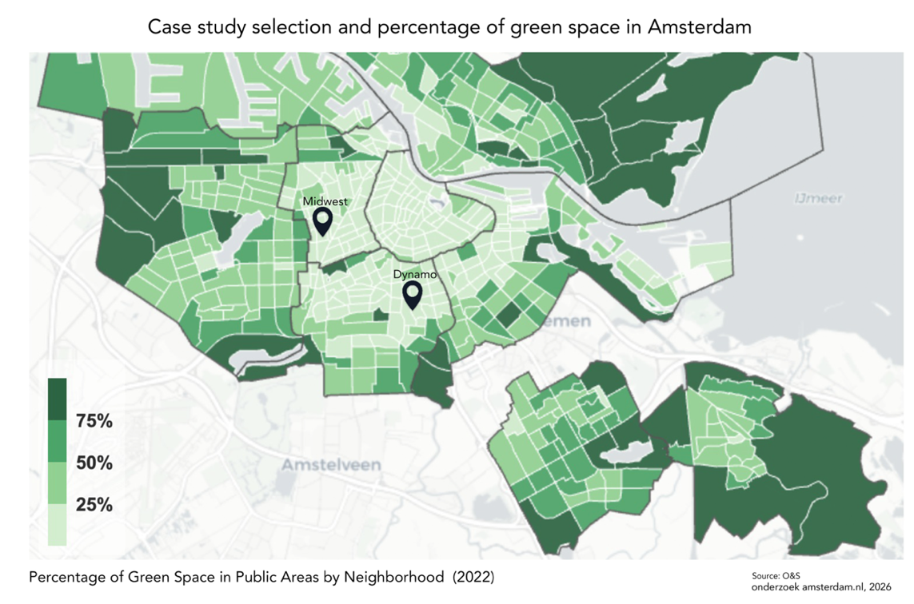
Figure 4 Case study locations and percentage of greenspace in public areas, by neighborhood in Amsterdam.

- Case 1 was selected as it represents the perspective of care for children in Amsterdam, as it is of the Dynamo play group located in a densely populated neighborhood where care for children is conducted outside. As a care space, it is also a form of organizational care that acts as an intermediary between formal institutional care via the municipality, and informal care, due to the nature of the organization as a nonprofit where the funding decisions are entirely dictated by the municipal government to address care needs in the city.
- Case 2 serves to represent the perspective of neighborhood care and care for more than human life, in a semi-public space that was planned privately, unlike the public parks planned by the municipality. As a care space, the organization acts more like an informal “collective-care” space where the social functions are determined by the non profit organization based on the initiative of local neighborhood residents.
- These two cases serve as a contrast to the municipal planning department, that is a formal institution with its own measures and agendas in the planning of green space in the city.

Case 1: Dynamo Playgroup at Hendrik de Keijser (De Pijp / Rivierenbuurt)
Location Context: Includes Oud-Pijp, Nieuwe Pijp, Zuid-Pijp, and IJsselbuurt. Boundaries are defined by caregivers' perceived radius of access rather than strict administrative borders.
About: Spelinloop Amsterdam De Pijp​ is located at Henrick de Keijserplein 45, 1073 SW Amsterdam, a volunteer-led community center operated by Stichting Buurtgebouw Henrick de Keijser with support from the municipality. Though the playgroup itself is conducted out of an indoor building, the participants interact with surrounding outdoor public spaces (e.g., Sarphatipark, IJsselplein) and construct a localized network of care.
Organization: Dynamo itself is a nonprofit organization funded by the municipality of Amsterdam that offers a variety of services, including the playgroup for children not yet of age to enter formal preschools. According to the director, the municipality of Amsterdam decides playgroup locations based on social demographic criteria such as: education, income, social housing percentages of an area, families with young children percentages, migration background, and language skills. Another factor that is considered is other social services in the area such as food banks and refugee centers.
Thus, case one is considered a distributed care space within the neighborhood as a nonprofit funded by municipality, and serves as an intermediary between municipality and local community. There is no cost, as it is fully funded by municipality, aside from when they go on excursions to ticketed activities such as the zoo, in which discounted rates are offered to participants, according to the playgroup leader.

Case 2: Midwest Community Center (Oud-West / De Baarsjes)
Location Context: Situated in the Hoofdweg e.o. neighborhood in the greater De Baarsjes. According to Midwest, parts of De Baarsjes (and particularly in the neighborhoods surrounding MidWest), a quarter of the youth grow up in poverty. And one in five households must make ends meet on a minimum wage. It functions as an immediate neighborhood green space situated between three major city parks (Erasmuspark, Rembrandtpark, and Vondelpark), and the center of a network of care within the neighborhood.
About: Midwest describes itself as a “village hall in the city” that was founded in 2012 (Midwest.nl, 2026). It is also a “social enterprise, meeting place, and workplace with the goal of creating social impact in the neighborhood.” It is a non-traditional community center featuring indoor café and kitchen, offices, and outdoor courtyard gardens where composting initiatives, plastic recycling, and a native plant nursery also exist.
Organization: According to the founder, the building itself was a former school owned by the municipality, but is now privately owned, and funded by the nonprofit Midwest foundation that runs out of it. According to their annual MAEX Social Handprint, which quantifies social impact in relation to the United Nations Sustainable Development Goals (Midwest.nl, 2026),
“we do this by strengthening social cohesion and cultural enrichment through our programming, offering discounts on venue rental for social initiatives that we provide with a workspace, and collaborating with other initiatives that also contribute to a better world. In this way, through entrepreneurship, creativity, and empowering community makers, we give our village hall in the city a solid future. In terms of social impact as well as financially.”

Perspective 3: Municipality of Amsterdam
Organization: The Amsterdam municipality is currently organized into five umbrella organizations, or “clusters,” of which each has their own departments within them. This is excluding the executive and management staff, as well as the districts that have their own executive and committees for the seven districts of Amsterdam. They deal with the local implementation and management of municipal efforts such as for streets, waste, local public space and neighborhood initiatives. This research on “care-full planning practices” in relation to outdoor green space focuses primarily on cluster Ruimte en Economie, the spatial planning and economy cluster. It includes the departments of Spatial Planning and Sustainability (Ruimte en Duurzaamheid), Mobility and Public Space (Verkeer en Openbare Ruimte), Land and Development (Grond en Ontwikkeling), Wonen (Housing), Municipal Real Estate (Gemeentelijk Vastgoed), Engineering Bureau (Ingenieursbureau), Parking, (Parkeren), and the Project Management Bureau (Projectmanagementbureau).
Maintenance of outdoor space is conducted by the Amsterdam maintenance department. The municipality has multiple departments that are siloed in how they operate. The organizational structure of the municipality reinforces fragmentation of care efforts, with responsibilities distributed across departments and clusters and with differences between planning, implementation, and maintenance.

Data Collection Methods
Overall, the steps taken were:
- Data collection
- Deductive analysis using three predetermined categories
- Inductive identification of emerging themes
- Analysis within each of the three perspectives/cases
- Cross-perspective synthesis
Primary qualitative data was gathered using three complementary field methods alongside desk research. The main research methods include 1) participant observation field work 2) experiential mapping of caregiver’s daily routes to and within selected care spaces 3) semi structured interviews and supporting desk research.

Participant Observation Fieldwork
Fieldwork was conducted in the selected public green spaces (Sarphatipark, Henrik d. Keiser Plein, Ijselplein, Midwest) to document the practice of care observed here, once or twice a month from May to August at different times of day on weekdays and weekends. This involved: observing how caregivers navigate spatial and material barriers while performing care labor, in consideration with time and weather conditions. On one day it was rainy, and there was no activity in the playground areas. Field notes were made to record observations of material/physical affordances on different visits, and social affordances or care burdens based on theoretical literature review related to urban care infrastructure (e.g., Binet et al., 2023; Tronto, 1993). Also occasionally, conducting informal interviews with space users to capture immediate impressions of available spatial affordances.

Experiential Mapping & Visual Ethnography
To address the daily embodied experiences of space users, mapping exercises captured caregivers' spatial routines and sensory engagements with the outdoor built environment of each case study.
The use of experiential mapping is a key component of this research to understand the daily experiences of caregivers by mapping their daily emotions. This methodology firstly, serves useful for urban planners to integrate the perceptions of citizens into the planning process, and secondly, because “these co-produced knowledges, analyses, and creative practices valorize tacit and bodily ways of knowing” (Rekacewicz et al., 2025) .The ethnographic exercises employed draw from established methodologies used in similar research on multisensory experiences in outdoor space such as the visual ethnography and sensory notation exercises used by (Tabassum, 2025) and (Pink, 2007). The walking journey for caregivers of children drew inspiration from a similar approach where care mobility of mothers was studied via walking-journeys (see Clement & Waitt, 2017). The experiential mapping techniques differed based on the care site due to the focus of the sessions and to make it more accessible depending on the ability of the interviewees.
Ideally, participants would have taken the photographs themselves during the photo journeys, allowing them to directly determine what was documented and to engage more actively in the visual component of the research. However, for the parents in Case Study 1, this was not always practical because they were simultaneously performing active caregiving responsibilities for their children during the walks. Rather than requiring participants to divide their attention between caregiving and documenting their surroundings, I took photographs when participants pointed out features or notable experiences along their routes. This adaptation did not substantially alter the focus of the photo journeys, as participants continued to determine which places, features, and sensory experiences were relevant to the research and provided the accompanying interpretation and context for the photographs.

Case study 1 method: "Sensing the Site" Visual Ethnography (Dynamo Playgroup)
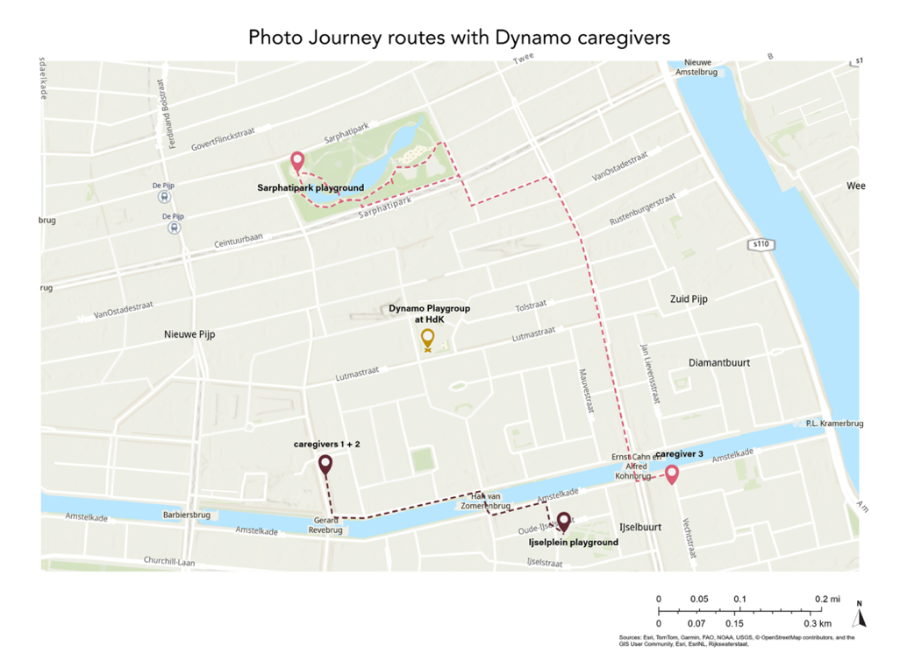
Figure 5 Map of routes and Dynamo playgroup location

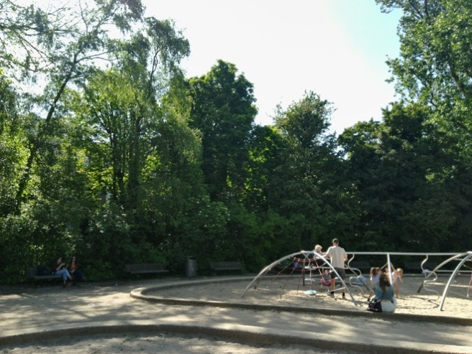
Figure 6 Picture of Sarphatipark playground,own work.
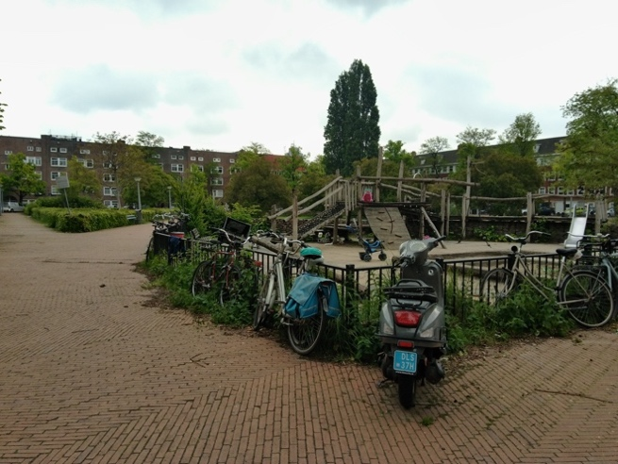
Figure 7 Picture of Ijselplein playground, own work.

The visual ethnography approach adopted here has two components. First, I conducted semi-structured interviews with participants before planning the photo-journey route. Second, photo journeys were conducted with parents walking from their homes to local play areas, during which pleasant and unpleasant sensory experiences along their routes were documented. These were conducted with parents that attend the Dynamo Henrick de Keijser playgroup, from their respective houses to the play areas they choose to visit.

Caregiver 1 & 2:
Parents of a two-year-old boy living in a fifth-floor apartment formerly owned by the mother’s family, without their own access to private green space. (Conducted in May, 2026).

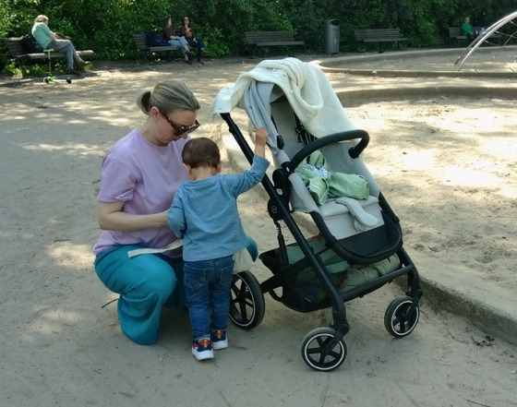
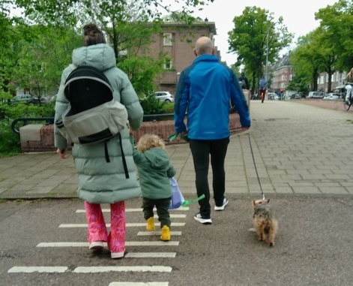
Caregiver 3:
Pregnant, part-time stay-at-home mother managing primary caregiving duties while her partner works, walking from her apartment to Sarphati Park. Due to the apartment’s location on the first floor, she has access to a small, paved outdoor terrace. (Conducted in May, 2026).
Figure 8 Photo of caregiver 3 and child, own work. See Appendix 9.1.2 for mapped photo journey route
Figure 9 Photo of caregiver 1, 2, and child, own work. See Appendix 9.1.1 for the mapped photo journey route

Case study 2 method: Spatial-Emotional Mapping (Midwest)
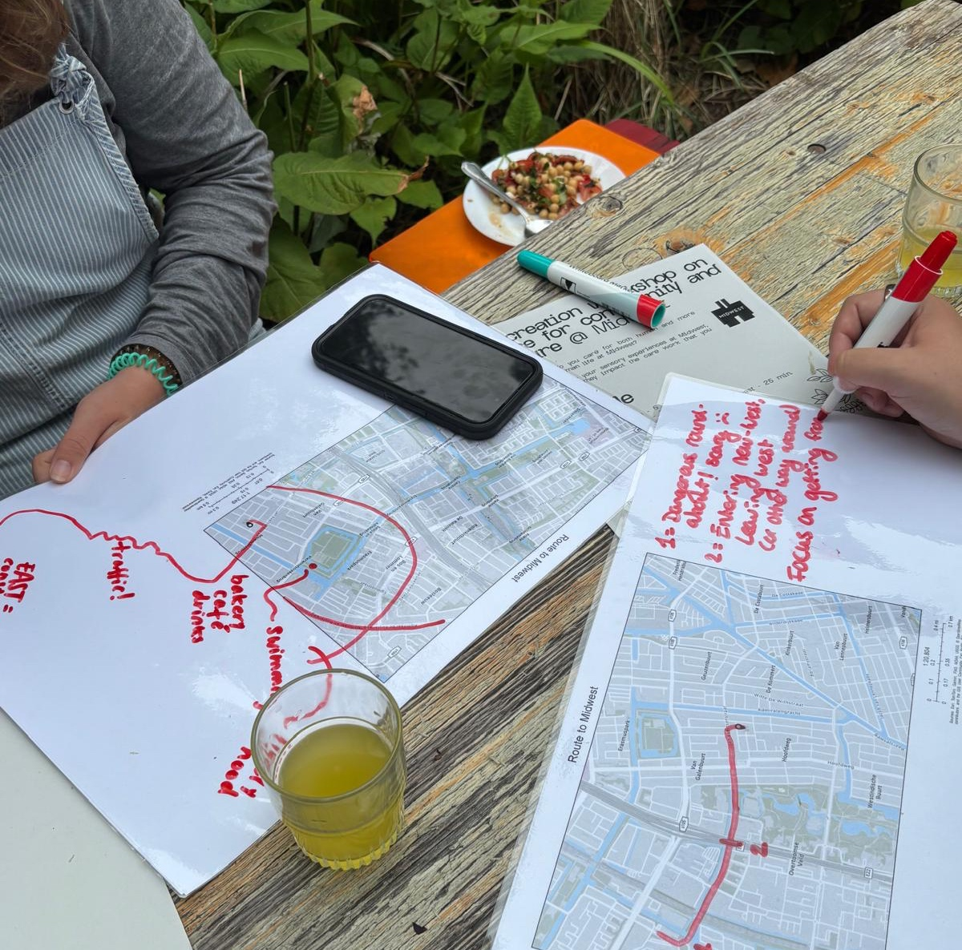
Figure 10 Photo of cocreation session at Midwest, own work.
In case 2, a workshop format allowed for more participants to join and for results to be collected most easily. Participants mapped their routes to Midwest, identifying points of interest and associated emotions. They then mapped their physical movements within Midwest's outdoor space, highlighting locations of strong connection and emotion to explain how spatial features relate to care practices they conduct. I organized sessions by sharing “co-creation session on Midwest as care infrastructure” workshop flyers after connecting via message with the outreach coordinator at Midwest, who also attended session and helped me to find participants.
Participants in joint session: One community member (one personal work/leisure user) and two Midwest employees (one in youth events/programming, one in communications/outreach). Conducted in June, 2026.
Participant in individual session: Volunteer from plastic recycling workshop at Midwest, Conducted in July, 2026.
See Appendix 9.2 for the cocreation maps.

Semi-Structured & Informal Interviews
Semi-structured interviews were conducted to understand how planning decisions affect the mental and physical health of caregivers and their ability to conduct care that is mental, manual, and physical. Interviews also used to understand how care for humans is entangled with care for more than human life at both locations. This method allows for listening to what the interviewees “care about or fear, what common interests we might share, what arguments or strategies or offers we might try” and to delve “further in” on a specific issue rather than “abstracting out the relevant moral principles (Davoudi & Ormerod, 2025). This is a useful tool to extract themes of care through their lived experiences in Amsterdam.
Interviews were thus conducted across the three primary stakeholder groups:
- Dynamo/De Pijp Care Space: Parents (interviewed prior to visual mapping exercises), the playgroup leader, and the director of the speelinloop program at parent nonprofit organization Dynamo. Also two informal interviews were held during initial observation of playgroup with caretakers, and one at Sarphati park. An informal phone call interview was also conducted with the volunteer leader of the Sarphati park association (Vereniging in Dutch).
- Midwest Care Space: Employees involved in the compost project, head gardener and designer, and toxic-free plant sale manager. The founder/co-owner/director was also interviewed. Informal interviews also occurred spontaneously during visits with people in the café space and people in the gardens to learn about their involvement with Midwest.
- Planners & Project Managers: Municipal employees from the Economy and Planning cluster, including a project manager for gender inclusivity in urban development from the project management bureau, as well as project manager and landscape architect both in the Spatial Planning and Sustainability department (Ruimte & Duurzaamheid), to examine how planning policy addresses the care deficit and balances human and more-than-human needs.

Desk Research
Desk research was conducted in parallel with fieldwork to analyze policy documents (e.g., Green Vision 2020-2050, municipal survey reports, Green and Red planning handbooks) and organizational literature from Dynamo and Midwest, contextualizing how these organizations define and deliver care infrastructure as “care spaces,” and particularly in relation to outdoor green space. This includes information that pertains to business model, governance, funding structures, leadership and personnel structure of the organization, and mission of the organizations.

Qualitative Data Analysis Methods and Analytical Framework
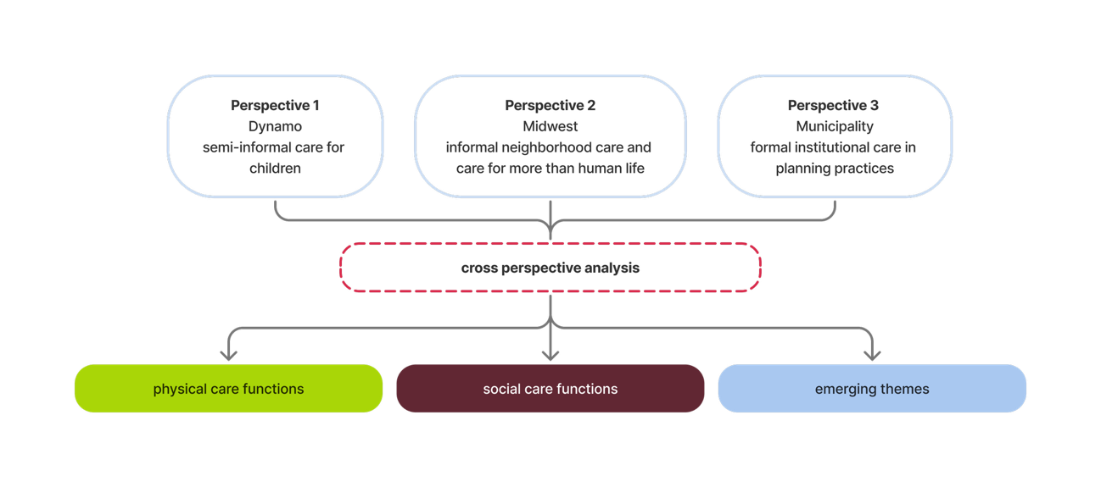
Figure 11 Analytical framework
The overall data analysis conducted in this research was a combined deductive–inductive approach. A deductive approach was used to thematically code and analyze the results from the field observations and semi formal interviews. The thematic codes were based on the “urban infrastructures of care” theoretical framework, where the care functions of outdoor infrastructure can be seen as the physical and social functions.
The two predetermined categories are:
- physical functions of care infrastructure which include material affordances in the outdoors that either support or hinder care work conducted in each case study
- social functions of the care which focus on actions that reflect relational ties, and feelings by individuals that support care: such as community cohesion, emotional safety, accessibility/inclusivity, and non-commodified human connection.
The field observations made were first based on affordances determined by literature review of “urban infrastructure of care” to include both social and physical/material functions (see Binet et al., 2023). Field observations were made repeatedly over the duration of the research starting in April and continuing approx. once per month through July, at the different locations, as more care affordances were examined after interviews with caregivers from both case studies.
When reoccurring themes emerged from each perspective, the two case studies and the planning practices, an inductive approach was used to create these categories.
The emerging themes were identified through repeated engagement with the data and compared with theory based on the initial literature review related to feminist ethics of care and ecofeminist city planning theory that inform outdoor space as an urban infrastructure of care. Emerging themes were considered significant where they were recurrent across participants or data sources in each perspective, appeared as significant contrasts between cases, or provided a particularly relevant case-specific insight into the research question. Themes occurring only once were not treated as generalizable findings but were retained where they provided meaningful insight into an individual experience or case.
The data collected per case study was integrated together at the end once the deductive and inductive themes were determined to organize the results for each perspective. Interviews, observations, maps, photos and documents were considered together.
See Appendix 9.3-5 for tables of code analysis findings from each perspective.

Synthesis
From mapping exercises:
From case study 1 maps created from photo journeys: sensory/emotional experiences conducting care work that determined spatial/material affordances, as well as movement/mobility to and from care sites, and choices for the selected care route taken.
From case study 2 maps : sensory/emotional experiences to Midwest from home, as well as mapped locations of care practices and sensory/emotional experiences within the space to reflect care work conducted.

Then those observations, along with the interviews and desk research data, were interpreted through the themes mentioned: Physical care functions / Social care functions / Emerging themes.
After findings from each perspective were compiled into the themes (physical, social, and the emerging themes), they were synthesized using cross perspective analysis of these themes, and cross compared and analyzed for resulting tensions. The tensions that resulted across each perspective were then examined based on the practices of care that conflicted with the planning efforts. This informed the findings for how the planning practices relate to outdoor space as an infrastructure of care in Amsterdam, which are first shown via a cross synthesis table in the results chapter.

RESULTS

Cross-perspective Synthesis
The results are first organized into a cross-perspective synthesis table where the analytical themes across all three perspectives are described and compared. The concluding results are organized into the social and physical care functions that are explained in detail, as well as the emerging themes that arose across the perspectives.
Table 1 Cross Synthesis by Analytical Theme
Analytical theme | - Dynamo | - MidWest | - Spatial Planning
Physical care functions | N/A- relies on community center and surrounding public city parks to facilitate care work out of.  Physical affordances of city parks defined by lived experiences of caregivers in Dynamo do not always match the standard amenities planned for. In particular:  - public restrooms  - waste bins  - Caring sidewalks (level, paved, wide enough for multiple people to pass each other)  - toys  - playground structures with “safe” materials  - gates | - Creating accessible urban greenspace for people without access to private gardens  - Providing restorative space and supporting social care through outdoor space  - Providing a private alternative to public greenspace  - Low maintenance and climate adaptive infrastructure  - Outdoor gardens creating spatial diversity for different care needs  - Indoor–outdoor continuity | N/A- Care not explicitly planned  material and green infrastructure -Red and Green handbook set standards for amenities not based on care  City parks: planning priority is socialization, recreation, and health  Access to public green space  Ecological functions of green space- biodiversity, wildlife, climate adaptation  Maintenance
Social care functions | - Social networking among caregivers  - Connecting parents across social backgrounds  - Emotional support and reducing isolation  - Communication and continuity of care  - Maintaining relationships beyond the playgroup  - Informal peer support  - Child socialization and education  - Outdoor space as developmental care for children  - Facilitating caregiver flexibility and ease  - Addressing gaps in Amsterdam's childcare support network | - neighborhood resident empowerment  - community cohesion  - emotional safety  - multi-generational inclusion  - non-commodified human connection  - Supporting connection to nature  - Community ownership and sense of belonging through making and maintenance | - Social dimensions of care are recognized through separate initiatives by the city related to education, finances, childcare, accessibility of outdoor spaces etc.  - City parks and greenspace - provides public space for socialization and interaction, mobility, human and more than human life connection  - Care mobility,  Gender-inclusive planning, Safety, Citizen participation
Table 2 Cross Synthesis by Emerging Theme
Emerging theme | - Dynamo | - MidWest | - Spatial Planning
Care mobility | Necessary for caregivers of children at Dynamo, needs improvement | Social network of care exists between Midwest and surrounding organizations and initiatives | Not planned for yet, but considered
Human/more-than-human entanglement | Conflict between care for children and more than human life | Entanglement embraced here through celebration of life cycle of nature, children not prioritized in outdoor spaces | Different green spaces prioritize human and more than human life differently, maintenance practices show conflict
Subjectivity of Accessibility | Accessible for all but concerns about social exclusion due to economic status and education levels among group attendees | accessibility is conditional and relational | Difficult to plan for but prioritized in planning documents and efforts
Political and Financial Conditions of Care | Fully reliant on municipal funding and input | Structure is independent of municipal funding and decision making | directly influences planning priorities and decisions related to outdoor space

Perspective 1 Dynamo as a Care Space
On an organizational level, the Dynamo playgroup serves as an intermediary link between larger care resources established by the municipality via funding and care site designation, to local community care networks, as shown by the playgroup in De Pijp. Taken together, the care functions analyzed demonstrate that Dynamo operates as more than a site for childcare or children's play, but can strengthen broader urban care networks in the city by connecting caregivers to one another and to the outdoor public spaces in which every day caregiving takes place

Perspective 2 Midwest as a Care Space
Midwest is a non-traditional community center where the indoor and outdoor spaces work together to support the care work conducted here. Care is organized here unconventionally, not only through the activities taking place at Midwest, but also through the financial and governance structures that make these activities possible. The organization operates as an intermediary between commercial activity, private investment, community initiatives, and public benefit, with social impact explicitly incorporated into how it defines and evaluates its success. It demonstrates how a local neighborhood initiative can act as a care-collective, to contribute to care infrastructure in a city such as Amsterdam where care is not inherently integrated into planning and everyday practice.

Perspective 3 Planning Practices in Amsterdam as Care
The findings from this research demonstrate that Amsterdam's existing planning practices produce some elements of care infrastructure, but this care is fragmented across climate adaptation, mobility, accessibility, safety, maintenance, and civic participation agendas rather than functioning as an explicit, integrated planning framework centered on care. The organization of the municipality contributes to this due to its siloed nature, as care can be considered an outcome of the different agendas, rather than a targeted priority across departments.

Physical care functions of outdoor green space in Amsterdam
The green spaces studied in this research include both municipally planned city parks in De Pijp (Perspective 1), as well as privately owned but publicly accessible outdoor gardens in De Baarjses (Perspective 2). These green spaces both provide necessary physical care functions in their respective neighborhoods, but the specific care work that is conducted out of them differs due to the planned intent of the green spaces, the spatial layout, and the related social organizations that conduct care work out of green space in the city.

Perspective 3 Planned physical functions
Municipal planning of public greenspaces contributes to outdoor space as an infrastructure of care through the provision and improvement of physical and ecological functions. The Amsterdam Green Vision (2020–2050) identifies green space as important for social well-being, leisure, climate adaptation, health, and biodiversity (City of Amsterdam, 2020). Its principal goals include ensuring enough diverse green space for everyone, making green infrastructure multifunctional, integrating biodiversity into urban planning and management, and working together on green space. Measures such as green routes, increasing accessible green space, and “green by default” contribute to access to outdoor space and the quality of the urban environment. These measures can contribute to outdoor space as a physical infrastructure of care through the improvement of the quality-of-life people may have both journeying to, or within, these spaces, as an increase in accessible green space most likely reduces crowdedness in existing parks, and improving material infrastructures within parks also improves care work being conducted. The improvement of more than human life is also a direct benefit through these measures.
However, the plan never explicitly states care or a focus on improving greenspace access specifically for women/other caretakers, or for young children (City of Amsterdam, 2020).
From a municipal planning perspective, outdoor green space functions through the provision of multiple physical, ecological and social functions embedded within everyday public space. However, the reality appears to be more about meeting standardizations for specific targets based on the existing and competing uses of space. This means that green space can provide multiple care functions, while care itself is not necessarily the organizing principle through which these functions are prioritized.
The physical provision of care through green space is therefore divided between policy and planning on the one hand and everyday maintenance on the other. The municipality can plan a park as multifunctional green infrastructure, but its actual capacity to provide care functions such as: shade, biodiversity, recreation, safety, accessibility, and other functions depend heavily on the ongoing maintenance work of the Greenery, Flora and Fauna department. Though this maintenance work conducted at city parks is primarily conducted by the municipality, gaps within maintenance are partially filled by volunteer groups, such as the Sarphati Park association (via personal communication, 2026).

Perspective 1 Daily experiences of physical care functions for childcare
The results from Perspective 1 indicate that caregivers of children in Amsterdam rely almost daily on municipally planned city parks and playgrounds to conduct care work out of, particularly when they do not have access to private green space, which was the case for all the interview participants. Parks, playgrounds, and community-based initiatives function as site-specific care infrastructure within a broader care system that caregivers rely on to conduct care work out of. The municipal green spaces provide the physical space through which important social functions are conducted out of: caregivers can spend time with children, children can play and socialize, and caregivers can encounter other people and develop informal support networks. However, the physical affordances of city parks defined by lived experiences of caregivers in Dynamo do not always match the standard amenities planned for.
The Dynamo playgroup and its participants relied on the Henrik de Keisjer community center building that the playgroup was organized out of, as well as nearby outdoor play spaces such as Sarphati park. Every parent that was interviewed from this playgroup, rely on outdoor space such as city parks to care for their children to some extent, and felt that there were not enough options nearby to conduct care work out of that were easily accessible and “safe” for their children. According to Parent 1,
“Amsterdam just doesn’t feel designed for children. The playgrounds are often overcrowded, public parks are the only outdoor option, and there aren’t enough safe spaces. There are also practical issues like the lack of public toilets. As a pregnant woman or parent with a small child, you can’t really spend a full day outside because there’s nowhere reliable to go to the bathroom. You end up depending on cafés, but then you feel obligated to buy something. Amsterdam is expensive, and there aren’t many child-friendly cafés. There are some newer “family centers,” but many feel commercialized. You pay for coffee or food just to access a small play area”.
The care participants studied rely on the urban environment as a connected network of different care sites to take place successfully, so the outdoor care spaces and the Dynamo play group serves as different locations within a larger network of care sites which enable social care work to take place. Through the mapping journeys and interviews with caregivers from Dynamo, it became apparent that the daily care for children relies on many material features within outdoor green space to be successful. These physical features, which serve as care affordances, are listed here:

Table 3 Physical Care Affordances Identified
Built
- public restrooms
- comfortable seating/benches placed for socialization and with unobstructed views
- waste bins
- Caring sidewalks (level, paved, wide enough for multiple people to pass each other)
- drinking water
- running water features (ponds, streams, canals, fountains, pools)
- shared toys/play equipment
- playground structures
with “safe” materials
- enclosure from surroundings with functioning gates
- shade structures (can include living trees and vegetation)
- indoor/outdoor access
- proximity to cafes
Living
- animals, insects, and other wildlife
- trees, grasses, shrubs, other vegetation

In outdoor spaces where these features were not available, care was more laborious. The care burdens were not limited to the parks themselves, but within the larger care infrastructure network for caregivers traveling to and from these sites. Some of the “care burdens” mentioned include: trash, playground equipment deemed unsafe for their children to play with, or unstimulating. Materiality of the space was frequently mentioned by different caregivers, who notice their children interacting with materials, as reflected by the mapping journey of parent 3, who pointed out many unsafe materials she observed within Sarphati park.

Perspective 2 Informally planned physical care functions
Perspective 2 shows how a semi-private outdoor space functions as care infrastructure, without influence from municipal design standards and guidelines. At Midwest, the physical building and the gardens directly support the care work being conducted in the various rooms. The garden designer stated that at Midwest, "the garden and the building support each other" (Theun, via personal communication 2026). Based on the results of the mapping exercises and via interviews, it can be determined that the use of the indoor and outdoor space is often intertwined in support of the various care activities that occur at Midwest (see map below).
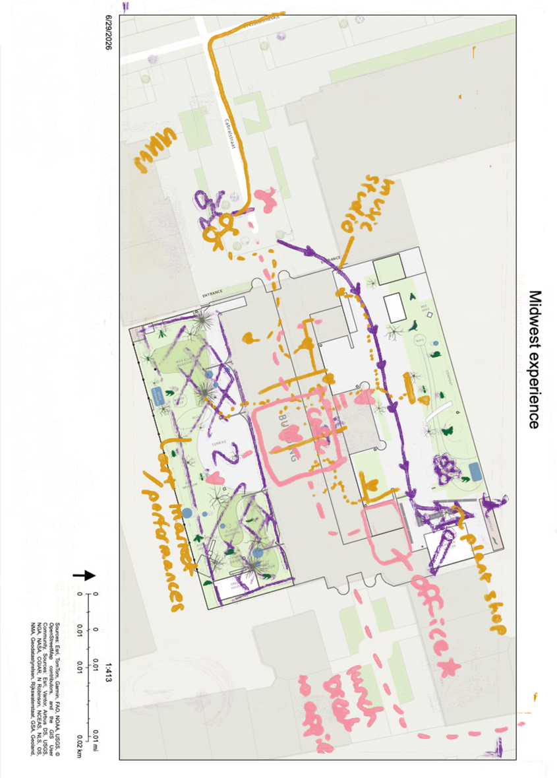
Figure 12 Physical care functions identified at Midwest, own work and work of cocreation participants

The spatial layout of Midwest and its outdoor space is designed so that the garden serves to support the indoor care work, as just another setting for care work to occur in, that perhaps cannot happen inside. “The garden now supports people in ways that indoor spaces cannot. People hold difficult conversations here. Families celebrate births here. There has even been a funeral here"​(Theun, via interview, 2026). This sense of difference between the gardens is also felt by the mapping participants, as they all had different feelings in the north and south garden related to the activities they conducted here and when compared to inside. Other physical functions identified are how it compensates partially for unequal access to private greenspace in the city, as many people come to Midwest to spend time in the gardens, which are more private and intimate than traditional city parks due to the size of the gardens, and in terms of people that access the spaces. The use of materials at Midwest also contributes to a sense of ownership and connection to the space, as the material is all repurposed or salvaged. The founder of Midwest stated that she has brought her own furniture to Midwest, and that her son and friends painted the outdoor tables in the garden. This material reuse reflects collective care and allows participants to see their own labor, histories, and contributions embedded in the space. These physical care functions are possible in this space due to the private ownership, unlike municipally planned spaces that follow specific guidelines.

Social care functions of outdoor green space in Amsterdam
The social care functions of outdoor greenspace are varied depending on the form of care work being conducted, particularly for care for human compared to nonhuman life. The care functions that are possible in municipally planned city parks are somewhat different than those privately owned but publicly accessible outdoor spaces such as Midwest.

Perspective 3 Planned social care functions
The concept of planning for care is not reflected explicitly in the social functions related to outdoor space in the city. Across the municipal interviews and policy documents, these practices indicate that care is considered across multiple departments rather than through a single, explicit framework for planning for care. These planning practices include: funding for local community organizations, gender-inclusive planning, care mobility, safety, and citizen participation
Care infrastructure for caretakers of children through financial means and funding directed at groups such as Dynamo is one way the city of Amsterdam offers care for citizens and alleviates some burdens. However, the role of Dynamo is necessary as there is still some distrust with the municipality among some marginalized groups, according to Ineke, due to the childcare benefit scandal where parents with mostly migratory backgrounds were wrongly accused of making fraudulent claims for childcare allowances (see Berends, 2021). This suggests that municipal support for care can operate indirectly through community-based organizations, which it can act as an intermediary between residents and municipal structures, rather than through the municipality providing all social care functions directly through its own services.
Regarding planning features that support social functions of care, the incorporation of gender-inclusive thinking into design through the Gender Inclusivity department is one way forward, according to a project manager for gender inclusivity research in the municipality. She works to train across departments on how to incorporate gender inclusive design into their approaches, and on testing “pilot projects” (via interview, 2026). Through their research and training, they raise awareness of how gender-inclusive features in planning support not only women, but everyone. However, the conversations related to gender-inclusive design thinking is “often hijacked by conversations of safety.” This is especially true after the murder of the young girl biking home at night. According to Rixt, a landscape architect within the spatial planning department, this news caused immediate urgency in all departments, including hers, to address safety in outdoor green spaces, where measures were requested such as trimming shrubs and improving lighting in parks. While safety was described as an important consideration, this emphasis also illustrates how discussions of gender-inclusive planning can become concentrated on safety rather than addressing the broader range of social needs associated with care. Safety is an aspect of accessibility of outdoor spaces that should be planned for, but not as the only aspect of planning for care.
Care mobility research is another specific way that care is being considered in the municipality. However, this research within the municipality on how to incorporate gender-inclusive thinking into planning, via an agenda known as Amsterdam Make Space (Amsterdam Maakt Ruimte), does not reference care-full planning principles and instead focuses on goals such as “gender mainstreaming” in the planning departments, via training and education across departments at an individual level, as currently it is extremely spread out across multiple departments with their own agendas and goals (Kruyff, S., 2024). The organizational structure of these initiatives therefore reflects a distributed approach to care, in which responsibility for incorporating care-related considerations remains spread across the departments.
The municipality also connects to residents and their concerns through communication and outreach efforts across various departments. Regarding outdoor space, residents can connect with the municipality to voice their concerns and receive assistance through multiple routes. One of these routes is through citizen assemblies.
Citizen assemblies provide a formal route through which residents can influence municipal planning. A project manager from the planning department mentioned them as a way for citizens to voice their concerns and be involved in influencing policies related to planning and green space access in the city. One assembly on green space was titled “How do we make a growing Amsterdam greener together?” and resulted in the proposal for a more permanent ‘Green City Citizens’ Council.’ Another was held on the topic of trash in the city: “There was also a civil assembly on trash…And there were many advices about what can be better in the municipality. So also due to many complaints and due to budget cuts before by political decisions in that department” (Laurie, via interview, 2026). Together, these findings show that citizens are not only recipients of municipal care infrastructure but also participate in monitoring, communicating, maintaining, and shaping outdoor green space through practices funded by the municipality. However, this citizen participation at times appears to supplement gaps in municipal capacity rather than to replace formal municipal responsibility, such as through volunteer groups. The municipal employees interviewed recognized though that the most active citizen led groups concerned about green space were also the ones with the most time and influence, which may impact the level of citizen led care in green spaces in certain neighborhoods when compared to others in less affluent areas of the city.
Another example is the Green Agenda, implemented between 2015 and 2018, that promoted the creation of new green areas in Amsterdam specifically through the involvement of residents in greening initiatives (Pellerey & Giezen, 2024). According to a municipal landscape architect from the planning department, “we (currently) have a really green orientated office,” which indicates institutional support for green-oriented planning and could provide a basis for support for care infrastructure changes in green space, but only when able to be executed and funded properly.
Overall, the social care functions identified within municipal planning are therefore present through several separate initiatives rather than through an explicit framework of planning for care. Gender-inclusive planning and care mobility broaden the consideration of who uses and moves through public space, while community funding and citizen engagement create additional routes through which residents can access and influence care-related resources. At the same time, the findings show that these functions remain distributed across different programs, departments, and forms of municipal-community collaboration. Rather than representing a single municipal approach to care, planning for care emerges through a collection of practices addressing specific dimensions of residents’ social needs. Furthermore, it was suggested via interviews with different department employees that even with outreach efforts to engage citizens in municipal efforts, the municipality cannot address all care needs without external pressure or support from citizen-led initiatives and organizations.

Perspective 1 Social care functions for childcare
Outdoor green spaces serve a dual social care function for care work associated with childcare, as they provide opportunities for children to play and socialize while also creating settings in which caregivers can continue to develop their own relationships with others and with the children.
Dynamo creates opportunities for caregivers to develop and maintain social networks through a regular, accessible meeting point. The playgroup provides a structured setting where relationships can develop between caregivers who may otherwise have limited opportunities to connect with one another. Parent 3 described the value of the playgroup for both herself and her child: “Eventually we found the free playgroup nearby through the community center. It’s amazing... It gives him social interaction and gives me a break from just sitting at home all day” (Parent 3, via interview). This experience was also reflected in the relationships between Parents 1, 2, and 3, who became acquainted through the playgroup and subsequently socialized with their children outside of the sessions. The playgroup director similarly described the group as a starting point for parents to establish their own networks, noting that “Most groups have an app group as well... You see that some people become friends or they go with each other to the park... You can be anonymous, but... we are sort of your neighbor” (Playgroup director via interview, 2026). Dynamo therefore facilitates social connections that extend beyond the organized activity, where the playgroup is not merely a planned gathering but a starting point for wider informal networks of care to take place beyond the playgroup.
The social function of Dynamo is particularly significant in relation to the isolation experienced by some caregivers in Amsterdam. Parents from the Dynamo playgroup described becoming a parent in the city as difficult because of a perceived “cultural” lack of connection and support among parents. Caregivers described feelings of isolation and lack of social fulfillment following parenthood in comparison with their previous social lives in Amsterdam before parenthood. Parent 3 had attempted to connect with other parents in parks and through paid playgroups but found these interactions less successful, with some parents appearing unwilling to socialize beyond brief encounters. Therefore, the regularity and structure of Dynamo provide a different environment for social interaction: rather than relying on spontaneous encounters in public space, caregivers return to a consistent group in which relationships can develop naturally over time. A crucial social care function of Dynamo is thus its ability to create conditions for relationships that may not emerge through the casual use of public space. The free and regular nature of the playgroup is also important, as it provides an accessible opportunity for caregivers to participate in social life without the financial or social barriers associated with some alternative activities, such as the paid playgroup sessions mentioned by one parent.
Overall, outdoor space provides everyday opportunities for people to experience and engage with urban nature and more-than-human processes. The developmental function of outdoor space is particularly evident in children's interactions with nature. According to the De Pijp playgroup leader Loubna, parks, zoos, and petting zoos are common destinations for caregivers with young children, while observations in the park showed children displaying curiosity and engagement with wildlife, often encouraged by caregivers from a safe distance. These spaces therefore support children's physical, social, and educational development while simultaneously creating opportunities for caregiver interaction.
The Dynamo playgroup acts as a meeting point from which caregivers continue to socialize outdoors when time, interest, and weather allow. Parents discuss where they will take their children to play after the session and may visit nearby parks together. In this way, the relationships established within Dynamo become embedded in everyday public spaces, which is not always possible without this organized group setting. Some parents interviewed felt that conducting childcare in outdoor shared greenspaces was not easy for full time caregivers due to the lack of available space for them. According to one parent:
“We’ve also realised that Amsterdam seems designed around the assumption that young children are in daycare during the week. But for stay-at-home parents, or families not using daycare, there are very few places to go. Libraries help, and there are occasional community initiatives, but finding them requires a lot of effort and insider knowledge.”
While the Dynamo playgroup is available to fill this gap for full time care givers, the social support is only during the set playgroup hours, available twice a week. The financial organization of childcare further reinforces the importance of these spaces. The high costs associated with childcare in the Netherlands, alongside the complexity of the Dutch childcare benefit system, can place additional pressure on families and influence how they organize their time between paid work, formal childcare, and direct caregiving. In this context, publicly accessible greenspaces and free community initiatives such as playgroups can provide important affordances for care, as they offer opportunities for children's play and social development while reducing the financial and spatial resources required of caregivers.

Perspective 2 Social care functions through collective-care
The mission of Midwest as a care organization focuses primarily on the social impact the space has on the neighborhood through their different programs. The physical functions of Midwest serve to directly support the vision of the founder, Anita, for social care among neighbors. According to the gardener of the outdoor space, “(Her) primary concern was social care, care for people and the neighborhood.” She feels that people should take individual responsibility to help others and care for them when they can, and felt that a neighborhood center was an effective way to execute this vision.
The social care at Midwest allows for the bridging of socio-economic differences through connection, and it also allows space for individualized support. This form of care is created through programs that provide space for emotional safety rather than just financial resources or physical care. The activities at Midwest are varied and allow for people of different emotional circumstances to participate. This is seen through Rouwen en Vieren (“Mourning and Celebrating”) group, which explicitly “centers emotional care but invites people to hold space for loss without judgment...” The physical activity provides mental space for people who are struggling emotionally to feel their emotions and process them with others in the community, allowing for mourning, grief, and emotional processing to happen not individually, but in solidarity with others. According to Anita, being present is enough. This initiative has expanded across the Netherlands, indicating that this form of collective activity has been taken up beyond the immediate neighborhood. Other social initiatives for those in the community that may be struggling include support for people that are burned out or have trauma. The Turning Tables initiative helps those who are integrating into Dutch society from other countries and is based on friendship rather than language or vocational support. This is by design according to Anita, who stated that
“if we want to get stronger communities, of course we can have dinner and of course we can have like coffee table moments….but if we find subjects where we can really get connected because we are interested, this is also an effective way to connect.”
This can create a sense of community through shared interests and participation, as people are encouraged to build connections without asking anything in particular besides showing up. A program coordinator at Midwest stated that she enjoys the dinners as “some elderly people or people who are lonelier and by themselves…they come here and they have dinner with younger people,” which allows intergenerational connections to occur naturally.
Reciprocal forms of care are also enabled through the organization’s social programming, which is flexible and changes in response to local needs. For example, community dinners began during Covid as free meals for residents in need and later developed into affordable neighborhood dinners. Similarly, a volunteer experiencing mental burnout contributed to garden maintenance according to his available capacity. Rather than requiring him to perform a predetermined task, he swept the garden patios and came at times that suited him. This reciprocal model is also evident in the founder’s broader approach to community participation. She described using her own resources and social network to support initiatives in the neighborhood and encouraging this through how Midwest is structured. These findings suggest that MidWest operates through a reciprocal model in which care is produced through participation rather than delivered in only one direction. This corresponds with the organization's broader organizational structure: people can enter MidWest as users, contributors, organizers, workers, volunteers, or community members, and these roles can overlap.
Midwest does not prescribe specific programs to occur within the neighborhood center as might be expected in a more traditional community center. Their programs focus more on how people can “find themselves and discover their talents” on their own terms (Anita, via interview). Rather, many of the programs are developed by local neighbors and residents that come to Midwest with their own initiatives. This makes it much more flexible and open for individuals to become involved in their community directly through acts of intentional care. According to Anita, "one of our slogans is van buren makers maken... so we try to make program makers from neighbors." The social care programming can be seen in Appendix 9.4.2.
Care functions that Midwest supports include opportunities for personal growth and development, such as curiosity, leisure, and adventure, which emerged as emotional experiences associated with entering Midwest and its garden spaces. One mapping participant, for example, mentioned adventure as an important emotion felt when entering Midwest and the garden spaces, as seen in the map below.
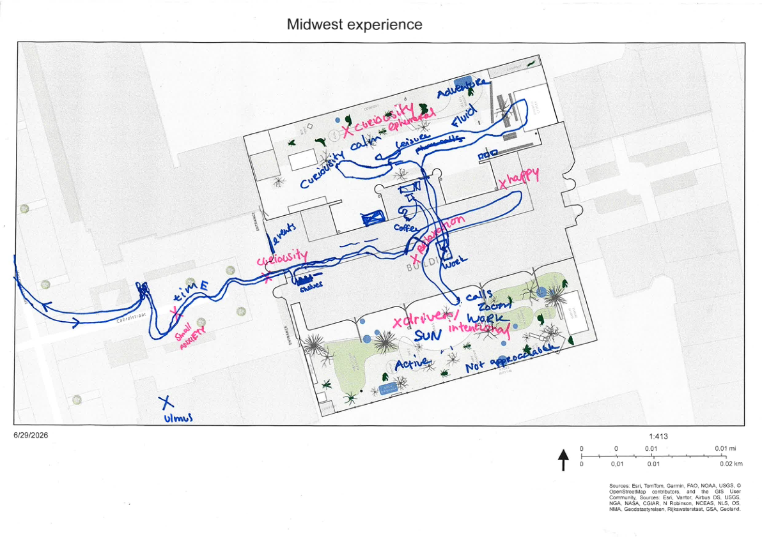
Figure 13 Social care experiences at Midwest by participant 4 (see Appendix 9.2)
These experiences reflect the mission of Midwest to support social care in a way that is not one-sided, from caregiver to care receiver, but rather allows care to be reciprocal. The organizational structure of Midwest enables residents to participate in both receiving and contributing to care according to their own capacities. This differs from more formally structured municipal public-space services, where care-related resources and services may be organized primarily through institutional provision rather than reciprocal participation.
The social care functions at Dynamo
- Social networking among caregivers
- maintaining connections beyond playgroup
- Connecting parents across social backgrounds
- Emotional support and reducing isolation
- Communication and continuity of care
- Informal peer support
- Community belonging
- Child socialization and education
- Outdoor space as developmental care for children
- Facilitating caregiver flexibility and ease
- Addressing gaps in Amsterdam's childcare support network

The social care functions at Midwest
- neighborhood resident autonomy and empowerment
- community cohesion
- emotional safety
- multi-generational inclusion
- non-commodified human connection.
- Personal connections to nature
Table 5 Social care functions identified through perspective 1 and 2

Emerging themes

Care mobility as care infrastructure
Care mobility research is one specific way that care is being considered already in the municipality’s planning efforts. It is directly connected to outdoor space, as the urban infrastructure of care extends beyond outdoor spaces as sites of care to the journeys and mobility networks that connect people to them. The daily experiences people have conducting care include the experiences arriving to and from outdoor spaces. This experience is heavily influenced by spatial planning in Amsterdam, and provides crucial context to outdoor space as an infrastructure of care. This theme emerged in all perspectives, as the daily experiences arriving to and from outdoor space influenced how participants perceived the care functions of these sites.
When it comes to caring for children, “female mobility is often related to care work and therefore has a more diverse pattern while mostly taking place close to home” (Sánchez de Madariaga, 2013). Therefore, caregivers strongly depend on public transport, walking, and cycling infrastructures, as well as the quality of public spaces. In my results related to the care experiences of parents during the walking journey, safety for their children seemed to be one of the most looming thoughts in how they engaged with the outdoors. Though both parent groups, and other caregivers interviewed, had access to outdoor space within walking distance from their private homes, the journey itself was a moment where care work was actively being conducted to ensure the safety and emotional wellbeing of their children and themselves.
MidWest functions not only as a destination for care, but as an anchor within wider everyday mobility networks, as shown by the mapping exercise results. MidWest operates as more than an isolated care space. Its location connects it to nearby businesses, parks, shops, and other community spaces that participants incorporate into their everyday routines. People stopping at nearby shops or visiting other establishments they enjoy contributes to familiarity with the surrounding neighborhood and, potentially, to the familiarity experienced within MidWest itself.
All participants interviewed travelled to MidWest by bicycle, with most living within a 10–15 minute cycling journey. One employee travelled from Science Park in Oost, demonstrating that the organization also attracts people from beyond its immediate neighborhood. Despite this distance, she described developing personal ties to businesses and organizations around MidWest through her connection to the space. This suggests that mobility to and from a care space can also facilitate relationships with the wider neighborhood, extending the social infrastructure of care beyond the boundaries of the site itself.
The routes mapped by participants also revealed that mobility itself can involve different forms of care. One employee described the route from Nieuw-West as stressful near major roads and bridges, but calmer as she approached MidWest and the smaller streets of Old West. Two participants deliberately selected alternative routes to avoid busy roads and highways and to travel through greener areas. A volunteer Nils described sometimes travelling through Erasmus Park even though it took longer because he can “enjoy beauty” this way. These choices demonstrate that the route to a care space is not simply a means of accessing the destination, but can itself contribute to emotional wellbeing and shape the experience of care in the urban environment.

Human and more than human interactions in outdoor environments
The interaction between human and more than human life is a recurring theme across the findings on care in outdoor spaces. The way these interactions are viewed differs by perspective and personal experience of the interviewees.

Planning and the Separation of Human and More-than-Human Values
Regarding planning practices, there are differences within the municipality’s departments over what to prioritize when care for human and more than human life intersect. The municipality's categorization of different types and functions of green space also influences goals regarding planning and maintenance efforts, as there are different “values” prioritized for each categorization of green space. City parks are designated as recreation zones for leisure, sport, and socialization, whereas the nature parks are the designated nature areas with protected wildlife areas (City of Amsterdam, Monitor green Report, p. 10, see Appendix 9.5). In this categorization, different functions and values are assigned to different types of green space, with human-oriented recreation and more-than-human nature protection addressed through separate designations.
More-than-human life is also considered through efforts to improve biodiversity and protect wildlife, although interviewees described these efforts in relation to different municipal priorities and functions of green space. Nonetheless, the focus on outdoor green space improvement and “greening efforts” remains a key priority of the current municipality, as emphasized by employees interviewed from the Department of Planning and Sustainability.

Negotiating Human and More-than-Human Care in Maintenance
Municipal maintenance of outdoor space is also a way in which care for human and more than human life intersect. There are sometimes clashes between citizen values that the municipality must respond to, despite their own internal values and agendas, and the guidelines and visions that shape municipal work. Rixt from the Green department mentioned that following the tragic death of a teenage girl, requests came from all departments for the immediate and significant trimming of shrubs for safety, but this is not good for biodiversity. As she explained, “these contradictions are common” in municipal decisions and practices related to care for nature.
These competing priorities were also visible in the everyday use and management of MidWest’s garden. Attempts to increase biodiversity, such as introducing frogs into different ponds, produced unintended consequences when the frogs became a food source for herons. Similarly, allowing children to run freely through the garden was considered problematic because they could “trample all the life.” Theun explained that a larger garden could potentially accommodate a separate children's area, but the current size of the garden creates a tension between children's use and the preservation of other forms of life.

Community and Institutional Care for Urban Nature
In some cases, such as with Sarphati Park, gaps in municipal maintenance are fulfilled through volunteer groups. The Sarphatipark Association (Vereniging in Dutch) is a volunteer group that meets to conduct maintenance and gardening work in the park. According to Hans, the volunteer leader, many people who volunteer do so to reconnect with the outdoors and nature, and include people with a passion for gardening who do not have access to their own garden in the city. The work is unpaid, and so the care work conducted is motivated in part by participants’ own interests, while also constituting a form of care for more-than-human life in the city.
The association also sponsors the Groen Gemaal, a free plant exchange space and small garden within the park. During its limited opening hours three times a week, residents can receive gardening advice, exchange plants, and borrow gardening tools. It is also run by volunteers from local greening initiatives in the neighborhood, including those involved in the Sarphati Park Association. Together, these activities demonstrate that care for urban greenspace is organized through networks of people, institutions, and unpaid labor, connecting care for people with care for the spaces and non-human life around them.
At MidWest, care for the garden is similarly organized through the relationship between people, the built environment, and more-than-human life. The relationship between the built environment and the garden is explicitly described by the head gardener Theun as, “the garden and the building support each other.” Gardening at MidWest involves practices of observation, listening, intervention, and sometimes non-intervention. Theun described his approach:
“I'm gardening right now by sitting here. I notice things. For example, I see purple flowers over there that aren't from the fruit trees. Later I'll investigate where they came from. That's how gardening works here. You notice something and follow it… Sometimes it's plants. Sometimes it's birds. Sometimes insects.”
This shows that gardening is not always an active process. The physical provision of a low maintenance garden allows for this form of calm, meditative, observational care to take place. These practices demonstrate that the garden is not maintained solely according to predetermined human uses. The garden design was also influenced by non-human activity, including the movement of Anita’s dog through the space, which Theun observed when modifying pathways in the garden. At the same time, Theun emphasized that human well-being cannot be separated from ecological well-being: “Care for nature and care for people are deeply entangled.”

Representing and Negotiating More-than-Human Interests
One way that these interests for human and more-than-human life can be considered equally, is through a representative. When asked about how to improve efforts of care in the municipality, spatial planning project manager Laurie mentioned the importance of “looking at how ecological biodiversity is being discussed, because that’s one of the stakes of Green, who doesn't really have a good representative at tables. You see this concept of rights for nature being more brought up, of course, which is interesting….” (Laurie, via personal communication, 2026). She described the importance of creating an equal conversation among stakeholders, including more-than-human life, so that these interests are represented when determining courses of action regarding green planning practices. The idea of representation was also present in MidWest’s approach to gardening and organizational decision-making.
Outside of his role at Midwest, Theun’s role as a “speaker for the living” through the Zoöp initiative in the Netherlands further illustrates how more-than-human interests can be represented within organizational decision-making. This relates to the discussion with the municipality regarding the need for greater representation of ecological biodiversity within municipal planning.

Subjectivity of Accessibility
In my research on outdoor green space as care infrastructure in Amsterdam, one of the criteria was that it had to be “accessible.” This is a very subjective word though, and the definition of accessible varied depending on context. The findings across the two case studies demonstrate that accessibility was experienced differently depending on how people encountered and understood a space, including its social environment, rules, physical availability, and communication.

Social Accessibility and Inclusion at Dynamo
According to the playgroup coordinator at Dynamo, it is important that the group feels welcoming to all people to come. However, the goal has always been to offer their services and attract people that could benefit the most from the services. This has become a problem in certain areas where the sociodemographic of the area may have shifted. Ineke stated that one of the more recent problems they’ve had is that some of the new group members that have been joining are from higher socio-economic status, such as higher educated English-speaking parents/care-givers who invite their friends of similar status to the groups, and talk together about social plans that perhaps other attendees cannot relate to. Though the group is technically open to all people, according to the playgroup director, "if the group who are the well-educated and verbally good is too big, the other ones don't come anymore. So it has to be [a good balance].” The findings therefore indicate that formal openness does not necessarily correspond with experienced social accessibility. This can make some other parents feel uncomfortable or excluded, making the group less socially accessible. Maintaining a socially inclusive environment is indicated by the playgroup director as thus requiring attention to the composition and interactions within the group, particularly when certain groups become more dominant.

Navigation of Midwest for visitors
The findings suggest that accessibility at MidWest extends beyond whether activities or spaces are physically free to enter. Although MidWest provides a variety of social activities without formal requirements for participation, the organization’s multiple functions can make it difficult for some visitors to understand how they can use the space. One cocreation participant described MidWest as “an unknown space” when they first arrived and explained that the “variety of purposes makes it super confusing,” which hindered their willingness to return. Similarly, observations showed that visitors sometimes needed clarification about whether they could sit and work in the café without purchasing a day pass, while other activities taking place in the building were free. During summer heatwaves, the MidWest café is open fully to the public to enjoy the air conditioning, but typically they expect people to order something from the café to use this space. During the cocreation session, one employee explained that MidWest is “for anyone who takes initiative to get something out of it” and that “if you come with a personal request then you will get a response from us.” These experiences indicate that access was partly dependent on knowing how to navigate the organization and understanding how and when different spaces could be used.
The gardens demonstrate a similar tension between formal and experienced accessibility. Although the gardens are technically free to enter, their gates are sometimes closed and visitors may need to enter through the building to access them. Their location behind gates also means that some people are unaware that the gardens are open to anyone to access. One visitor expressed that she would like to bring friends to the gardens on weekends but that they are always closed at that time. The variety of activities occurring simultaneously can further complicate how the space is used, as staff must manage different expectations around paid workspaces, free events, and community activities.

Accessibility through Communication
Accessibility is also shaped by language. MidWest’s advertisements, flyers, and website use Dutch, which may make the organization feel more locally oriented and accessible to Dutch-speaking residents, while potentially creating a barrier for English-speaking residents who want to become more involved. These findings suggest that accessibility at nontraditional community centers such as MidWest, is shaped by how people experience and interpret the space. This includes how clearly people understand its purpose and rules, when spaces are available, and whether they personally feel that the space is intended for them.
A similar issue emerged in the communication and outreach practices of Dynamo. Dynamo has shifted its communication outreach as some more privileged parents have found the group through Instagram posts in English. Dynamo tries to limit advertisement, especially in English, and prefers mainly word-of-mouth among group attendees to promote the group, as well as connections with other organizations, such as pediatricians’ offices that can refer caretakers to the group (Ineke, via interview, 2026). This demonstrates that accessibility is also shaped through the ways in which potential participants encounter information about the services, and are how they are invited to participate. The ability to be truly accessible to all is a difficult and somewhat sensitive topic for the organization to address directly. These findings therefore demonstrate that accessibility is not a fixed characteristic of outdoor space or care organizations, but is continually shaped through factors such as social composition, communication, spatial arrangements, availability, and personal experiences of entering and using the space. The tensions emerging from these different dimensions of accessibility are explored further in the following chapter.

Political and Financial Conditions of Care
The findings demonstrate several ways in which the broader crisis of care is reflected in the planning and organization of outdoor green space and community infrastructure in Amsterdam. These include the influence of changing political priorities on municipal funding for green and other care related initiatives, the financial burden and limited availability of childcare, and the development of alternative organizational funding models to sustain community-oriented activities.

Political Priorities and Municipal Funding
The influence of political decisions and priorities on funding emerged in interviews with municipal employees. One employee described how though the current administration has an emphasis on green initiatives, changes in political priorities can directly influence the emphasis placed on urban green space:
“(the) Alderman, if (they) are not interested in green, you immediately notice that. And that doesn't mean there's no work for me anymore, but the emphasis is on something else. So sometimes, I don't know, if the focus is more on affordable housing, then… it's shifts away from urban green areas.”
This indicates that attention and resources dedicated to urban green space are influenced by broader political priorities. While green space remains part of municipal planning, the relative emphasis placed on it can shift depending on the priorities and the financial decisions of the political administration. This creates a context in which care-related functions of outdoor space may compete with other urban needs, such as housing or transportation.

The Financial Burden of Childcare
The topic of the financial burden of childcare in Amsterdam came up multiple times during interviews with the parent groups, and has influenced their daily lives conducting care work. As parent one mentioned, (see Section 4.2.2) they feel that Amsterdam does “not feel designed for children” due to the lack of care affordances available in public spaces.
The expenses related to childcare in the Netherlands are connected to these experiences conducting childcare in outdoor shared greenspaces as the care burdens are related to the way the city is planned, such as noted experiences by caretakers that have paid to have a coffee to use toilet facilities near a park, or pay to take children to the zoo. While Dynamo offers some support that can alleviate the “crisis of care”, it must work within the confines of the existing care infrastructure of Amsterdam, as the playgroup itself is only offered to children under 3 that are not eligible for preschool subsidies, and is offered only twice a week following the Amsterdam school calendar, so has long summer holidays where the group is not active. The organization provides a form of supplementary care infrastructure, but its capacity to do so is shaped by the funding and eligibility structures set by the municipality.

Alternative Funding Models for Community Care
At Midwest, which does not focus on childcare but on other forms of care efforts (as mentioned in section 4.3.3), their funding practices are unconventional but allow them to achieve their goals within the neighborhood. Rather than relying entirely on external grants or donations, the building and nonprofit foundations have a reciprocal financial relationship, while income from room rentals and other commercial activities contributes to the operation of the organization. This allows external grants and excess café income to be directed toward improving the organization and funding accessible community initiatives. One employee explained that, “All the money we get…we reinvest revenues directly back into community programming” (via personal communication, 2026). Thus, the organizational structure itself functions as a mechanism through which commercial activity supports the accessibility of community-oriented activities.
Midwest describes this principle as: “making money is not an end in itself, but a means to keep our city pleasant and livable for everyone” (Midwest.nl, 2026). Private ownership and the cross-subsidization financial model has enabled Midwest to operate with greater financial independence from conventional municipal funding structures. As one interviewee explained:
“If you're a commercial party, you pay full price, but if you're a neighborhood initiative or someone who wants to do knitting lessons... then you pay much less. So it's a model where the commercial side pays for the community side.”
This model allows different users to access the same organizational infrastructure at different costs according to their own financial capacity.
Together, the findings from Dynamo and MidWest demonstrate different organizational responses to the financial conditions surrounding care. Dynamo provides care within the limitations of publicly supported programming, while MidWest uses a cross-subsidization model to generate resources for community activities. These examples illustrate how the provision of care infrastructure in the city is shaped by the financial structures through which organizations can sustain their activities. The implications of these different funding structures, and their relationship to the broader crisis of care, are explored further in the following chapter.

Discussion
The cross-perspective analysis revealed several tensions between the ways care is formally planned for and the ways care is experienced and practiced in green spaces in Amsterdam. These tensions demonstrate that care infrastructure is not only produced through formal planning, but also through the everyday relationships and care practices that occur in outdoor spaces, through organizations, and personal choices. Care is provisional, fragile, relational, and an “embodied practice” (Alam & Houston, 2020) that promotes “social relationships of mutuality and trust rather than one-way dependence” (Lawson, 2007, p. 3). This relational understanding of care highlights the potential gap between how infrastructure that is planned and the lived conditions through which care is actually conducted, and is explored via tension one of the discussion. The phases of care developed by Tronto (1993, 2013, 2020) are used to interpret these tensions, considering not only whether care needs are recognized and how responsibilities are assigned, but also how care is enacted, responded to, and sustained in relation to the outdoor spaces examined in this thesis. Three additional tensions emerged from this analysis: (1) the relationship between planned and experienced physical and social care by care participants; (2) the challenges of caring for human and more-than-human life within outdoor environments where multispecies entanglement occurs; and (3) the financial structures through which care work is enabled, and their relationship to the broader crisis of care in Amsterdam. Together, these tensions demonstrate the complexity of developing care-full planning practices in which care is not only identified as a planning objective but is experienced and sustained in everyday urban life.

Tension 1 Formal planning vs. lived experiences of care infrastructure in Amsterdam

Attentiveness and Responsibility from Municipality
Based on the results of the care infrastructure practices examined in this research, the municipality plans outdoor green space with goals related to accessibility, climate adaptation, and biodiversity. It is spatially organized by usage for either humans or wildlife, as seen in the designation of city parks as recreation zones for leisure, sport, and socialization (City of Amsterdam, 2024, p. 13). Funding is allocated across different departments for different social services that may include but do not always directly address care work, such as childcare, education, and health services. Care is reflected in the current municipality via the designation and allocation of these services, which align most closely with Tronto’s first two phases of care: “caring about,” which involves attentiveness to identifying care needs, and “caring for,” which involves taking responsibility for ensuring that these needs are met (Tronto, 1993, p. 205).
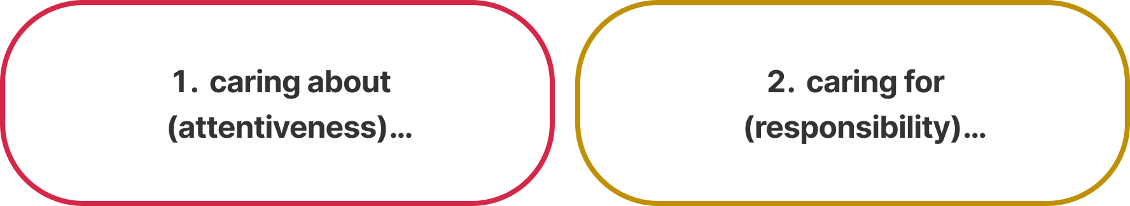
Figure 14 Caring attributes of Municipality of Amsterdam
The municipality of Amsterdam does not complete these acts of care itself, but provides care services so that individual citizens may complete these acts of care. This distinction is important because municipal planning establishes the conditions through which care can take place, while the actual practices of care are often carried out by individuals, organizations, and communities.
The care functions researched related to the City of Amsterdam planning department shows that there is fragmentation of care-related responsibilities. The decision making is distributed across different departments/actors, which is an important organizational dimension that influences care infrastructure. The tension that arises across all perspectives is due to organizational differences. According to project manager Laurie,
“we're pretty divided in departments who are doing this and that. And if you have a concept or you have advice for us as municipality, it does help if you point out that this would be an advice for a specific department or for a specific role as for landscape architects or more for project managers.”
This organization contributes to the lack of care related to competence and responsiveness needed to achieve care successfully. This is why it is necessary to look at the daily experiences in the city, where care giving and receiving are achieved.
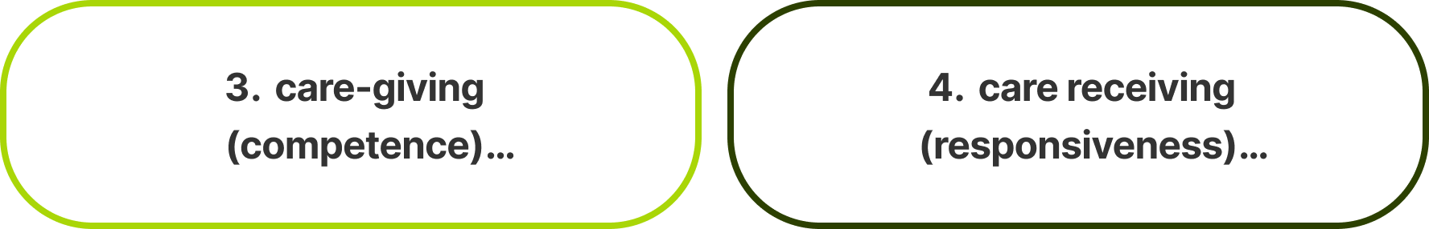
Figure 15 Caring attributes of care participants in outdoor spaces

Competence and Responsiveness not planned for
To conduct care work every day in the outdoor greenspaces, care work taken by individual caregivers towards care receivers was studied. This is the “actual care-giving work, that should be done with competence and skill,” using the right resources and services in a timely manner (Tronto, 1993; Dalmer & Campbell, 2020) for care receivers, who respond to the acts of care within the space. When observed and evaluated within the outdoors, however, the care work was not always sufficiently completed (Tronto, 1993).

The lived experiences of these caregivers and care receivers in outdoor greenspace reveal that the planned-for functions are not entirely suited for care practices. The care affordances and burdens that repeatedly arose during this research relate to physical structures and materials within public outdoor greenspaces, time, space, and financial constraints, feelings related to safety, social connection, and feelings of belonging and accessibility. One parent stated that
“the city increasingly feels commercialized and individualistic rather than community-focused. At the same time, Amsterdam still has many beautiful qualities for adults such as the cafés, canals, culture, and atmosphere. But for full-time parents with young children, the city can feel exhausting and difficult to navigate every day.”
This research finding relates to the modern crisis of care, as the daily experiences of caretakers of children are strained by the everyday infrastructure in the city, which the current planning practices do not seem to fully address.

Care infrastructure extends beyond boundaries of outdoor care sites
Related to care infrastructure, care mobility is a theme that arose repeatedly across all three perspectives. The everyday experiences of caregivers as they navigate the city to conduct care work showed that there were many burdens on the journey from private homes to public outdoor space, such as increased stress navigating the streets to get to and from greenspace, feelings of danger in relation to car and bicycle traffic and trash, and awareness of the time and physical effort spent traveling to and from outdoor spaces. While care mobility is mentioned as a concept to improve upon in planning efforts, current concerns focus primarily on female safety efforts (see 4.3.1). More holistic care efforts, such as the day-to-day experiences within parks as people conduct care for each other and more-than-human life, receive less explicit attention. Care mobility is not just about whether a caregiver can physically reach a green space safely; it includes whether the spatial and temporal organization of the city makes that journey manageable for the realities of care work.

The spatial and temporal conditions of care mobility
As care work is situated within certain temporal and spatial conditions, this is particularly relevant for experiences of caring for children. In relation to care for children, which is based on personal preferences and decisions taken by caretakers, many participants described adjusting when they visit outdoor spaces according to weather, their own schedules, and the routines of their children. For example, during periods of high heat, parents preferred to visit in the evening, while heavy rain could prevent or delay a visit. The parents interviewed that care for young children also avoid the park during certain times of the weekdays when they know the school children from the surrounding elementary schools will be in the park. The scheduling of the photo journeys similarly demonstrated this temporal flexibility. Several journeys had to be rescheduled because a child was sick, weather conditions were poor, or parents' schedules changed. It was important to be accommodating and flexible as care work is personal for both the caregiver and care receiver and is often shaped by circumstances that caregivers cannot fully anticipate or control. These temporal negotiations demonstrate that the capacity to use outdoor green space for care depends not only on the physical qualities of the space or the journey to it, but also on whether its use can be accommodated within the changing responsibilities of everyday care.

Municipal response to care burdens
This reflects the clash between the care work that is conducted at the municipality and the care that is needed to address the current crisis of care in the city. The actions of the municipality that delegate funding and goals across different departments reflect attentiveness and responsibility, but the findings suggest limitations in responsiveness when care burdens are brought up, as seen with the case of the Sarphati Park volunteer group, where the leader shared that they lack communication and “follow-up” by the municipality when concerns within the park regarding broken equipment, fallen trees, trash, etc. are brought up. Whether this lack of follow up be due to overstaffing, budget, or simply lack of accountability due to the siloed structure of the departments, is not confirmed though in this research.
The concerns in the municipality show that care-full planning practices here are more so related to delegation and coordination. As Binet et al. ( 2023, p. 291) argue, many of the strategies that can support urban infrastructures of care, including expanding green space and improving access to public transit, are already established planning priorities. The challenge is therefore “one of coordination as much as it is one of innovation.” This reflects the findings of this research, where accessibility, green space, safety, mobility, and social services are each addressed through existing municipal practices but are not always coordinated around the everyday needs and experiences of caregivers. The concerns raised by the Sarphati Park volunteer group, for example, demonstrate how care burdens can persist despite existing municipal goals and resources, when communication and follow-up between community actors and the municipality are limited. In this sense, the issue is not necessarily that care is absent from municipal planning, but that care is fragmented across planning priorities, departments, and responsibilities.
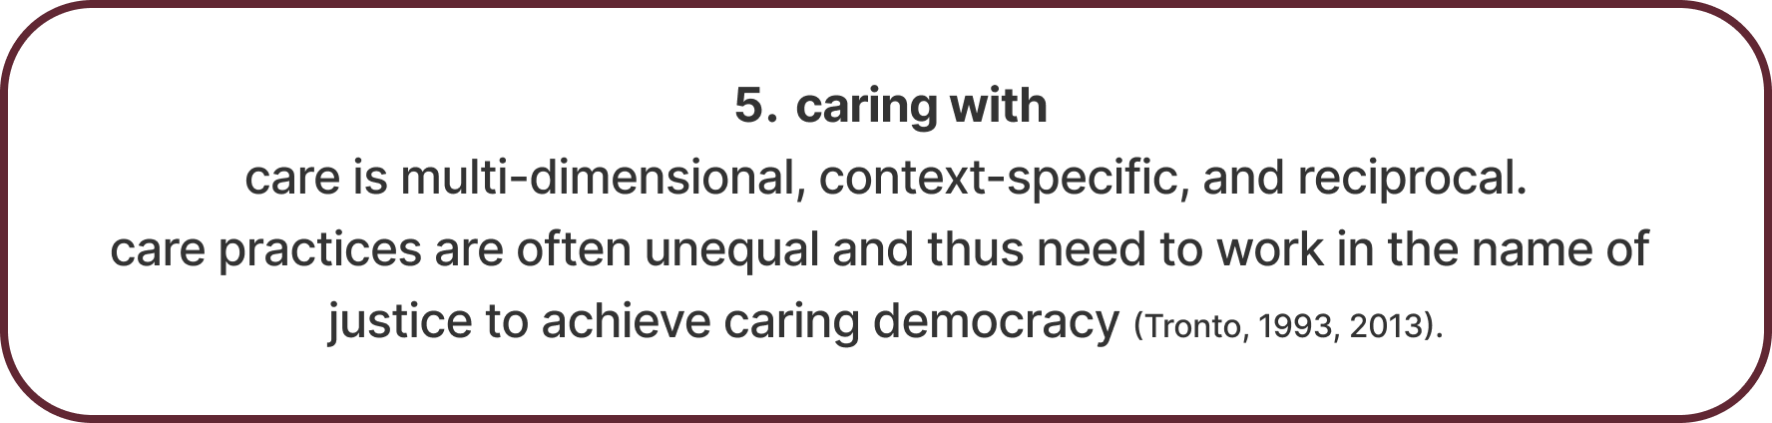
Figure 16 Caring attributes of care spaces in cities

Lived experiences: “Caring with” in practice
The lived experiences of care participants within the “care space” organizations also differ from those concerned with the municipality, as care is not one-sided but reciprocal between care participants, and between the care space organizations and the attendees. Based on interviews with the playgroup leader, the playgroup director, and observations of parents, caregiving requires active presence, empathy, and maintaining emotional boundary management. Providing care in diverse urban contexts requires empathy, active listening, and openness across cultures and backgrounds. According to the playgroup leader Loubna,
“You do it with your body, with your spirit, with your soul, with everything... your mindset has to be like open for other thoughts and other religions and other cultures... Always listen to somebody, even listen to somebody's body language.”
Developing emotional boundaries is also important in care work, as caregivers and practitioners alike undergo a learning curve to manage stress and avoid caregiver burnout.
“Everybody has his (baggage), but you have to know what happens at work stays at work, because if you bring it home with you, you're gonna be sick of it... I've learned a lot” (Loubna, via interview, 2026).
This value of care being uneven based on one’s ability to offer and receive care at different times and with different energy levels is reflected in Tronto’s notion of “caring with” as an important phase of care to consider for a “caring democracy” (Tronto, 2020; Williams, 2017) in cities. These care groups allow space for tolerance and differences in care work, demonstrating that care is relational and requires the capacity to both provide and receive support. To address the crisis of care that many parents feel, this is important to consider, as parents often feel overwhelmed and lack the capacity to conduct care on their own without an adequate support system in the city. Together, these findings demonstrate that care infrastructure cannot be understood only through the services or spaces planned and provided by institutions; it also emerges through the everyday relationships, adaptations, and reciprocal practices that occur within these spaces. These experiences contribute to the second tension, between care spaces and municipal organization that is not currently structured to include the ethics for “caring with” to occur.

Tension 2 “Care spaces” as organizational infrastructure of care in the city
While outdoor space in Amsterdam create spatial conditions for care to occur in public, organizations such as Dynamo and MidWest may be necessary to activate and maintain these caring functions on a day-to-day level. The interviews conducted indicate that different forms of care can come into conflict during implementation. For example, decisions concerning safety, biodiversity, recreation, accessibility, and maintenance can require different interventions or priorities. This means that municipal planning is not only about providing care functions, but also about negotiating between different understandings of what needs to be cared for, to be a truly caring city.
The two care space perspectives examined in this research are not directly part of the municipality, as they are both nonprofits and therefore separate entities. While Dynamo as a care space is more connected to the municipality through its direct funding and decision making, it is intentionally separate. This is considered an advantage according to the director of the playgroups Ineke, who said that this distance allows for more trust in the organization at a local community level (see Section 5.4.3.1).
The second care space perspective is Midwest, which is operated entirely separate from the municipality. This separation seemingly allows them to focus on an approach to care work that is more flexible and adaptive to the needs and desires of the community members. In the beginning, Midwest operated as a nonprofit out of the building that was still owned by the municipality. Ultimately though they purchased the building from the municipality to continue the initiative there. Though it was not ideal for the founder at the time, it ultimately allowed them to also have more ownership and control over the social services and activities offered. Ownership of the physical facilities also allowed for investments for spatial improvements of both the indoor and outdoor spaces. The only tie Midwest now has to the municipality is indirectly via funding and grants for various programs that are held in the building by partner organizations and community members. The physical, social, and organizational functions at Midwest allow for functions of a “caring democracy” to occur. This may be due to the smaller scale, as this is not easily possible within the municipality that is both large and siloed. However, both Midwest and Dynamo can be considered two care spaces that serve as a bridge to “care-full planning” within the city, as caring for democracy is more easily represented in smaller community groups at the neighborhood level rather than at the city level given the organizational structure of City of Amsterdam (Müller et al., 2025).
With Midwest though, personal capital and initiative for change allows for quick changes and more impact on a personal level when compared to the municipality. Dynamo serves as a medium, as it is funded by municipality but not able to make their own decisions regarding where money goes. Overall, most challenges and tensions recognized within the municipality attempting to create social care are related to issues with funding and organization rather than interest or knowledge.

Tension 3 Caring for Multispecies Entanglement: Human care vs. more-than-human care
One of the key tensions that arose in each perspective of outdoor space as care infrastructure in Amsterdam is related to the care for human life versus more than human life. In perspective one, which focuses primarily on care for young children via the Dynamo playgroup, the caregivers prioritized the safety of the children (the care receivers) over the nature and wildlife that they were interacting with in the outdoor environment. However, at Midwest many of the involved community members were very conscious and intentional regarding the relationship between human and more than human life. The gardener and founder explained that the gardens were designed as a celebration of the full life cycle of living things. This approach to care in the outdoor greenspaces is not one that prioritizes human interaction with the space above the natural processes in the space but rather focuses on working, or caring towards, a balance between the functions. Through these actions, care was conducted as an act of observation, maintenance, and continuously adapting to adjust to changing needs of the wildlife (more than human life), and the human life that interacted with it. This form of care is possible at a smaller, more initiate scale such as Midwest but is difficult on larger scales such as city parks planned by the municipality.
Plans for city parks in Amsterdam have designated goals of “human recreation, socialization, and health (City of Amsterdam, 2024). While more than human life is addressed indirectly through the planning of city parks, as it contributes to human health and climate adaptation measures, this is not a key priority in these spaces. Often, it conflicts with care for human life as people have their own views of what is considered a safe or neat park regarding garden and maintenance practices, such as the example of the shrubs being trimmed back for citizen concerns of safety, which is not good for the birds and other wildlife that rely on the shrubs for sustenance or habitats. According to a project manager from the Spatial Planning Department, more than human life could be cared for better in planning decisions via a representative. Equal representation for the “rights of nature” has been a recent concern in planning, often being addressed via a spokesperson that serves as representative for nature in the government in various democratic processes such as citizen assemblies, where citizens voice their concerns and desires in the municipality regarding planning decisions (Laurie, 2026). There are some initiatives in the Netherlands that the gardener of Midwest himself has been involved in (Zoönomic Institute, n.d.). While it is not established within the municipality of Amsterdam, the focus on green initiatives due to the current political climate of the city signifies that there is more discussion regarding how to address care for more than human life in a more balanced way when compared to human life.

Tension 4 Financial structure and crisis of care
Across all three perspectives, the financial cost of care was brought up by individuals interviewed. In perspective one, participants of the playgroups as well as employees brought up the cost of childcare as being somewhat inaccessible in the Netherlands, even with the subsidies offered by the government. Parents interviewed, often women, mentioned that the cost of childcare contributed to their decision to stay at home and care for their children rather than sending their children to formal care centers. This concern about the cost of childcare is reflected in OECD data on net childcare costs, which account for childcare fees after benefits and subsidies. In 2021, net childcare costs for a couple with two children using full-time center-based childcare were equivalent to 22% of average earnings in the Netherlands, compared with 11% in Denmark and 1% in Germany (OECD, 2025). The financial structure of formal childcare can influence how families organize care, potentially shifting care from formal institutions back into the private household. Part of Dynamo’s mission outside of the free playgroups is to connect parents with formal support to apply for subsidies available to them, showing that it is somewhat inaccessible without prior knowledge of the system.
As an organization, the financial structure of Midwest was crucial to keep it running after the municipality no longer wanted to rent it out. This structure relied on the founder’s ability to find private funding via personal connections, and ensure there was enough revenue from sales to fund the free social programs held there. This demonstrates how the provision of free care-oriented programs can depend on other forms of income and private financial capacity. Regarding maintenance of the gardens and the facilities, the unique ownership structure allows for the building organization to pay the nonprofit social foundation for upkeep, so that the nonprofit can be self-sufficient regardless of earnings related to their various activities. This allows for the security of the organization from external influence such as with Dynamo where the funding allocation from the municipality also dictates their decisions as an organization.
Similarly, the municipality’s ability to fund more recent green initiatives and maintain the physical infrastructure in city parks and other public spaces relies on the funds allocated to these care practices. While currently the administration is more “left-leaning” and “green-focused,” this is not always the case, and priorities can shift depending on which aldermen are in office. Pressure from citizens allows for some changes, but the continuation of care-oriented infrastructure remains dependent on political priorities and available funding.
Across the three perspectives, financial structures therefore influence both access to care and the ability to sustain care infrastructure. At the household level, the cost of formal childcare can shape how care is organized within families. At the organizational level, neighborhood-level care spaces may depend on private funding, revenue-generating activities, and the financial capacity of individuals or organizations. At the municipal level, the maintenance and development of care infrastructure depend on political decisions about where limited public resources are allocated. This creates a tension between the recognition of care as necessary to support life, and the financial structures through which care is provided. Care practices require ongoing investment, maintenance, and labor, but these forms of work are not always treated as infrastructure or prioritized in financial decision-making. The findings therefore suggest that the crisis of care is not only a question of whether or where care spaces exist in Amsterdam, but also whether the financial and political structures exist to make these spaces accessible, and sustain these spaces over time.

Wage-labor: Financial restraints related to time
Financial and time constraints emerged as primary barriers for caregivers, driven by the competing time and energy demands of full-time income generation, termed "wage labor" by ecofeminist scholars (Dengler et al., 2025, p. 870). This structural limitation directly impacts community-led care spaces such as those researched in this paper. For example, operations at MidWest’s Plantenwinkel rely heavily on unpaid volunteer labor (personal communication, 2026), with the organizer receiving only part-time municipal compensation. Similarly, active membership in the Sarphatipark association consists predominantly of retirees, and there are almost no volunteers that are parents with young or school-aged children (volunteer director, via interview). According to a municipal employee, the ability of citizens to raise concerns with the municipality is also related to time and knowledge of how to voice concerns, which reflects why most of the actively involved citizen groups are in districts are the ones with higher education levels and earnings. These findings align with ecofeminist arguments that the demographic homogeneity often observed in care for more-than-human life, such as community gardens and city park volunteer maintenance initiatives, is less a matter of selective interest and more a function of socioeconomic capacity. Because these activities remain largely underfunded, engagement requires discretionary time that working caregivers typically lack. Improving inclusive participation and accessibility in Amsterdam’s outdoor care spaces thus necessitates consistent financial backing to alleviate “wage labor” so that more people can take part in it. This would require a structural change though in the municipality, where funding is often reliant on the political agenda of the current councilmen. According to one employee in the department of planning, there is funding for green initiatives due to the current administration being more left leaning, but priorities in funding delegation are influenced often by political agendas. Furthermore, at the time of the interview the budget cuts were about to be announced, which often pauses projects. Maintenance of green is known to be understaffed and funded, which is why volunteer groups are needed. This is a direct result of the municipal structure.

Limitations
Several methodological and practical limitations should be considered when interpreting the findings of this study.

Sampling and Scope Adjustments
First, scope and recruitment constraints necessitated adjustments to the initial research design. While the study originally aimed to compare three distinct neighborhoods to ensure demographic diversity, recruitment challenges, particularly among unpaid child caregivers, required narrowing the focus to just two cases (perspective 1 Dynamo and perspective 2 Midwest). Recruiting unpaid caregivers posed significant hurdles due to time limitations and the high relational trust needed for the walking-journey research method. Consequently, the research focus was reframed toward a deeper exploration of "care spaces," incorporating organizational and institutional dimensions alongside social and physical functions. Additionally, key institutional perspectives (e.g., municipal maintenance and playground planning departments) were difficult to access, leaving some administrative viewpoints underrepresented.

Methodological Inconsistencies and Analytical Subjectivity
Second, variations in experiential mapping techniques across participant groups may have affected data comparability. To accommodate participants' varying schedules and capacities, mapping exercises could not be standardized or repeated. At Midwest, inconsistent base maps were used for care route mapping, complicating cross-case spatial analysis. Furthermore, categorizing mapping outputs into physical and social functions relied heavily on researcher interpretation, introducing an element of subjectivity. While deductive coding structured the analytical framework, inductive coding was used to capture unexpected themes, which also may introduce researcher bias.

Language Barrier and Selection Bias
Third, language barriers introduced a potential selection bias. Due to the primary researcher’s limited Dutch proficiency, participation was restricted to English-speaking caretakers and staff. In the Dutch context, language proficiency often correlates with socioeconomic status, educational background, or migrant background. Relying on English-speaking referrals (such as at Dynamo) may therefore exclude the perspectives of non-English-speaking caregivers, limiting the generalizability of the socio-spatial findings across Amsterdam’s broader population.

Future Research
To build upon these findings, future research should use longitudinal experiential mapping over extended periods and incorporate multilingual and more inclusive recruitment strategies to capture a broader range of care experiences, and across more diverse urban demographics. While this research looked primarily at caregivers of children as one perspective, future research could examine the experiences of other groups most burdened by the “crisis of care,” that are engaged in care practices, such as those involved in care practices with: older adults, migrants, people that are physically or mentally disabled, and others whose experiences may be shaped by different social, cultural, and spatial conditions.
Future research into care-full planning practices in Amsterdam would also benefit from examining the Municipality of Amsterdam’s planning framework through a comparative lens, contrasting its policy mechanisms with those of cities that have more explicitly incorporated care and gender equity into their urban planning practices. Exemplars such as Bogotá’s District Care System (Sistema Distrital de Cuidado), which clusters local services to relieve time poverty among informal caregivers, and Barcelona’s human-centered spatial interventions offer valuable examples for different approaches on how to integrate care into urban planning and governance (Bayas Fernández & Bregolat i Campos, 2021; Müller et al., 2025).
Additionally, municipal experts in Amsterdam focused on gender-inclusive planning highlight Vienna as a relevant European comparative case due to its decades-long application of gender mainstreaming in public space design and housing allocation (see Klimmer-Pölleritzer & Nuss, 2013). Conducting a comparative spatial and institutional analysis between Amsterdam, Vienna, and other cities incorporating care into their urban governance approaches could explore how different municipal organization and planning practices shape the provision of physical and social care infrastructure.
Regarding the care functions of outdoor green space, further research on the entanglement of human and more-than-human care could examine gardening and maintenance as a practice of care, as well as the implications of rights-of-nature approaches within Amsterdam. This could provide insight into how everyday interactions with plants, soil, wildlife, and other forms of urban nature intersect with practices of caring for human and more-than-human life.
Finally, while this research examined selected care spaces and the practices and experiences occurring through them, comparative research across a wider range of care spaces in Amsterdam could allow further clarification as to how different spatial, organizational, and institutional conditions shape care practices. Examining a broader range of initiatives could reveal both common characteristics and important differences in how outdoor green spaces function as infrastructures of care, and could help identify the conditions under which these spaces support more democratic practices of caring.

Conclusion
To address the modern “crisis of care” through planning efforts of outdoor green spaces, care cannot be addressed only through individual policies concerning accessibility, safety, mobility, or greenery as it currently is in the municipality of Amsterdam. Instead, it requires analyzing green spaces as an urban infrastructure of care. Through two different case studies in Amsterdam that represent care for children and care for more than human life, this thesis determines that while the physical qualities of outdoor green spaces in Amsterdam shape the potential for care, their caring capacity is also produced through social relationships, organizational structures, mobility networks, and institutional and financial conditions of the current planning practices that constrain them.
This thesis extends existing research on urban care by bringing together three dimensions that are typically considered separately: the organized spaces in which care takes place (care spaces), the material conditions that facilitate or constrain care (the physical and social care functions), and the people who give and receive care (the care participants). The findings demonstrate the relevance of this perspective about care in outdoor green space, where the organizational and spatial-temporal conditions influence people's capacity to give and receive care, and through an ecofeminist approach, how the entanglement of human and more than human life results from this care work.
This research contributes to the growing field of research on care-full urban planning by examining the relationship between planned and experienced urban infrastructure of care (Binet et al., 2023). The findings highlight the importance of connecting lived experiences of care to planning processes, expanding the scope of care in public spaces to include mobility as a care networks, supporting community-based organizations that activate care locally as care-collectives, and considering more-than-human interests alongside human needs. In doing so, the research demonstrates that the capacity of urban green space to function as infrastructure of care cannot be assessed through physical accessibility or the provision of green space alone. This also contributes to an understanding of care as a public and collective planning concern rather than solely an individual or private responsibility. As Williams (2017) argues, a feminist ethic of care can act as “a transformative ethic that can guide our thinking about what constitutes the just city” (p. 821).
In answering how outdoor green spaces function as urban infrastructures of care in Amsterdam, this research demonstrates that their caring capacity is relational, situated, and sustained through both material and social conditions. Understanding these relationships makes visible the unequal experiences through which care is conducted in the city and opens possibilities for planning more just and “care-full” urban spaces.

Declaration and Acknowledgements
Declaration
I acknowledge the use of AI (chatgpt) in this research paper to help with the transcription of interview audio files, and to organize interview findings into prompted categories. It was also used to check some sections for grammatical and spelling errors in the writing of this report.
A record of prompts and outputs is available upon request.

Acknowledgements
Thank you to my supervisors for their continued support as I wrote my first thesis. Though I doubted my own research capabilities and struggled to balance the workload at times with my other responsibilities, they supported me through the process and had confidence in my results, even at times when I did not grasp it myself.
Thank you to the De Pijp Spelinloop for allowing me to attend the sessions and to Loubna for her warmth and openness. Thank you to the parents and their children from the group for their time and knowledge of the city as care infrastructure. Allowing me into your homes to spend time with you navigating (to and from) the neighborhood playgrounds was incredibly insightful for my research.
Thank you to Midwest and everyone involved for speaking with me and allowing me to observe, record, and organize a cocreation session in your neighborhood space. Thank you especially to the founder Anita for an inspiring and informational interview, and to Sofie for helping me organize my research despite her own busy schedule over the summer.
Last, thank you to my parents for supporting me and my choice to study so far from home in a country where everything has been new, challenging, and rewarding.

References

Literature Review
Alam, A., & Houston, D. (2020). Rethinking care as alternate infrastructure. Cities, 100, 102662. https://doi.org/10.1016/j.cities.2020.102662
Bayas Fernández, B. & Bregolat i Campos, J. (2021). Ecofeminist proposals for reimagining the city: Public and community paths. Observatori del Deute en la Globalització. https://odg.cat/wp-content/uploads/2021/10/Ecofeminist_cities.pdf
Binet, A., Houston-Read, R., Gavin, V., Baty, C., Abreu, D., Genty, J., Tulloch, A., Reid, A., & Arcaya, M. (2023). The Urban Infrastructure of Care: Planning for Equitable Social Reproduction. Journal of the American Planning Association, 89(3), 282–294. https://doi.org/10.1080/01944363.2022.2099955
Clement, S., & Waitt, G. (2017). Walking, mothering and care: A sensory ethnography of journeying on-foot with children in Wollongong, Australia. Gender, Place & Culture, 24(8), 1185–1203. https://doi.org/10.1080/0966369X.2017.1372376
Davoudi, S., & Ormerod, E. (2025). ‘Care-full’ planning: Towards an ethics and politics of care in planning. Planning Theory, 14730952251331242. https://doi.org/10.1177/14730952251331242
De Haas, W., Hassink, J., & Stuiver, M. (2021). The Role of Urban Green Space in Promoting Inclusion: Experiences From the Netherlands. Frontiers in Environmental Science, 9, 618198. https://doi.org/10.3389/fenvs.2021.618198
Dengler, C., & Lang, M. (2022). Commoning Care: Feminist Degrowth Visions for a Socio-Ecological Transformation. Feminist Economics, 28(1), 1–28. https://doi.org/10.1080/13545701.2021.1942511
Dengler, C., Völkle, H., & Ware, S. (2025). Time and space for social-ecological transformation: Care-full commoning in and beyond the ecofeminist city. Environmental Politics, 34(5), 861–881. https://doi.org/10.1080/09644016.2024.2411934
Forstner, A., & Kainrath, M. (2013). Manual for Gender Mainstreaming in Urban Planning
and Development. Urban Development Vienna, City of Vienna.
Hartig, T., Mitchell, R., De Vries, S., & Frumkin, H. (2014). Nature and Health. Annual Review of Public Health, 35(1), 207–228. https://doi.org/10.1146/annurev-publhealth-032013-182443
Karsten, L., Kamphuis, A., & Remeijnse, C. (2015). ‘Time-out’ with the family: The shaping
of family leisure in the new urban consumption spaces of cafes, bars and restaurants. Leisure Studies, 34(2), 166–181. https://doi.org/10.1080/02614367.2013.845241
Morrow, O., & Parker, B. (2020). Care, commoning and collectivity: From grand domestic revolution to urban transformation. Urban Geography, 41(4), 607–624. https://doi.org/10.1080/02723638.2020.1785258
Müller, H., Huning, S., & Böcker, N. (2025). Caring Cities: Towards a Public Urban Culture of Care? Urban Planning, 10, 10016. https://doi.org/10.17645/up.10016
Nelischer, C., Loukaitou-Sideris, A., & Wendel, G. (2025). Caring public space: Advancing justice through intergenerational public space design and planning. Journal of Urban Affairs, 47(8), 2789–2808. https://doi.org/10.1080/07352166.2023.2291074
Pellerey, V., & Giezen, M. (2024). More green but less just? Analyzing urban green spaces, participation, and environmental justice in Amsterdam. Journal of Environmental Planning and Management, 1–35. https://doi.org/10.1080/09640568.2024.2406858
Privitera, E. (Lizzy). (2025). Planning ahead: Toward a critical, environmental, just, and action-oriented planning theory, practice, and journal. plaNext–Next Generation Planning, 15. https://doi.org/10.24306/plnxt/116
Rekacewicz, P., Mandler, T., Cordero, D., Echague, P. A. A., Hardon, A., Pauchano, B., Pelagio, S., Rios Sandoval, M., & Tan, M. L. (2025). Mapping everyday urban political ecologies: Experiential cartography as embodied methodology. Urban Political Ecology, 1(1–2), 88–117. https://doi.org/10.1177/30497515251364723
Rivano Eckerdal, J., Engström, L., Färber, A., Hamm, M., Kofi, J., Landau-Donnelly, F., & Van Melik, R. (2024). Social infrastructuring in public libraries: Librarians’ continuous care in everyday library practice. Journal of Documentation, 80(7), 206–225. https://doi.org/10.1108/JD-12-2023-0260
Tabassum, M. (2025). Understanding urban green spaces through lenses of sensory experience: A case study of neighborhood parks in Dhaka city. The Senses and Society, 20(1), 62–94. https://doi.org/10.1080/17458927.2024.2392960
Tronto J.C. (1993) Moral Boundaries: A Political Argument for an Ethic of Care. New York:
Psychology Press.
Tronto J.C. (1998) An ethic of care. Generations 22(3): 15–20.
Tronto, J. C. (2020). Caring Democracy: Markets, Equality, and Justice. New York University Press. https://doi.org/10.18574/nyu/9780814770450.001.0001
Williams, M. J. (2017). Care‐full Justice in the City. Antipode, 49(3), 821–839. https://doi.org/10.1111/anti.12279

Desk Research
Berends, S. (2021). Dutch child benefit scandal: Origin and latest developments (ESPN Flash Report No. 2021/51). European Social Policy Network, European Commission.
Carter, A. (2025, April 25). Types of childcare in the Netherlands. IamExpat.
https://www.iamexpat.nl/education/early-childhood-education/types-childcare-netherlands 
City of Amsterdam. (2023). Amsterdam maakt ruimte: Koersdocument. https://openresearch.amsterdam/nl/page/101669/amsterdam-maakt-ruimte---koersdocument
City of Amsterdam. (2022). Citizens’ assemblies. In City of Amsterdam#https://www.amsterdam.nl/en/districts-neighbourhoods/citizens-assemblies/
City of Amsterdam. (2020, December 1). Groen in de stad in kaart. Onderzoek en Statistiek.
https://onderzoek.amsterdam.nl/artikel/groen-in-de-stad-in-kaart
City of Amsterdam. (2020). Groenvisie 2020–2050: Een leefbare stad voor mens en dier.
https://openresearch.amsterdam/nl/page/63897/groenvisie-2020-2050
City of Amsterdam. (2024). Monitor groen 2024 . Amsterdam.nl.
https://onderzoek.amsterdam.nl/publicatie/monitor-groen-2024
City of Amsterdam. (2026). Organisatie. Amsterdam.nl.
https://www.amsterdam.nl/bestuur-organisatie/
City of Amsterdam. (2017). Subsidy green in Amsterdam. In City of Amsterdam.
https://www.amsterdam.nl/en/housing/subsidy-green-amsterdam/
Kruyff, S., Nowakowska, Z., & Tol, Y. (2024). Ruimte voor iedereen: Wat we in Amsterdam
kunnen leren van het genderperspectief op de openbare ruimte. Strategieteam Verkeer en Openbare Ruimte, Gemeente Amsterdam.
Lundberg, T. (2016, September 4). Parents in the Netherlands use childcare more than rest of EU. IamExpat. https://www.iamexpat.nl/expat-info/dutch-news/parents- netherlands-use-childcare-more-rest-eu
Stichting Midwest. (n.d.). Wat. Retrieved August 4, 2026, from
https://www.inmidwest.nl/wat/
Statistics Netherlands (CBS) (2022, July 11). Childcare benefits for over 1 million children. Centraal Bureau voor de Statistiek. Statistics Netherlands. https://www.cbs.nl/en-gb/news/2022/28/childcare-benefits-for-over-1-million-children
OECD. (2025). Net childcare cost for parents using centre-based childcare, OECD data
explorer. Oecd.Org. https://data-explorer.oecd.org/vis?lc=en&df
Wat we doen - Dynamo. (2024, July 25). Dynamo. https://dynamo-amsterdam.nl/wat we-doen/
Zoönomic Institute. (n.d.). About. https://zoop.earth/en/page/946/about

Appendix

Perspective 1 Photo Journeys

Photo journey 1 Results
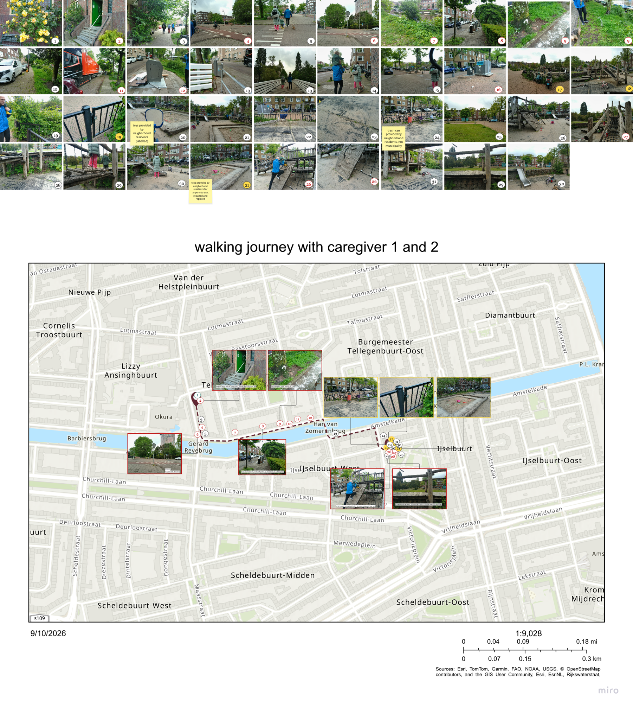
Figure 17 Caregivers 1 and 2 mapped photo journey route with care burdens and affordances

Photo Journey 2 Results
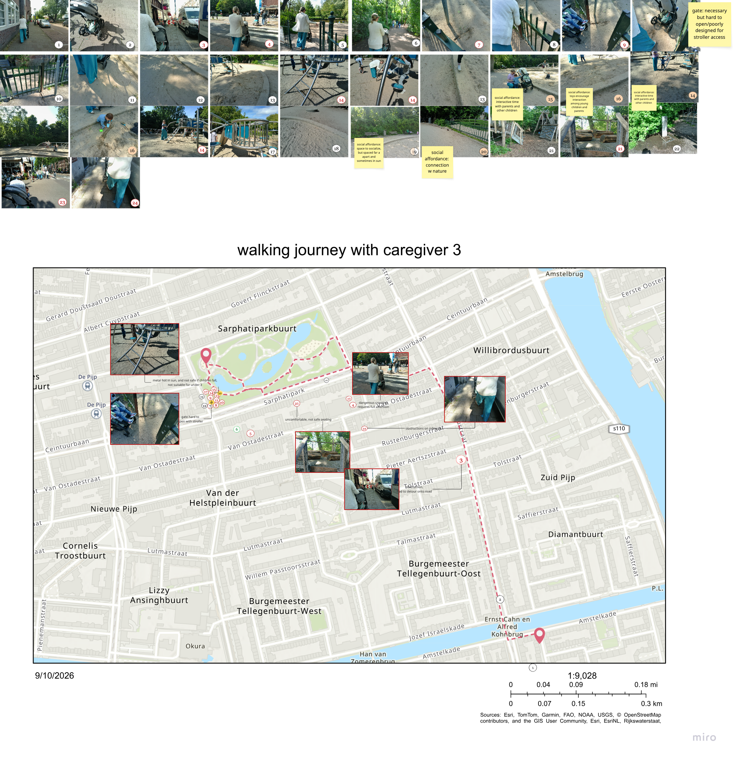
Figure 18 Caregiver 3 mapped photo journey route with care burdens and affordances

Perspective 2 Midwest Experiential Maps of Care Functions
From the cocreation session held at Midwest, the experiential mapping exercises show that the different gardens serve different purposes and through the design, elicit different feelings from people. The mapping through the spaces showed the physical functions, while the emotions felt in these spaces reflected how the social functions emerged through the space. The mapping also showed that the outdoor and indoor activities of humans and nature are entangled, and this is felt by people in the space. During the cocreation mapping session, Sofie mentioned when she first enters the indoor space of Midwest, she looks out both windows into the gardens to see the nature there and what activities are occurring. Yvonne also mentioned that she enjoys sitting outside, and the café staff will open the door to speak with her while they are inside working. According to the gardener, “People hold difficult conversations here. Families celebrate births here. There has even been a funeral here"(Theun, via personal communication, 2026). This is something that most likely cannot be conducted in city parks he said, as they are not private enough. But this serves as a crucial benefit for humans that cannot access private outdoor space of their own.
Cocreation participant 1 maps (top: care within Midwest, bottom: care route to Midwest)
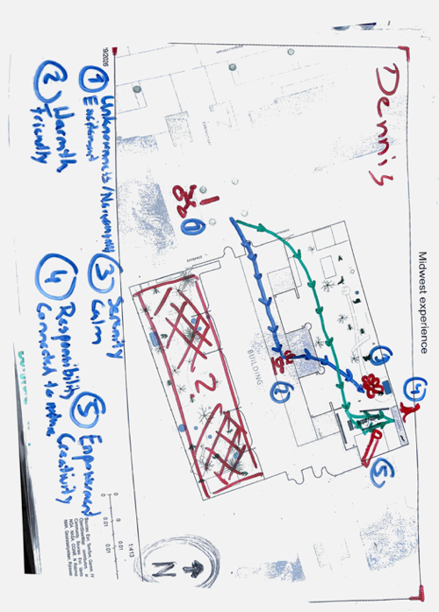

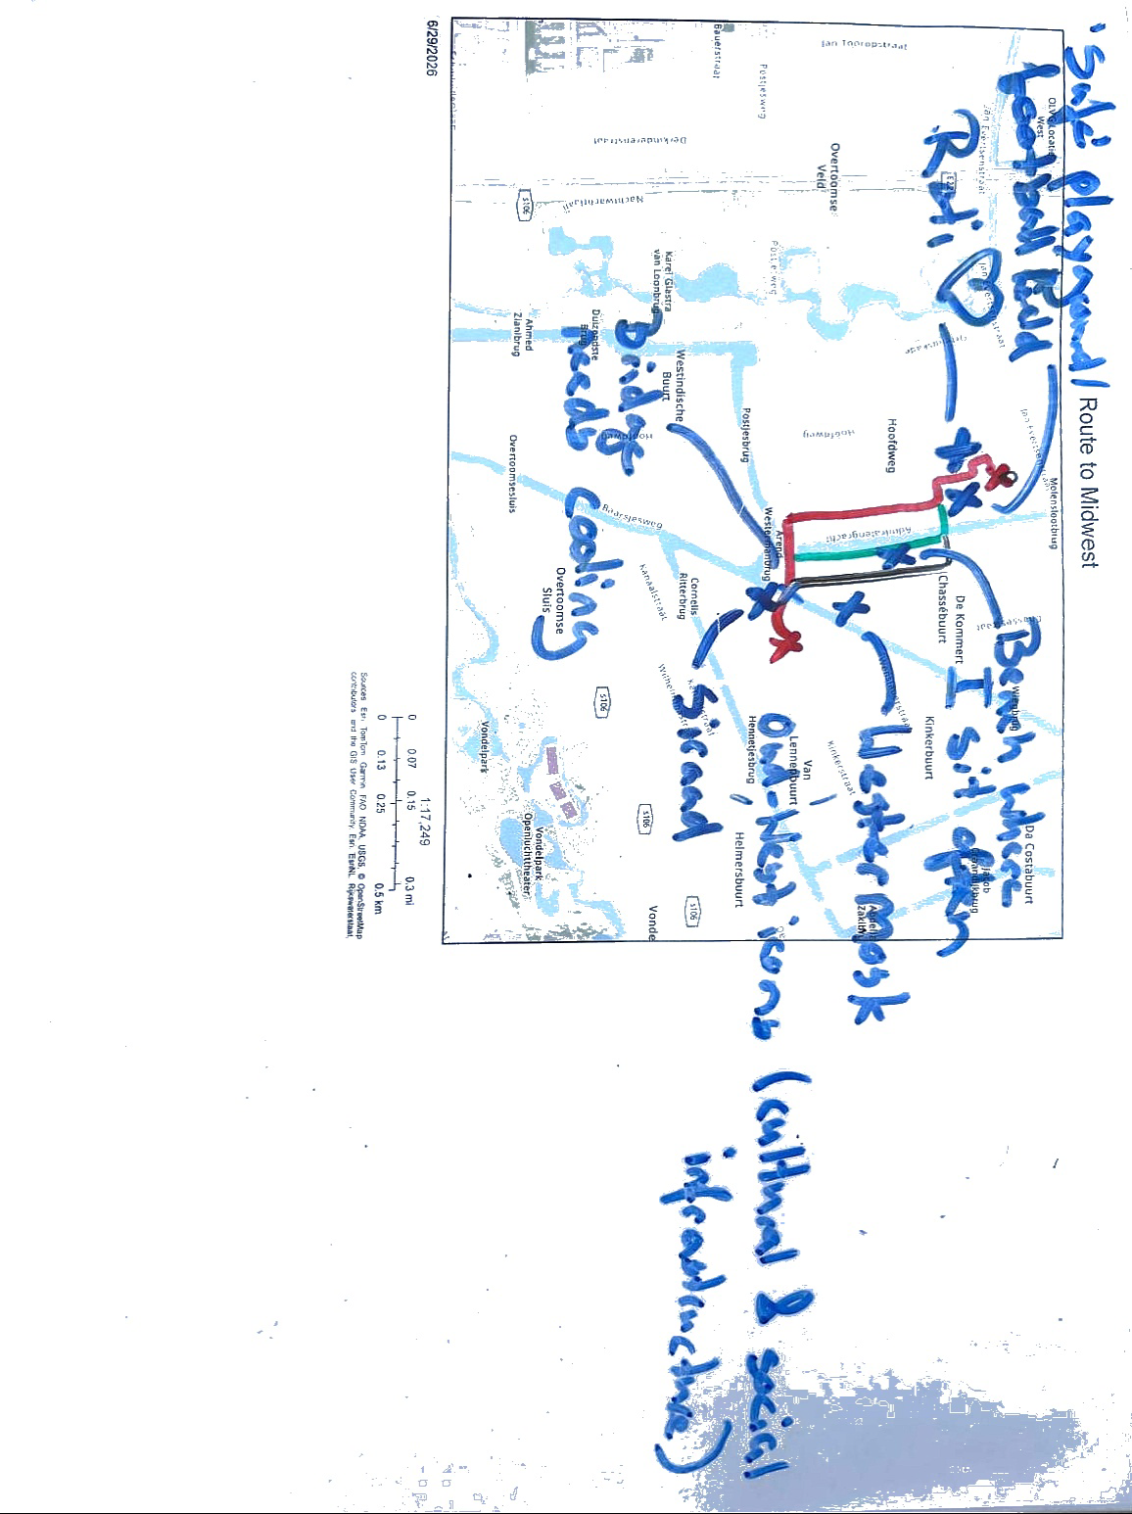

Cocreation participant 2 maps (top: care within Midwest, bottom: care route to Midwest

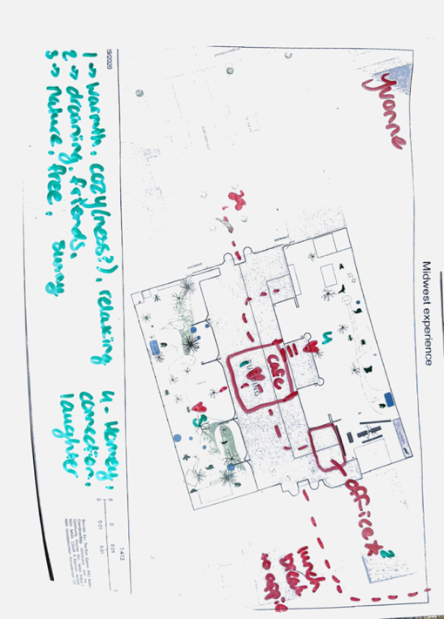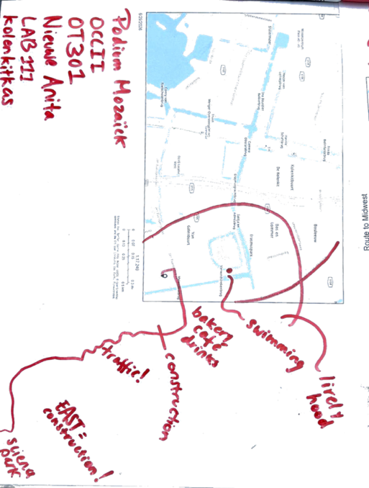

Cocreation participant 3 maps (top: care within Midwest, bottom: care route to Midwest)
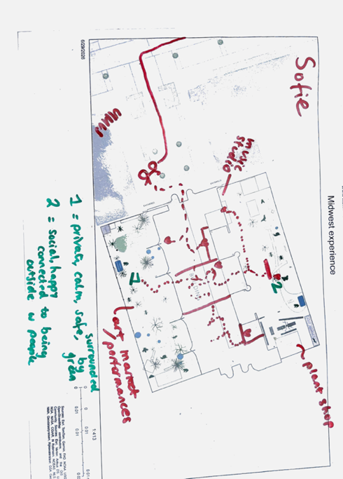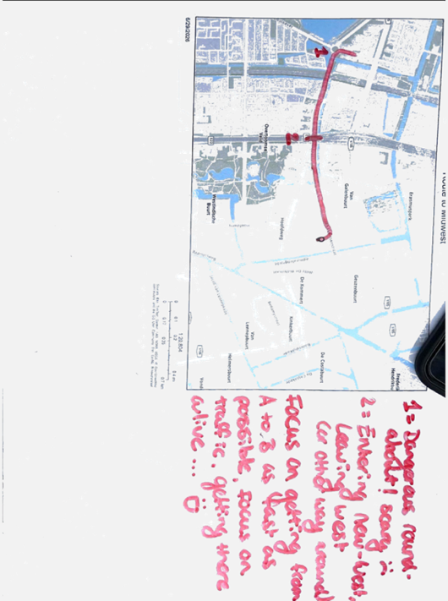

Individual Experiential Mapping Session with Participant 4
(top: care route to Midwest, bottom: care within Midwest; as seen in Figure 1

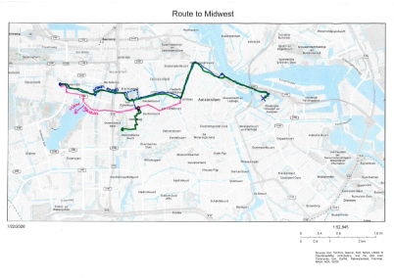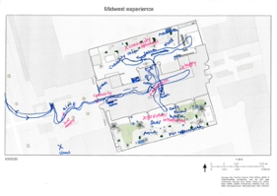

Dynamo Care Functions

Physical Care Functions
Physical care infrastructure identified: | Evidence/examples
Public restrooms  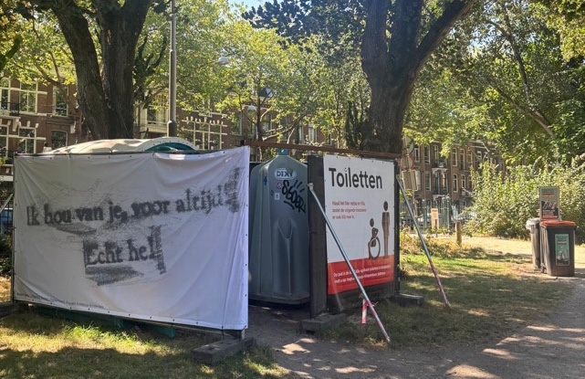 | The access to restrooms were mentioned heavily by the caregiver that was seven months pregnant, as her ability to access the toilet influenced how long she left the house, and if she could not make it home she would have to consider paying to use the toilet at a nearby café when she was out with her son. crucial for care of oneself, and of young children. Temporary toilets were not used by caregiver.
Seating/benches  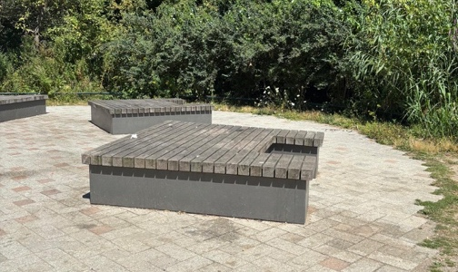  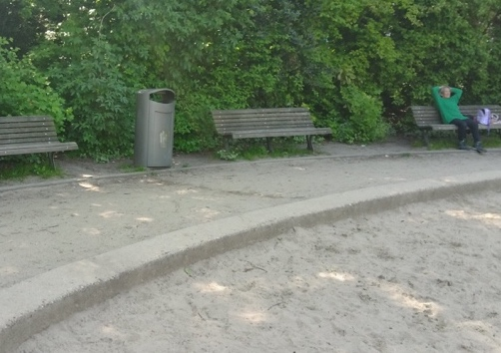 | Used often in all observed city parks for resting, socialization and to place items on. The materialities and configuration of seating structures provided such as tables and benches contribute significantly to the social aspects of the space.
Waste bins  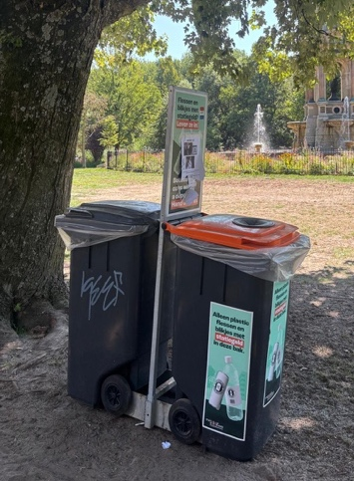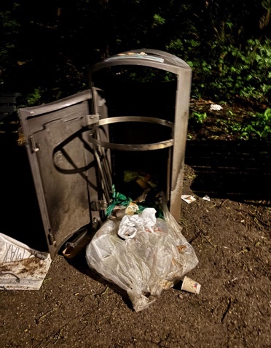 | Frequently used, but often in Sarphati park it was observed that these were left open- many times in public spaces people collecting them rummage through the trash and cause litter- related to statiegeld (bottle return) system in Netherlands. According to Sarphati park association volunteer lead, the trash bins are one of the main points of concern for members and the municipality. The municipality has implemented several different trash systems in the past to reduce littering in the park. He stated that so far, the most recent solution has been effective in reducing trash, as the trash bins are not as easily opened now, and they have installed more trash cans (personal communication, 2026). In Ijsselplein, there was a nonmunicipality issued trashbin within the gates that was placed there by local residents to fulfill the need for one.
Level, paved and wide sidewalks  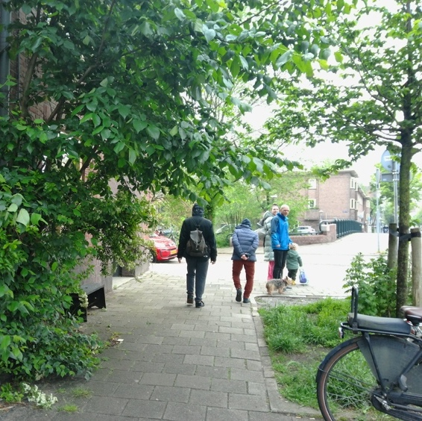 | accommodate caregivers pushing strollers and for young children walking together with parents safely off the busy and potentially unsafe streets are necessary for care work. Parent 1 and 2 walked together with their son and their elderly dog. They often had to stop to adjust to needs of their son and their dog. The dog was placed in a backpack and the son was carried at times when he did not wish to walk anymore on the approx. 700m walking journey from his house to the playground. Parent 3 felt that the sidewalks from her house to Sarphati park were mainly adequate for her journey, but occasionally there would be construction or automobiles parked on the sidewalk, making it more difficult to push the stroller. The main walking paths in the park were adequate for her to get to her destinations within the park.
Vegetative Cover: Living infrastructure including mature trees, shrubs, and open lawns providing shade, sensory stimulation, and space for play | As observed, also important for children’s development to interact with the vegetation.
Animals and Wildlife  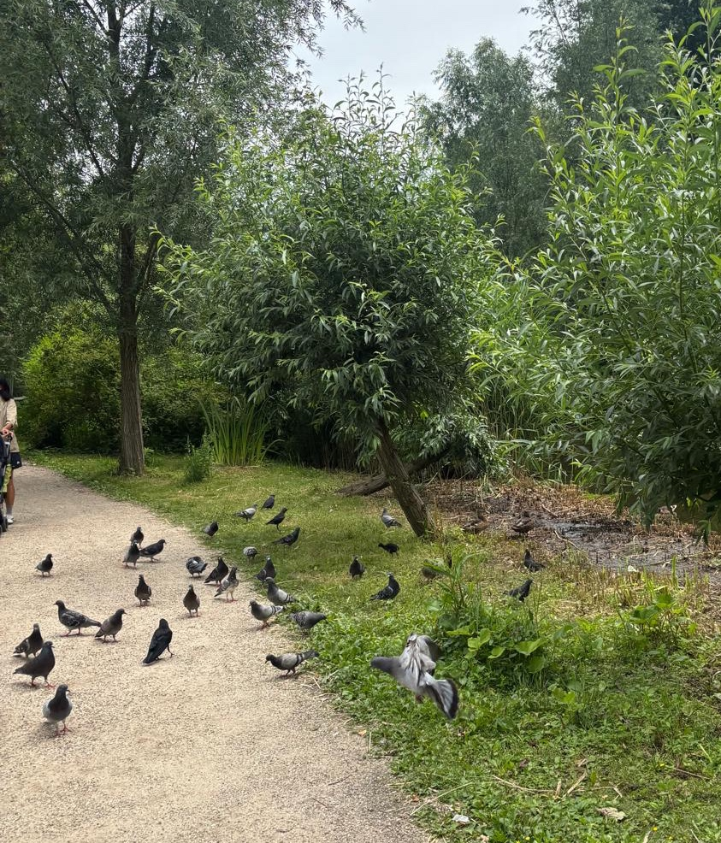 | It was common to see caretakers and children notice, and try to engage with animals and wildlife within the city park, such as birds and insects. The ducks and pigeons were often chased by children or pointed at by caretakers for children to notice. The playgroup also took the members to Artis and to the free petting zoo in De Pijp on excursions and mentioned the importance of this for their education and development (via observations and personal communication with Loubna, 2026). Parent 3 also often stops by the dog park as her and her son often enjoy watching the dogs play together.
Hydrological Elements:  Water bodies such as canals, ponds, and streams that serve as sensory focal points and are enjoyed visually, and audibly by caretakers and children alike | Many children would attempt to engage with the water features in the park such as the water fountains, which were deemed safe, but also the edge of the lakes and streams, which caretakers would take children away from for fear of them falling in. The water fountain by the dog area in the park often had puddles near them due to excess water, and many children were observed to engage in playing in it, as well as dogs.

Social Care Functions
Social care function | Description of function | Evidence / examples | Care implications
Social networking among caregivers | Provides a regular, accessible meeting point where parents/caregivers can meet others and develop relationships. | Parents 1, 2, and 3 became acquainted through the playgroup and socialize with their children outside of sessions. | Expands caregivers’ personal networks and reduces social isolation.
Connecting parents across social backgrounds | Encourages interaction between parents from different backgrounds and supports relationships beyond the playgroup. | The director described the group as a starting point for parents to meet outside the group, including through app/WhatsApp groups and park visits. | Builds informal support networks and social cohesion among caregivers.
Emotional support and reducing isolation | Creates a consistent social environment for caregivers who may otherwise experience loneliness or unfulfilled in social lives after becoming parents. | Parents described a lack of connection and support among parents in Amsterdam and feelings of isolation compared with their lives before having children. | Provides companionship, emotional support, and a sense of belonging.
Communication and continuity of care | WhatsApp groups facilitate ongoing communication between parents and Dynamo staff outside of playgroup sessions. | Parents share photos, updates about closures/openings, absences, travel, sick children, and information from Dynamo staff. | Maintains connections between sessions and makes the care network more flexible and responsive.
Maintaining relationships beyond the playgroup | Encourages parents to continue socializing after sessions and develop relationships independently of Dynamo. | Parents discuss where they will take their children to play together after the session; some go to parks together. | Extends the care network into everyday life and public space.
Informal peer support | Creates opportunities for parents to exchange information, experiences, and resources. | Dynamo staff occasionally share resources through the group chat; parents communicate about their children and activities. | Provides caregivers with practical knowledge and access to resources through their social network.
Community belonging | Creates a space where participants develop familiarity and a sense of connection with others in their neighborhood. | The director described Dynamo as being “sort of your neighbor.” Children aging out of the group are often acknowledged with thank-you messages and small celebrations. | Creates continuity, familiarity, and a sense of community around caregiving.
Child socialization | Provides children with regular opportunities to interact with other children in a shared environment. | Parent 3 described the playgroup as giving her son “social interaction.” Children interact during play and outdoor activities. | Supports children's social development while simultaneously creating opportunities for caregivers to connect.
Outdoor space as developmental care for children | Uses parks and other outdoor spaces as environments for children's physical, social, and educational development. | Children play physically, encounter wildlife, and explore outdoor environments; parks can provide children's first interaction with urban nature and wildlife. | Supports children's development while providing caregivers with shared places and activities through which to socialize.
Facilitating caregiver flexibility and ease | In-person relationships allow parents to spontaneously coordinate activities and continue socializing when time and weather permit. | Parents decide together where to take their children after the session. | Makes caregiving feel less isolated and creates flexible, informal forms of mutual support.
Addressing gaps in Amsterdam's childcare support network | Provides a free, structured alternative to paid playgroups and less successful attempts to socialize casually in parks. | Parent 3 had tried connecting with other parents in parks and paid playgroups but found these interactions limited and financially burdensome. | Helps compensate for perceived gaps in social connection and support for parents in the city.

Midwest Care Functions

Physical Care Functions
Physical care function | Description of function | Evidence/examples | Care implications
Provision of urban greenspace  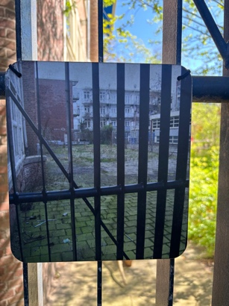 | Midwest transforms a previously paved, largely barren former schoolyard into a functioning green space accessible to people in the surrounding neighborhood. | The former outdoor space was described as a “stones and sand desert.” The garden was created through de-paving, planting, soil generation, and water retention. Mapping participants associated the gardens with “relaxation, connection, comfort, serenity, calmness, connection to nature” and good mental health. | Provides accessible everyday contact with greenery in a neighborhood where residents may have limited private outdoor space.
Providing restorative and emotional space | Different garden spaces provide opportunities for calm, retreat, reflection, and emotional restoration. | Nils: “And when I sit there, I feel very... It feels like a private area which just feels... calm and safe and like being surrounded by green. So for me, this is a less social garden." Mapping: gardens were associated with relaxation, serenity, calmness, and mental health. | Provides a physical environment for emotional restoration and temporary retreat from more active urban environments.
Supporting intimate emotional care | Gardens provide a setting for social interaction and significant personal or communal activities that require a more intimate environment than a public park. | Theun: “the garden now supports people in ways that indoor spaces cannot. People hold difficult conversations here. Families celebrate births here. There has even been a funeral here" | Demonstrates that outdoor space can support different forms of relational and emotional care, including difficult conversations, celebration, mourning, and community gathering.
Providing a semi-private alternative to public greenspace | The garden combines access to nature with a degree of privacy and familiarity that is not typically available in public parks. | Theun: “the garden now supports people in ways that indoor spaces cannot.” Nils: described the south garden as a “private area” that feels “calm and safe.” | Creates a form of semi-private outdoor care infrastructure for residents who may not have access to private gardens.
Entanglement with nature | The garden incorporates grasses, fruit trees, pioneer plants, organic matter, and wildlife-supporting processes to create a more natural environment within the city. | Theun described creating “different microclimates” through hills and valleys. Pioneer plants, grass, organic matter, and rainwater retention contribute to soil and multi-species life. | Provides everyday opportunities for people to experience and engage with urban nature and more-than-human processes.
Climate and ecological care infrastructure | Physical systems such as rainwater retention, downpipes, soil generation, and dew harvesting allow the garden to manage water and support ecological processes. | Theun: “In the garden, the downpipes from the roof empty directly into the garden. So they have water collection alongside the gardening projects, And the garden, they use it for water retention.” | The garden provides both human and ecological care, managing water while sustaining plant and other forms of life.
Low-maintenance ecological care | The garden's natural design with native grasses reduces the need for intensive ongoing intervention. Ecological processes occurring contribute to its maintenance. | Theun described current maintenance as requiring “a lot of sitting, listening, and observing as care work.” Pioneer plants helped stabilize soil and collect dew, while established trees became more resilient to heat. | Challenges conventional understandings of maintenance as constant intervention and shows observation and responsiveness as forms of care.
Providing access to greenspace for residents without private gardens  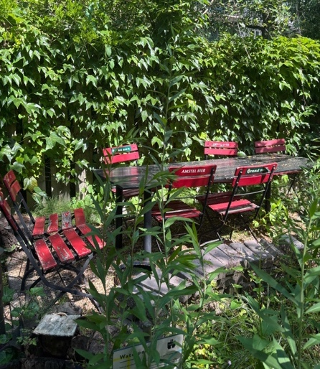 | Midwest offers neighborhood-scale outdoor space within walking distance for people who cannot afford or access private gardens. | Tom: wanted to move to a house with a small garden but could not find affordable housing in the neighborhood. He and his partner chose to stay because of the proximity to Midwest and their social community, giving them access to greenspace within walking distance. | Functions as a form of collective outdoor infrastructure, compensating partially for unequal access to private greenspace.
Outdoor gardens creating spatial diversity for different care needs  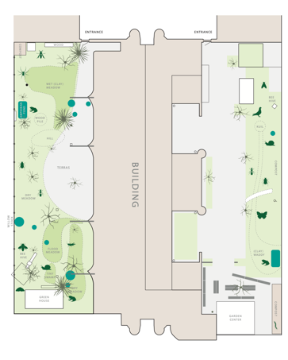  Map of Midwest gardens, provided by gardener | The two gardens have different levels of activity, enclosure, planting, and social interaction, allowing users to choose spaces according to their needs. | North Garden is described as the “curiosity garden,” with more paved areas and seating. South Garden contains hidden pathways and is perceived as calmer and more private. Nils: described the south garden as “less social.” | Provides choice and flexibility, allowing the same care space to accommodate socializing, activity, solitude, and retreat.
Supporting active social/community activities  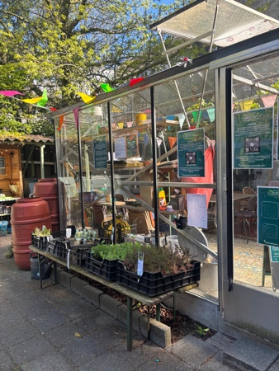 | The north garden provides more paved surfaces, seating, and connections to initiatives such as composting, native plant sales, and recycling. | The north garden was described as the “curiosity garden” because of its different initiatives. It contains more paved areas and places for people to sit. | Supports community participation and social interaction while linking care for people with ecological and environmental activities.
Indoor–outdoor continuity  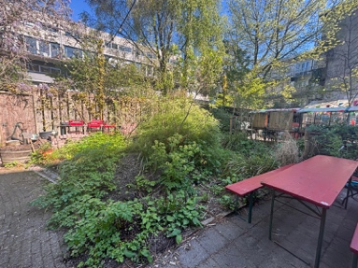 | The spatial relationship between the building and gardens allows activities and social interaction to move between indoor and outdoor spaces. | Theun: “the garden and the building support each other.” The north garden has a direct connection to the indoor space, creating a sense of fluidity between the two. | care function includes both indoor and outdoor environments rather than treating them as separate spaces.
Creating an inviting threshold  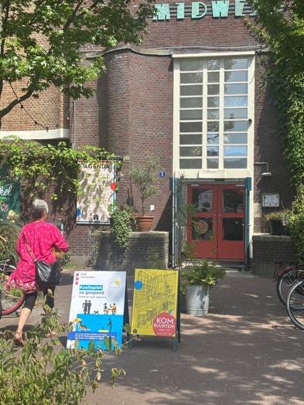 | The entrance, courtyard, signage, seating, bicycle parking, vegetation, and regular maintenance make the building approachable and welcoming from the street. | The entrance is set back from the street, creating a small front courtyard. Anita and staff intentionally maintain the entrance area, including signage, cleaning debris, and caring for vegetation. | Creates a welcoming threshold that encourages people to enter and establishes the building as an accessible neighborhood space.
Material care and sense of belonging  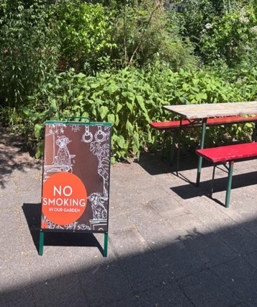 | Reused, salvaged, self-built, and personally meaningful objects are incorporated into the gardens and building. | Examples include a €300 greenhouse, found furniture, salvaged plants, self-painted tables, custom-built shelves, and grasses collected from a municipal maintenance project. | Material reuse reflects collective care and allows participants to see their own labor, histories, and contributions embedded in the space.
Community ownership through making and maintenance  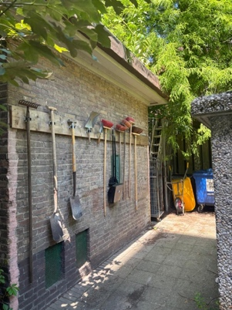 | Residents and users actively contribute to making, maintaining, and adapting the physical environment. | The gardens were manually created through de-paving and digging; residents contribute through recycling, composting, gardening, and making an repairing objects for the space. | Shifts care infrastructure from something simply provided to users toward something collectively produced and maintained.

Social Care Functions
North Garden 1: Social / Active Terrace | Evidence supporting the claim | Care implications
The north garden is described as one neighbor as “the curiosity garden” due to the different features and initiatives here such as compost and native plant sale, as well as recycling lab. This is also the larger garden where there is more paved areas rather than garden space, so there are more spots for humans to sit. The connection from here to the indoor space helps create a feeling of fluidity between the inside and outside. | “Sometimes there's people sitting on a picnic table and the door is open... It's really connective, I would say." (Yvonne, via personal communication 2026). | Support for people that are burned out or have trauma in the community, support for biodiversity, more than human and human connection, mental health
South Garden 2: Wild / Private Refuge | Evidence supporting the claim | Care implications
The gardens are considered more relaxing and peaceful than inside, and serve different functions. One person described it as the active sun garden where they take calls and sit for specific conversations. There are small, more hidden pathways in this garden as well as the water retention installations. | “And when I sit there, I feel very... It feels like a private area which just feels... calm and safe and like being surrounded by green. So for me, this is a less social garden."(Nils, via personal communication, 2026)  “the garden now supports people in ways that indoor spaces cannot. People hold difficult conversations here. Families celebrate births here. There has even been a funeral here"(Theun, via personal communication, 2026). | more than human and human connection, mental health, biodiversity in the city
Other Physical Spaces at Midwest | Evidence supporting the claim | Care implications
Café space and coworking space: the most active, exciting, but also stress inducing space for workers, and same for visitors due to variety of noise and activity happening there. Eating and socialization happen the most here. Eating together and cooking can be considered a form of care as it is life sustaining. | Observation, cocreation session results | Community, socialization, atmosphere
Kitchen: Employees enjoy seeing who is working in the kitchen and getting food there. The dishwashing room is also seen as a resting place away from the office according to employees during mapping session. | Yvonne and Sofie, cocreation session results | Food (nourishment), community
Offices: Located behind café and accessible when walking through the building, not a lot of light and connection compared to the other communal spaces such as cafe | According to Yvonne, a worker at Midwest, in the office “there's not a lot of daylight as well so that probably doesn't help. It feels a bit like a bunker because you can't really open a window and stuff.” But she feels productive and active here, and mapped both “draining and friends.” | Financial/organizational benefit
Rented rooms: former classrooms, did not get mentioned during interviews or workshop, but are available upon request for a certain amount, which differs in cost depending on initiative. |  | Access to affordable event space (rates differ per group)
Social Activities at Midwest | Evidence supporting the claim | Care implications
“Turning Tables” is for anyone to come and make friends over dinner and activities. Started by two sisters, they wanted to encourage younger people from diverse backgrounds to meet, invite refugee status teens to come as well. | It is a success because “it's about taking care of yourself and taking care of others. But it's on the basis of friendship. that's it” (Anita, via personal communication, 2026). | Connection with different socio-demographic backgrounds
The Rouwcafé (grief café), is for people in their 20s and 30s in the Amsterdam area who have lost someone, to get together monthly to share a meal | According to the website: “we find support (and companionship) in each other after the loss of a loved one.” | Companionship and support for people who have suffered loss, caring with
Neighborhood canteen (buurtkantine): community dinner at Midwest every Friday where a local neighborhood chef cooks a meal for an affordable price for anyone to join (12,50 or 5 euro with stadpas) to promote socialization and connection among neighborhood residents from different backgrounds over a shared meal | “some elderly people or people who are more lonely and by themselves…they come here and they have dinner with younger people..."(personal communication, 2026).  According to website, . the initiative started after they stopped the free meal program called “Bordje voor jou, bordje voor mij” that started during Covid out of necessity for accessible meals for residents in the area. | caring with, emotional connection and socialization with people from different sociodemographic backgrounds in the neighborhood
The Native Plant shop (In Dutch: De Inheemse Plantenwinkel) located in the North Garden of MidWest, is the first toxin-free local garden center in Amsterdam. They sell organic and pesticide-free garden plants from April through October, a large portion of which are 'native' plants in the Netherlands, and “are important for our threatened biodiversity: (wild) bees, butterflies, and other insects need these plant species to survive” | According to the shop coordinator Mila, it is quite successful in terms of interest and sales, but the funding is insecure. She receives funding to pay herself to run it but not for help, so it is run by a group of enthuastiastic volunteers (via personal communication, 2026). . Local growers are paid honest fees, resulting in no actual profit margin on the plants. She hopes to nudge conventional plant growers toward natural methods rather than a model intended for commercial scaling | Biodiversity, care for human and more than human life, accessible native plants. build awareness, educate the public
Compost station: free compost area in the North Garden of Midwest, in collaboration with Afval naar Oogst. There used to also be a fresh produce pick up point but this is no longer running. | Website, observation, interview w Tom | Environmental awareness
Broeii Recycle Lab : Plastic and food waste recycling workshop | Interview w Tom | Environmental awareness
Mourning & Celebrating at Mercatorplein (rouwen en vieren in Dutch):  Offers space to commemorate loved ones and celebrate gratitude. Anita, the founder, first brought up this one initiative as an example of care, which was started during covid times. | “take some time for the things or the people they mourn about, about their losses,” but also to celebrate “that if you lost somebody or you lost your health, there's always another side. And that's the side of love. So mourning and being sad is something you have to go through to get back to this feeling of, uh, once I was a happy person or I can be a happy person as well. So I have to celebrate life. I have to celebrate friendship. I have to celebrate love.” | Support and connection
The Young Dreamers Collective: “The collective was created in response to a request from young people to develop their creativity” which they receive external funding for. |  | Intergenerational support
Midwest Radio: supports local artists and musicians through events at Midwest which they also help to promote. |  | Music and creativity
Collaborative events:  Hosting and collaborating with other numerous neighborhood initiatives as well, eg. The Mall de Baarsjes, an initiative to support young people in talent development, who organized and hosted a festival with free admission at Midwest in August, | “MidWest is more than happy to give space to initiatives from the neighborhood and considers it important that young people themselves can help shape the place and the program. You too, right?”(via Midwest.nl, 2026). | Social connection and collaboration
Midwest as a “cooling place” in the city: in collaboration with the municipality, it is accessible to anyone when temperatures are too high, and reduce heat stress | Observations- Many people do come for this purpose in the summertime and sit and enjoy the AC, often bring pets as well, interviewed pregnant women who came specifically for the AC from her apartment to knit during her maternity leave | Health, well being

City of Amsterdam Planning Documents

Organization of Municipality
Figure 19 Organizational chart of Municipality of Amsterdam, via amsterdam.nl, 2026.
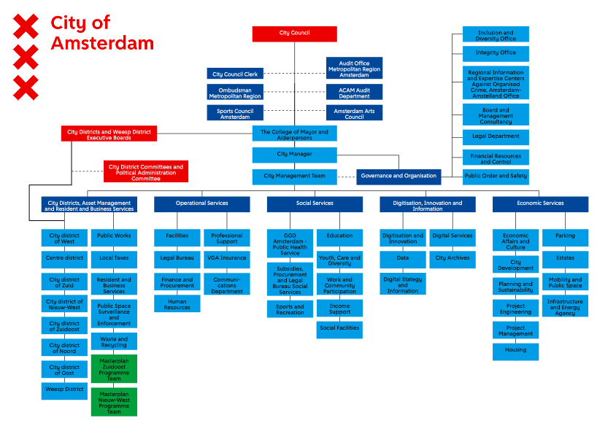

Physical (and Social) Care Functions
Table 4 Municipal Planning Documents and Care Functions
Planning policies/documents | Care implications in Amsterdam
Green vision 2020-2050  The vision identifies four main goals the plan will target. These are:  Principle 1: We will ensure there is enough diverse green space for everyone  Principle 2 We will ensure that green infrastructure is multifunctional  Principle 3 : Biodiversity will be integrated into urban planning, construction, and management  Principle 4 : Working together on green space  (Green Vision, p.33) | Physical Care , Care never explicitly mentioned  Aim of the vision is “to increase the amount of green infrastructure wherever possible and to make better use of existing green areas”(Green Vision, p . This is because the municipality recognizes that “green space is important for social well-being, leisure, climate adaptation, health, and biodiversity” (p 6). Many of these reasonings intersect with care functions.  Accessibility is a key theme, a necessary aspect of care infrastructure.  Green measures from the green vision:  Green routes: a 10-minute walk from your front door to a park, a 15-minute bike ride to a nature reserve.  A ‘green by default’ principle: wherever possible, we [the city] replace paving stones, bricks and asphalt with greenery to create a natural living environment with space for social interaction.  Public and accessible green spaces: allotments, sports parks and school gardens will become more accessible and inviting to a wider public.  Landscape parks: directly surrounding the city, we are creating areas for wilderness, spaces for urban agriculture and more facilities for sport and exercise.  New forest and parks: a new urban forest and new urban parks will be created
Red and Green Handbook (Puccine Method) | Physical Care -standard physical amenities (affordances)  he Green and Red planning handbooks follow the Puccini Method, which are “our own sets of rules of how we design, maintain, implement green (and hardscape) in urban space” (Rixt, via personal communication, 2026). The Puccinimethode demonstrates that Amsterdam approaches the physical environment through complementary green and hard infrastructures: the Green Handbook specifies the material conditions for vegetation, biodiversity, recreation, climate adaptation and human well-being, while the Red Handbook establishes the paving, lighting and street furniture that enable public spaces to be accessible, safe and usable as well as standardized (Rixt, via personal communication, 2026).  These standards focus on physical/material functions throughout the urban fabric such as parks, streets, pathways, playgrounds, sports grounds and other green spaces, however the consideration of care is not a priority in this way.
Amsterdam Make Space (Amsterdam Maakt Ruimte)  long-term spatial and mobility vision for the municipality, addressing rapid urban growth, climate change, and increasing density | Physical care principles, enables social care  Enforces care mobility principles, through goals to redistribute scarce public and urban space by reducing car-centric infrastructure (autoluw) and prioritizing pedestrians, cyclists, public transit, and climate resilience
Space for Everyone (Ruimte voor Iedereen)  research within the municipality on how to incorporate gender inclusive thinking into planning, | Social care and physical  The research done by the municipality in “Space for Everyone” shows there is awareness of how gender inclusive features in planning support not only for women, but everyone (Merel, via personal communication). However, the conversations related to gender inclusive design thinking are “often hijacked by conversations of safety.”

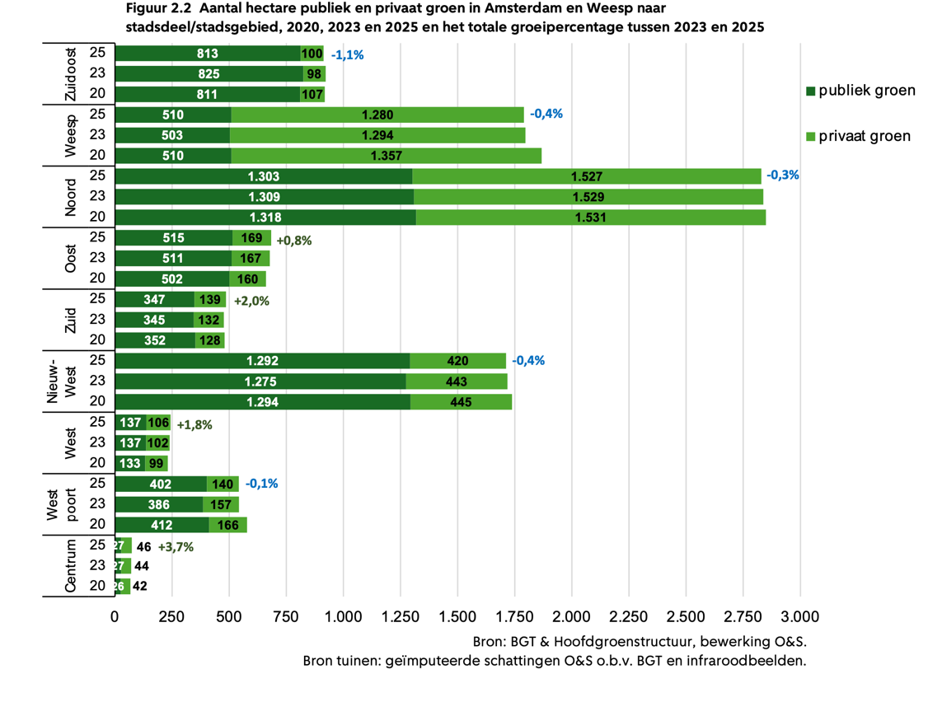
Figure 20 Total hectares of public and private green in Amsterdam per district, Monitor green report p. 13

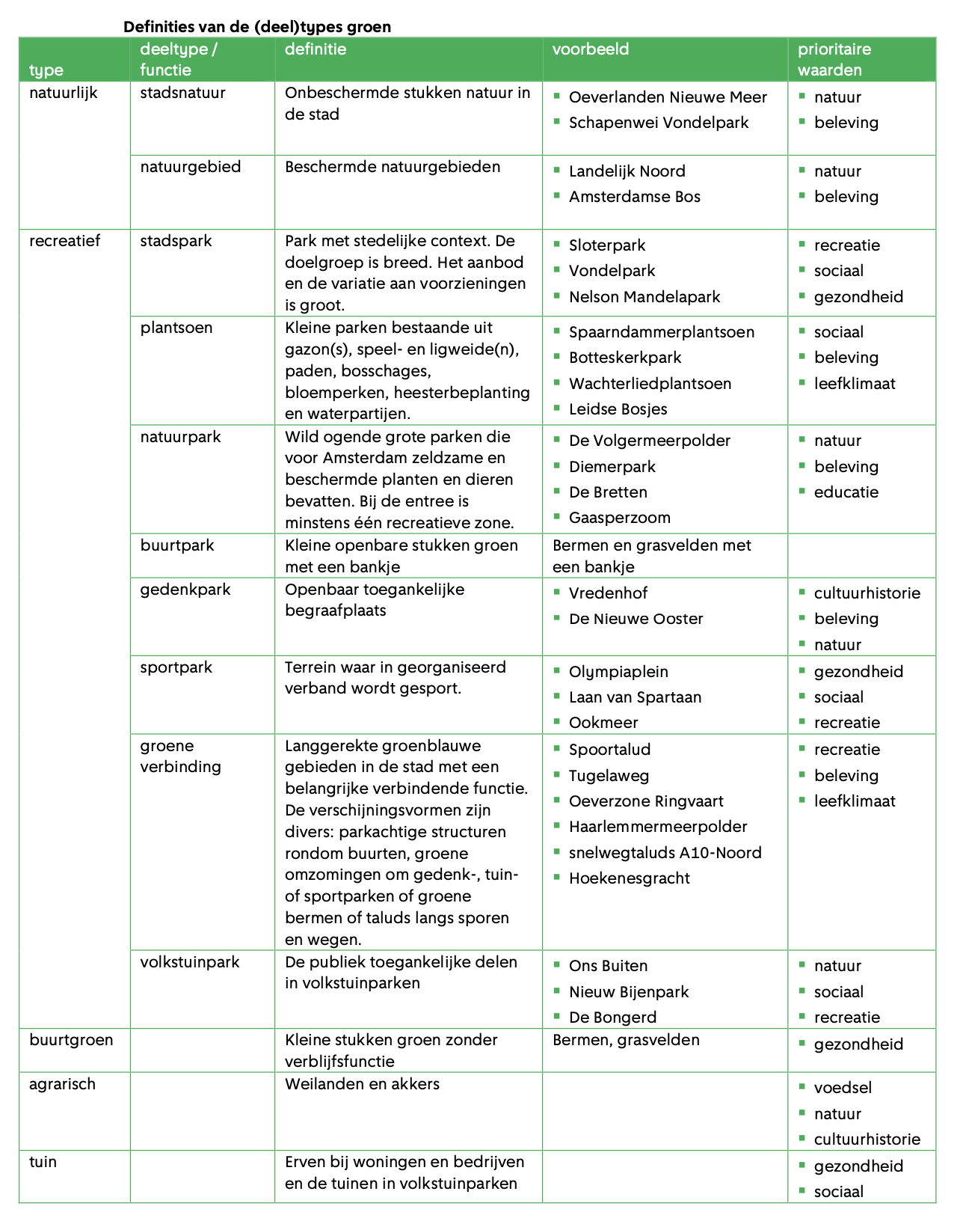
Figure 21 Definition of Green Spaces at the Municipality, Monitor green report p. 10

