P5 REFLECTION
Student Name: Wenying Wang
Student Number: 4245148
Tutors: Mick van Gemert; Suzanne Groenewold; Christian van Ees
Studio: Complex Projects-Chicago

Since our urban design concept in P2 is about introducing a new model for Pilsen’s old industrial area so as to create a symbiotic relationships between Pilsen and its surrounding counties, Pilsen’s new industrial district and its nearby residential district for the next 50 or 100 years, I also tried to test if I can introduce a new model of educational institution so as to imply the new learning mode because the development of industry and technology. If this model worked, it means it can help make the post-secondary education more affordable in Pilsen as well as in other counties in Chicago, and the skill gap of the workers in their industrial area can be partly filled.

My research starts on building a learning center for creative arts in Pilsen, Chicago, and the concept of my building is “sponge”. However, in terms of the configuration of function, there is no distinct difference between the new model and the existing learning center in the end. There are lots of reasons that can explain this: the configuration of the function is not only based on the user groups in my building, but also the climate even structural concept of the building. So in the end it seems to be just a mixed used complex building. The differences that are presented in the result are more about the fusion of different streams of traffic, the way the building is used and the emphasis on visual connection.

The concept came from the characteristics of the future learning environment: mingling exterior natural space; blurring the boundary of informal and formal learning spaces; increasing social interaction and visual connection. Because of the development of technology, the works like drawings, models, films by art students are more readable by nonprofessionals from internet or in a learning environment. Also, the advancement of the new technology and manufacturing makes customized production possible, the new industrial products from local producer or residents can inspire the art students or the orther way around.
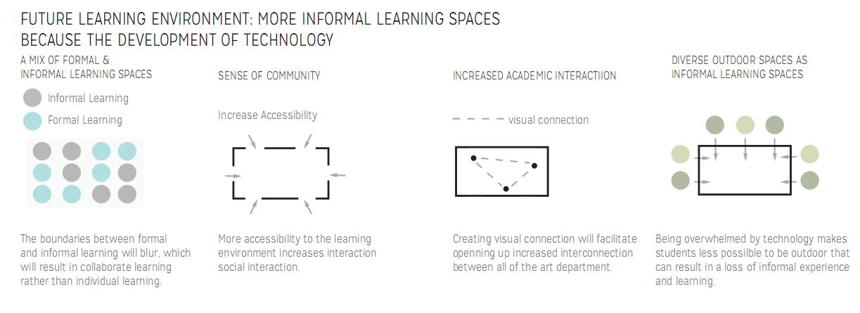
Figure 1. Future learning environment
Then I looked back to the typical sponge-like buildings and the architects in the history who liked such concept. Conducting this kind of research can help me rethink the concept and inspire me the approach to realize it. In the Project of The Simmons Hall at MIT, Steven Holl creates a porous structure which allows light to filter through multi-story high lounges in section and stir up interaction between students who are living in this dormitory.

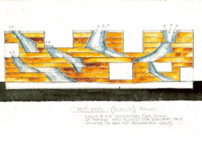
Figure 2. The Simmons Hall at MIT( http://images.adsttc.com/media/images/55e6/0db2/4d8d/5d5a/8600/0003/large_jpg/stevenholl1.jpg?1441140142)

Besides, there are more projects that felt like sponge in form such as sarphatistraat offices in Amsterdam by Steven Holl, King Abdullah II House of Culture and Art in Amman by Zaha Hadid, Ted Building Competition work in Taiwan by Bjarke Ingels Architect and Rolex Learning Center in Lausanne by SANAA. All of these buildings look porous from outside and the mass and void implies the relation between the space around and the space within the building. Another example, Taichung Metropolitan Opera House by Toyo Ito, although its concept is sound cave, the horizontally and vertically continuous surface still makes an expression of sponge.
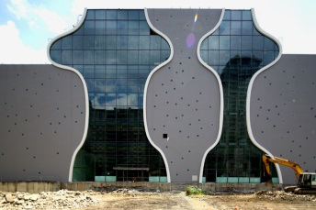
Figure 3. Taichung Metropolitan Opera House (http://www.designboom.com/architecture/toyo-ito-taichung-metropolitan-opera-house-taiwan-21-08-2014/)
With the development of technology, the traditional relationship between the tutor and the student is dissolved, the model of a master who is standing at the front of the class is not that important because the works of creative art are more readable and understandable. Besides, a horizontally and vertically continuous space helps to increase visual connection between users, or users and the creative art works so as to inspiring more users. Basing on both reasons, I decided to transform such a form into my learning center.

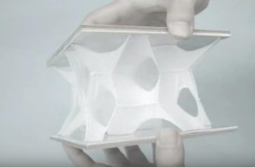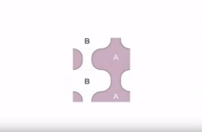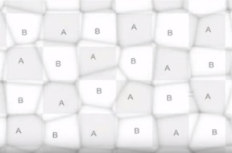
Figure 4-6. Taichung Metropolitan Opera House https://www.youtube.com/watch?v=OWlVZBn-z3g&index=5&list=PLnoJMA8iqApJ3SDJl2pBeewcy-phMFRgQ
In this case, Toyo Ito created a structure to separate two kind of space A and B in plan and section, but in its real design process, there is no functional or architectural distinction or even relationship between space A and B.
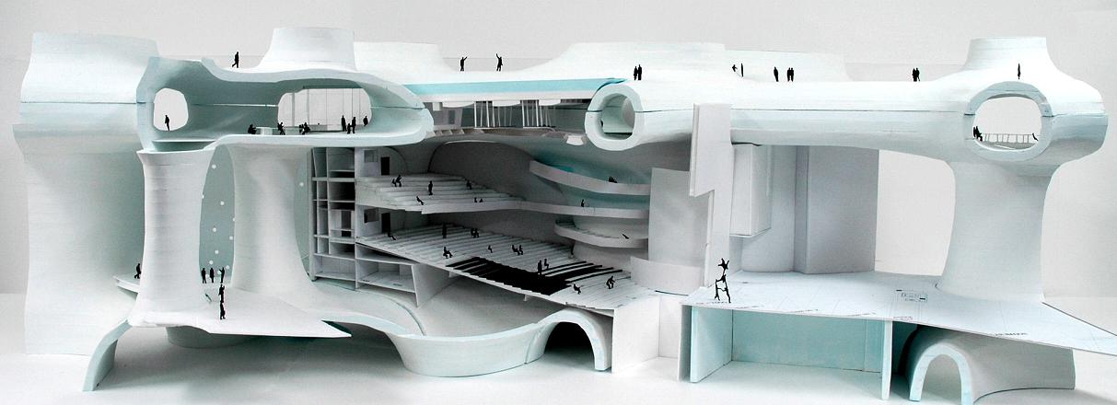
Figure 7-8. In Taichung Metropolitan Opera House, both space A and B are functional spaces

Secondly, because the existence of the floors which are supposed to attach to the continuous vertical wall, there is possibility to have both space A and B on one floor at the same time, which helps to realize one of my 4 themes: to mix or blurring informal and formal spaces in the plan in one of my preliminary design. And the following is how I did during my P3.
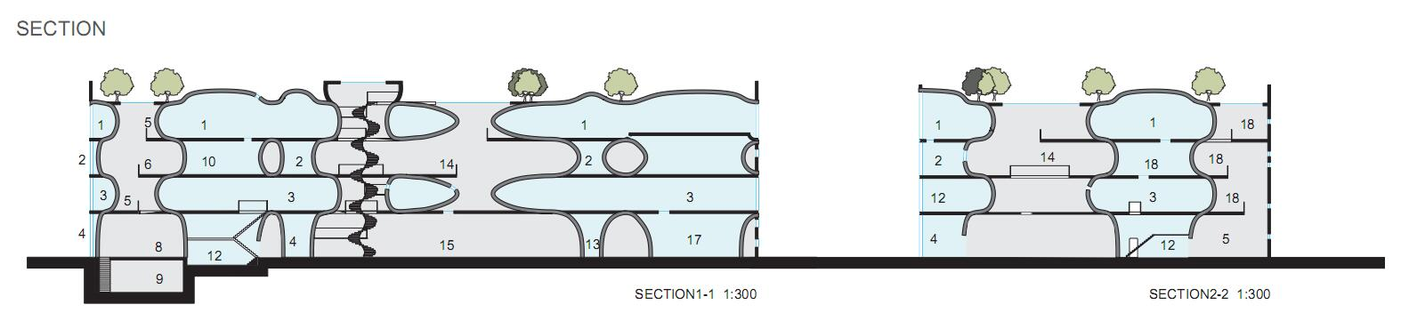
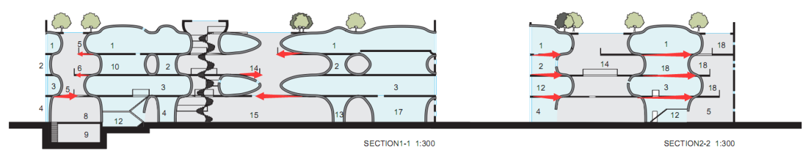
Figure 9. P3 section design, the red parts are the floors above the caves which are considered to be removed.
However, remove those floors above the caves can be more interesting because there will be a variety of space of different height. But the accompanying problem of this approach is 100% separate grey informal space and blue formal space in section and plan because on the same floor only one of them is accessible, which seems completely unnecessary in a new learning environment because it calls for a mixing of different functions so as to inspire the users.

In sum, defining space A and B becomes the critical issue in successfully transforming an opera house into a learning center. How to realize separating and mixing two different kinds of spaces at the same time? There are a lot of possibilities in define space A and B. They can be space and construction, public space and private space, noisy space and quiet space. I can chose any of those pairs to proceed my design, but in the end, none of those above division is related with and will help test what the future learning environment will looks like. Because it is not about first coming up with a beautiful design, afterwards you can look back to give it a new and complete concept. It is more about exploring what the future learning environment will look like if I try to blurring the formal and informal learning spaces.

Then the following research is all about trial and error in architectural design. In order to solve this contradiction, I mixed part of the blue formal and grey informal spaces and then reclassified my functional spaces into green intentional learning and yellow incidental learning part. In this way, the formal and informal learning programs can be partly mixed on each floor. Afterwards, I started to test in two directions to see which of them can work.
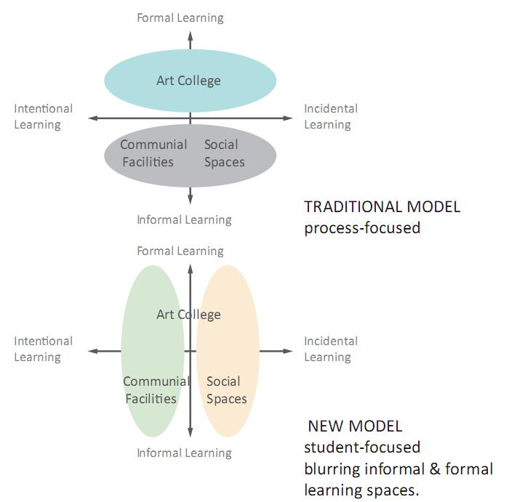
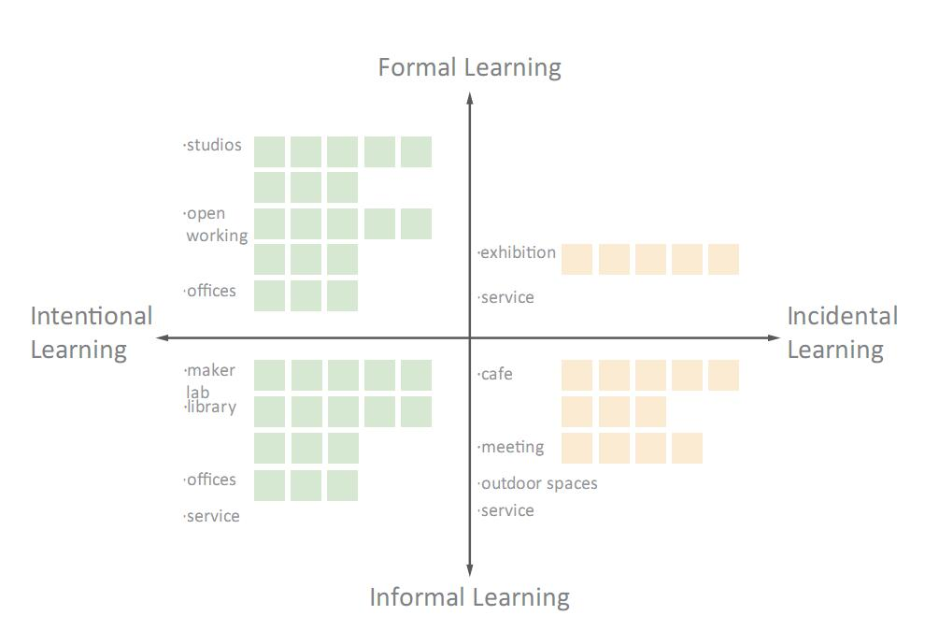
Figure 10-11. new classification.
The first approach is showed in the diagram below.
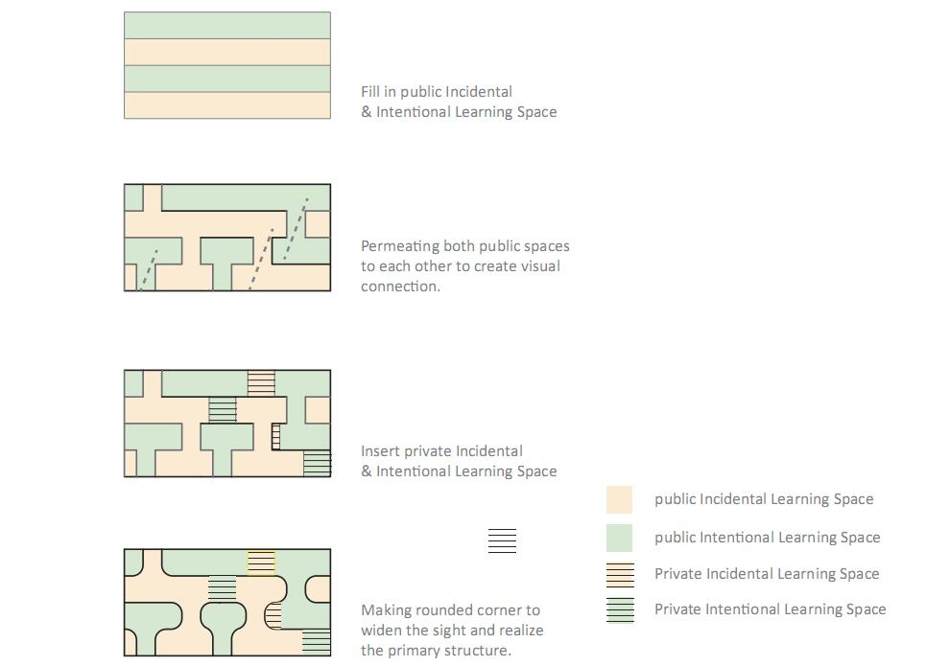
Figure 10-11. First Approach in section Diagram.
For the technical part, inserting private green and yellow spaces become difficult afterwards because on the same floor, if such private space will be larger than one studio, the span between 2 voids will become 15m at least, since the minimum size of the void should be 4m*4m, the floor thickness will become 1m at least, and for my 36m width and 4 to 5 story high building, there will be light problem in the center.

After weeks of trying, there can be a floor plan designed with both green and yellow spaces on the same floor level, but although the private spaces are in transparent glass construction, do they still break the image of a sponge or damage the concept of a sponge ( because it calls for the primary structure separating 2 kind of space!) ?

In the second approach I tried to mixed formal and informal space in time dimension. Vertically, I put the spaces that almost everyone will inevitably use like cafeteria in yellow to the top of my building so as to encourage a “vertical mixing experience”. This approach can mix more formal and informal space to some extent, and maybe this is the only way to do this.
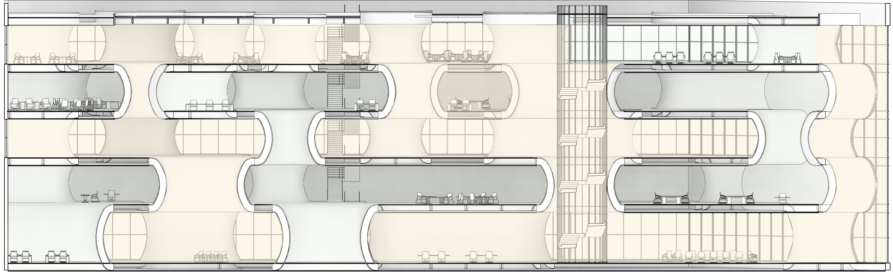
Figure 12 The temporary final result.
The roof of the top floor is partly transparent to allow for the light passing through the structure
on lower floors. Also, some studios in green are put on the top floor because of the limitation of structure.

When I looked back the whole P4 designing process, the most challenge for me is during the research, everything comes together and have to be figured out at the same time. It is too easy to get lost and lost priority in the designing process. Actually during the whole testing period I am always feeling confused about the necessity of remaining and separating space A and space B. Most of the time, the separation of green and yellow spaces is of no significance to my design. Because of the lack of precedents, I just compromise and chose the second solution in my P4 design period. And I am also waiting for feedback to my confusion. And if I am lucky enough to enter P5, I think I will have a more interesting plan, a more interactive relation between formal and informal spaces for my learning center.

The light problem of lower floors in my building is one of the following challenges. My building is 36m wide 21m high so it is not as narrow as the Simmons Hall at MIT or as flat as Rolex learning center, both of which allow light to pass through their porous appearance. As a result, the programs in the center of the building calls for transparent or porous structure with light pass through which I still need to study on.

